Pods:

* our ultimate aim is to deploy our application in the form of containers on a set of machines that are configured as worker nodes in a cluster.
* The containers are encapsulated into a Kubernetes object known as pods.
* A pod is a single instance of an application.
* A pod is the smallest object that you can create in Kubernetes.
* To scale up, you create new pods. And to scale down, you delete existing pod.
* But are we restricted to having a single container in a single pod? No.A single pod can have multiple containers, except for the fact that they're usually not multiple containers of the same kind.
* The multi-container pods are the pods that contain two or more related containers that share resources like network space, shared volumes, etc and work together as a single unit. simple Docker containers.
* Let's assume we were developing a process or a script to deploy our application on a Docker host.

Then we would first simply deploy our application using a simple Docker run Python add command, and the application runs fine, and our users are able to access it.

With the load increases, we deploy more instances of our application by running the Docker run commands many more times. This works fine and we're all happy.

Now, sometime in the future, our application is further developed, undergoes architectural changes and grows and gets complex. We now have a new helper container that helps our web application by processing or fetching data from elsewhere. These helper containers maintain a one-to-one relationship

with our application container and thus needs to communicate with the application containers directly and access data from those containers.

For this, we need to maintain a map of what app and helper containers

are connected to each other. We would need to establish network connectivity

between these containers ourselves using links and custom networks.

We would need to create shareable volumes and share it among the containers.

We would need to maintain a map of that as well. And most importantly, we would need to monitor the state of the application container and when it dies, manually kill the helper container as well as it's no longer required.

When a new container is deployed, we would need to deploy the new helper container as well. With pods, Kubernetes does all of this for us automatically.

We just need to define what containers a pod consists of and the containers in a pod by default will have access to the same storage, the same network namespace and same fit as in they will be created together and destroyed together.

* The kind refers to the type of object we are trying to create, ex (pod,deplyment,,)
* To deploy a docker container by creating a POD.

$ kubectl run nginx --image nginx

$ kubectl apply -f pod.yml

$ kubectl create -f pod.yml

$ kubectl run redis --image=redis123 --dry-run=client -o yaml > redis-definition.yaml

* To get the list of pods

$ kubectl get pods

* To describe pods

$ kubectl describe pod

* To edit pod

$ kubectl edit pod redis

Replicaset:

* Controllers are brain behind kubernetes
* Replicaset offers high availability, Load balancing and scaling.
* Replication Controller is the older technology that is being replaced by a ReplicaSet.
* ReplicaSet is the new way to setup replication.
* The role of the Replica Set is to monitor the pods and if any of them were to fail, deploy new ones.
* The Replica Set is in fact a process that monitors the pods.
* how does the Replica Set know what pods to monitor? There could be hundreds of other pods in the cluster running different applications. This is where labeling our pods during creation comes in handy. We could now provide these labels

as a filter for Replica Set. Under the selector section, we use the match labels filter and provide the same label that we used while creating the pods. This way, the Replica Set knows which pods to monitor. The same concept of labels and selectors.

* Selector only founded in replicaset not ReplicationController
* To Create the replicaset

$ kubectl create -f replicaset-definition.yaml

* To list all the replicaset

$ kubectl get replicaset

* There are multiple ways to scale replicaset
  + First way is to update the number of replicas in the replicaset-definition.yaml definition file. E.g replicas: 6 and then run:

$ kubectl apply -f replicaset-definition.yaml

* + Second way is to use **kubectl scale** command.

$ kubectl scale --replicas=6 -f replicaset-definition.yaml

* + Third way is to use **kubectl scale** command with type and name

$ kubectl scale --replicas=6 replicaset myapp-replicaset

* that the selector is one of the major differences between Replication Controller and Replica Set. The selector is not a required field in case of a Replication Controller but it is still available. as the labels provided in the pod definition file.

In case of Replica Set, a user input is required for this property and it has to be written in the form of matched lables.

**Deployment**

* The deployment provides us with the capability to upgrade the underlying instances seamlessly using rolling updates, undo changes, and pause, and resume changes as required.

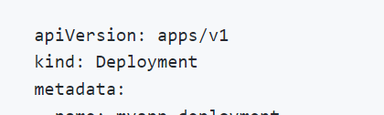

* create the deployment using deployment definition file

$ kubectl create -f deployment-definition.yaml

* To see the all objects at once
* $ kubectl get all

**Services**

* Kubernetes Services enable communication between various components within

and outside of the application. Kubernetes Services helps us connect applications together with other applications or users.

* Service types:
  + 1. Node Port:

NodePort where the service makes an internal port accessible on a port on the node.

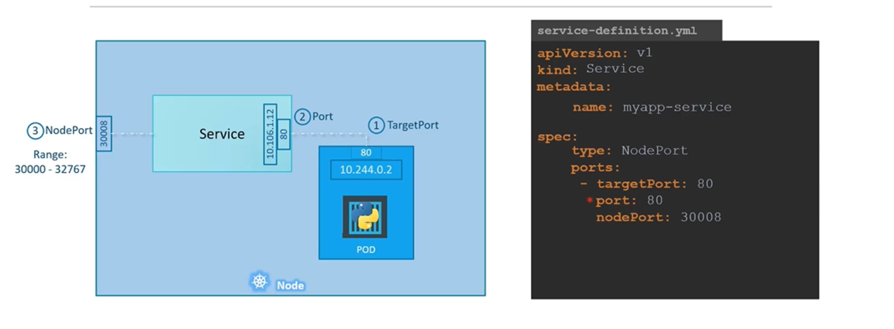

the only mandatory field is port, If you don't provide a targetPort, it is assumed to be the same as port.And if you don't provide a nodePort, a free port in the valid range between 30,000 and 32,767 is automatically allocated.

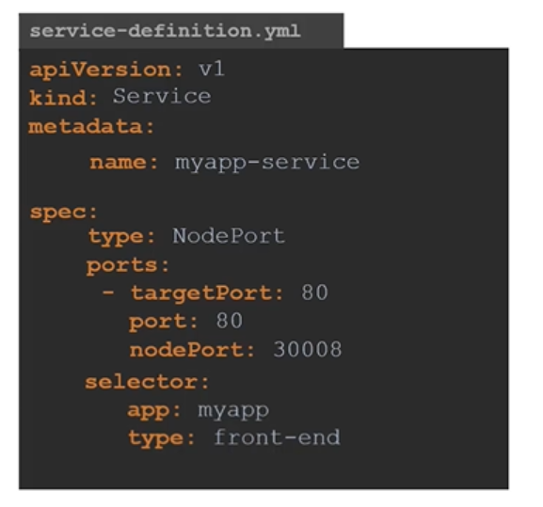

Service uses selector to specify the pod, you should take it from the label in the pod definition.

In a production environment, you have multiple instances of your web application running for high availability and load balancing purposes. In this case, we have multiple similar Pods running our web application. They all have the same labels with a key app and set to a value of my app. The same label is used as a selector during the creation of the service. So, when the service is created, it looks for a matching Pod with the label and finds three of them. The service then automatically selects all the three Pods. Ex: same node:

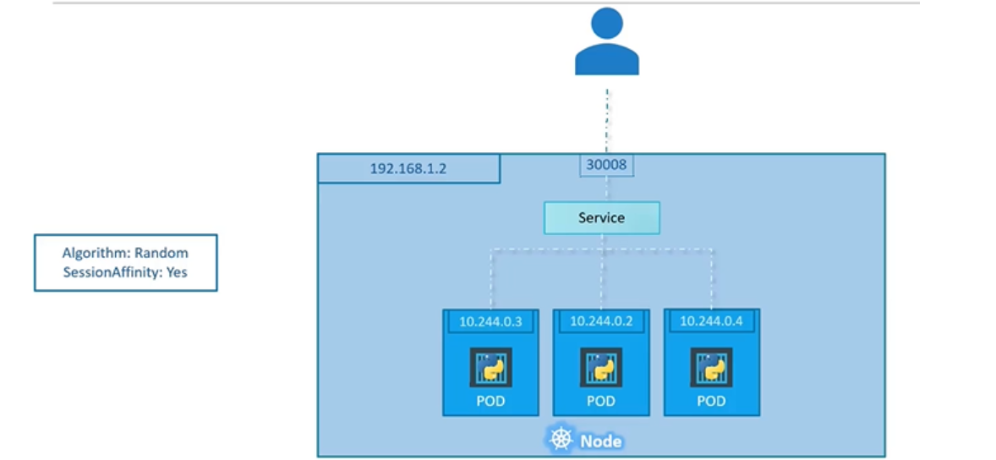

Ex: pods on different nodes.

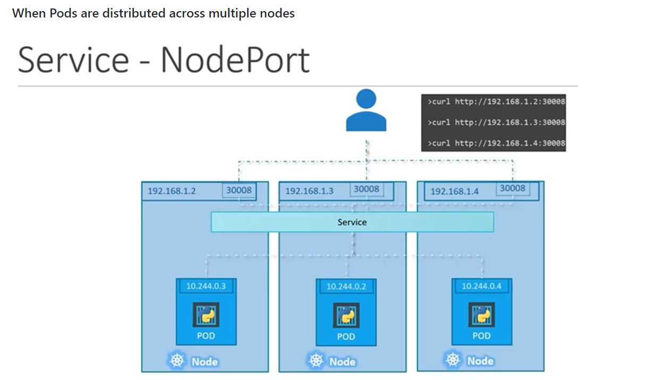

the Pods are distributed across multiple nodes. In this case, we have the web application on Pods on separate nodes in the cluster. When we create a service,

without us having to do any additional configuration Kubernetes automatically creates a service that spans across all the nodes in the cluster and maps the target port to the same node port on all the nodes in the cluster. This way you can access your application using the IP of any node in the cluster and using the same port number

which in this case is 30,008.

#### To create the service

$ kubectl create -f service-definition.yaml

* + 1. ClusterIP:

the service creates a virtual IP inside the cluster to enable communication between different services, such as a set of frontend servers to a set of backend servers.

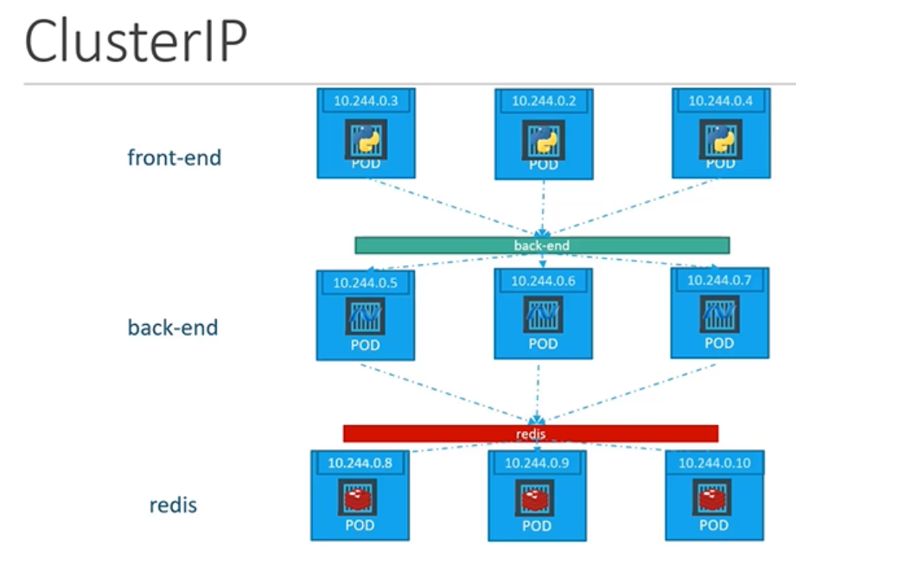

* + - * the service creates a **Virtual IP** inside the cluster to enable communication between different services such as a set of frontend servers to a set of backend servers.
      * A kubernetes service can help us group the pods together and provide a single interface to access the pod in a group.
      * Each layer can now scale or move as required without impacting communication between the various services.
      * To link the service to a set of ports we use selector we will refer to the pod definition file and copy the labels
      * 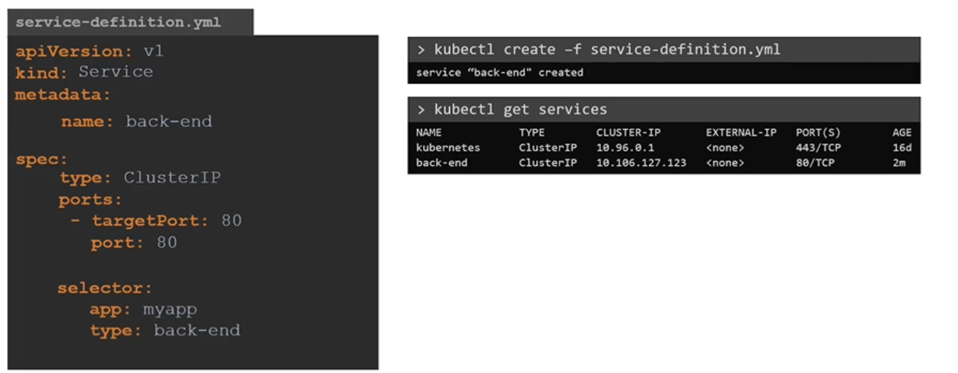
    1. Load Balancer:

Provisions a load balancer for our application in supported cloud providers.A good example of that would be to distribute load across the different web servers in your frontend tier. It will be external. To distribute the traffic across all nodes and making a unique url to access the application instead of multiple ip for the different nodes.

**NameSpaces**

* the **default** namespace in kubernetes. It is automatically created when kubernetes is setup initially. Also kubesystem and kubepublic.

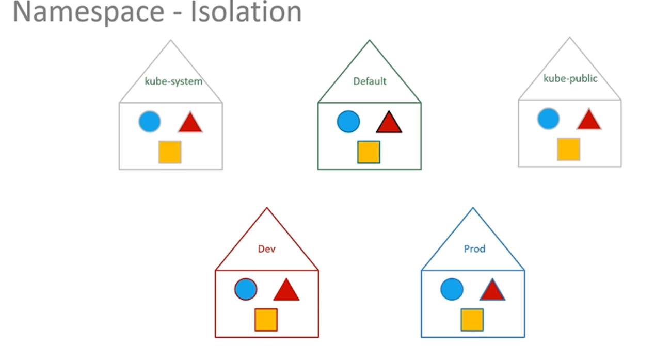

* kube-public. This is where resources that should be made available to all users are created.
* To list the pods in another namespace. Use **kubectl get pods** command along with the **--namespace** flag or argument.

$ kubectl get pods --namespace=kube-system

* To create the pod with the pod-definition file in another namespace, use the **--namespace** option.

$ kubectl create -f pod-definition.yaml --namespace=dev

* 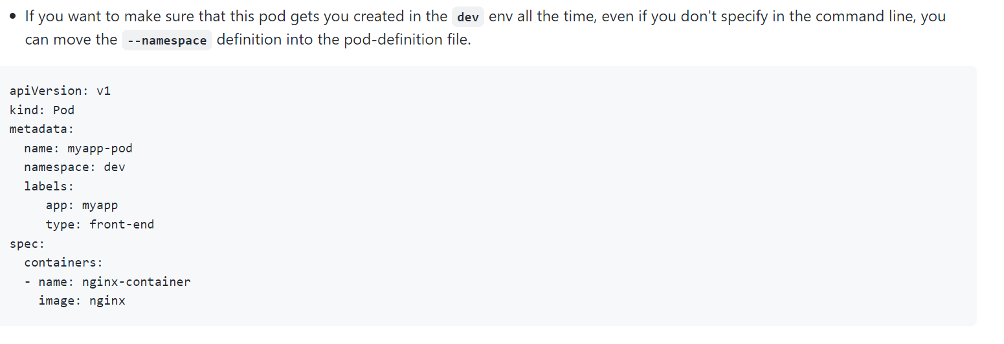
* To create a new namespace, create a namespace definition as shown below and then run **kubectl create**

$ kubectl create namespace dev

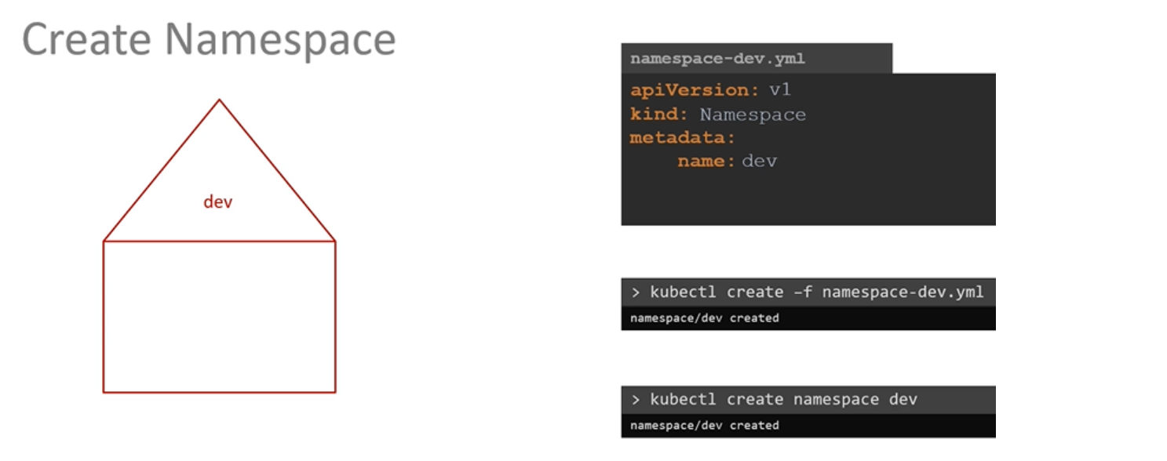

* By default, we will be in a **default** namespace. To switch to a particular namespace permenently run the below command.

$ kubectl config set-context $(kubectl config current-context) --namespace=dev

* Resource quota

To limit resources in a namespace, create a resource quota. To create one start with **ResourceQuota** definition file.

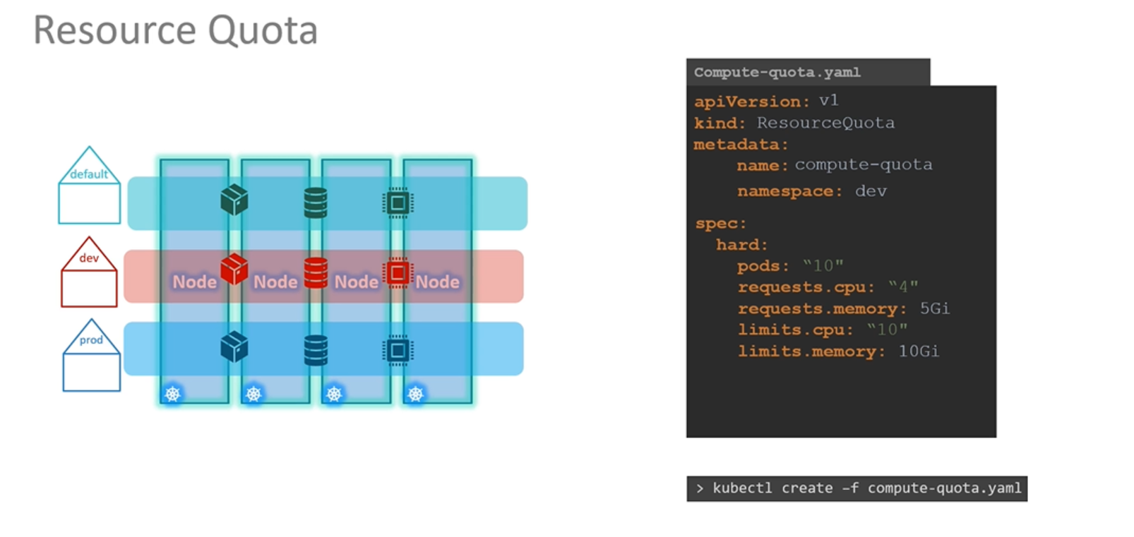

**Certification Tips - Imperative Commands with Kubectl**

**Create a deployment**

kubectl create deployment --image=nginx nginx

**Generate Deployment YAML file (-o yaml). Don't create it(--dry-run)**

kubectl create deployment --image=nginx nginx --dry-run=client -o yaml

**Generate Deployment with 4 Replicas**

kubectl create deployment nginx --image=nginx --replicas=4

You can also scale a deployment using the kubectl scale command.

kubectl scale deployment nginx --replicas=4

**Another way to do this is to save the YAML definition to a file and modify**

kubectl create deployment nginx --image=nginx --dry-run=client -o yaml > nginx-deployment.yaml

You can then update the YAML file with the replicas or any other field before creating the deployment.

#### Service

**Create a Service named redis-service of type ClusterIP to expose pod redis on port 6379**

kubectl expose pod redis --port=6379 --name redis-service -–type=ClusterIP

kubectl expose pod redis --port=6379 --name redis-service --dry-run=client -o yaml

(This will automatically use the pod's labels as selectors)

Or

kubectl create service clusterip redis --tcp=6379:6379 --dry-run=client -o yaml (This will not use the pods labels as selectors, instead it will assume selectors as **app=redis.**[You cannot pass in selectors as an option.](https://github.com/kubernetes/kubernetes/issues/46191) So it does not work very well if your pod has a different label set. So generate the file and modify the selectors before creating the service)

**Create a Service named nginx of type NodePort to expose pod nginx's port 80 on port 30080 on the nodes:**

kubectl expose pod nginx --type=NodePort --port=80 --name=nginx-service --dry-run=client -o yaml

(This will automatically use the pod's labels as selectors, [but you cannot specify the node port](https://github.com/kubernetes/kubernetes/issues/25478). You have to generate a definition file and then add the node port in manually before creating the service with the pod.)

Or

kubectl create service nodeport nginx --tcp=80:80 --node-port=30080 --dry-run=client -o yaml

(This will not use the pods labels as selectors)

Both the above commands have their own challenges. While one of it cannot accept a selector the other cannot accept a node port. I would recommend going with the kubectl expose command. If you need to specify a node port, generate a definition file using the same command and manually input the nodeport before creating the service.

Pods:

* Create pod with container port:

**$ kubectl run custom-nginx --image nginx --port=8080**

Namespace

$ kubectl create namespace dev-ns

Apply command

so we have the three sets of files, and we know that the local file is what's stored on our local system. The live object configuration is in the Kubernetes memory. But where is this json file that has the last applied configuration stored? Well, it's stored on the live object configuration on the Kubernetes cluster itself as an annotation named a last applied configuration. So remember that this is only done when you use the apply command. The kubectl create or replace command do not store the last applied configuration like this.

**Scheduling**

**Manual scheduling**

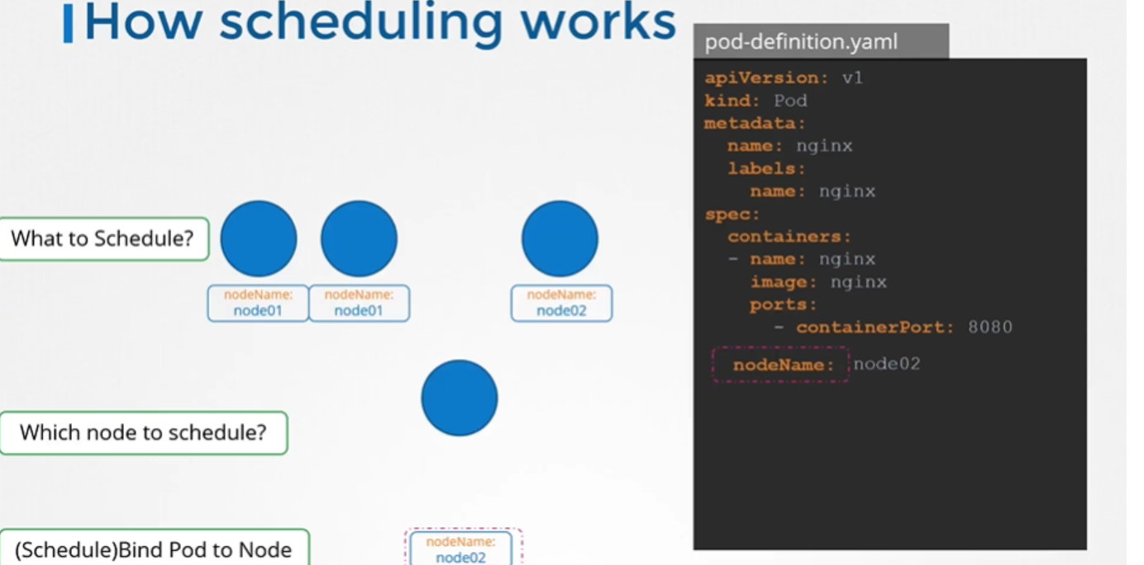

Every pod has a field called Node Name that, by default, is not set.

You don't typically specify this field when you create the pod manifest file.

Kubernetes adds it automatically. The scheduler goes through all the pods

and looks for those that do not have this property set. Those are the candidates for scheduling. It then identifies the right node for the pod by running the scheduling algorithm. Once identified, it schedules the pod on the node by setting the node name property to the name of the node by creating a binding object.

So if there is no scheduler to monitor and schedule nodes, what happens?

The pods continue to be in a pending state.

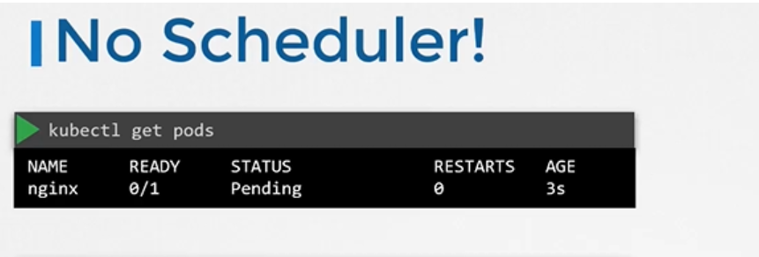

So what can you do about it?

You can manually assign pods to nodes yourself. Well, without a scheduler, the easiest way to schedule a pod is to simply set the node name field to the name of the node.

**Labels and Selectors**

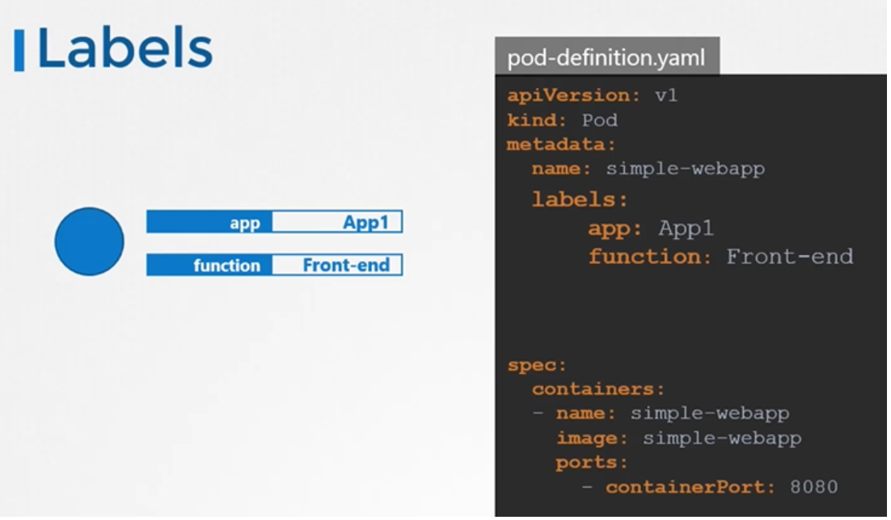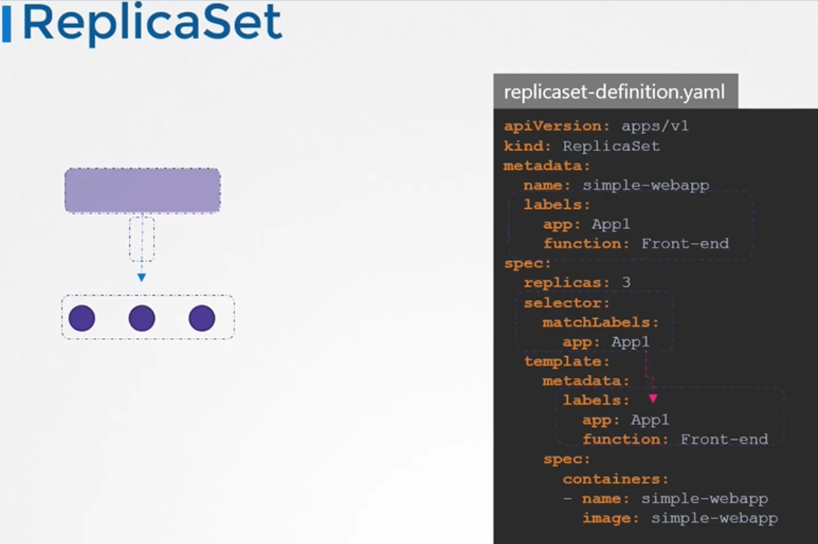

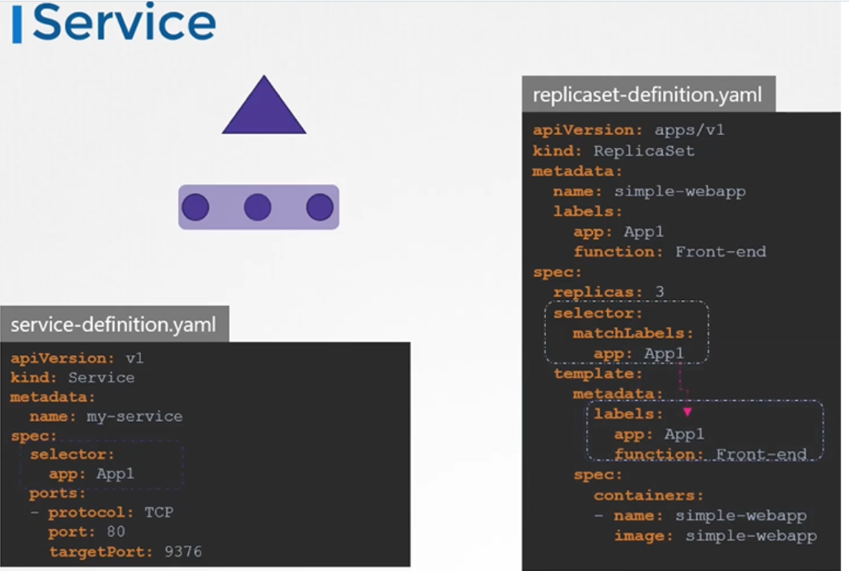

## **Annotations**

While labels and selectors are used to group objects, annotations are used to record other details for informative purpose.

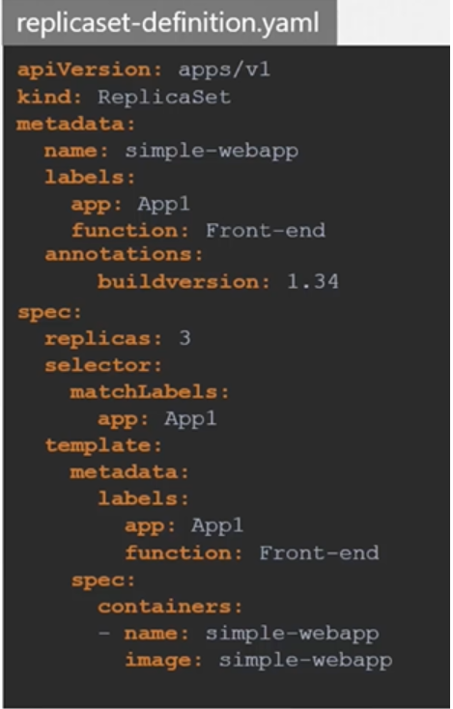

to select the pod with labels run the below command

$ kubectl get pods --selector app=App1

To get all object

$kubectl get all --selector env=prod

$kubectl get pods --selector env=prod,bu=finance,tier=frontend

# **Taints and Tolerations**

* Pod to node relationship and how you can restrict what pods are placed on what nodes.
* Taints and Tolerations are used to set restrictions on what pods can be scheduled on a node.
* Only pods which are tolerant to the particular taint on a node will get scheduled on that node.

## Taints

* Use **kubectl taint nodes** command to taint a node.

Syntax

$ kubectl taint nodes <node-name> key=value:taint-effect

Example

$ kubectl taint nodes node1 app=blue:NoSchedule

* The taint effect defines what would happen to the pods if they do not tolerate the taint.
* There are 3 taint effects
  + **NoSchedule**
  + **PreferNoSchedule**
  + **NoExecute**
* no schedule, which means the pods will not be scheduled on the node
* Prefer no schedule, which means the system will try to avoid placing a pod on the node, but that is not guaranteed.
* And third is no execute, which means that new pods will not be scheduled on the node and existing pods on the node, if any, will be evicted
* Untained node:

$kubectl taint node controlplane node-role.kubernetes.io/control-plane:NoSchedule-

## Tolerations

* Tolerations are added to pods by adding a **tolerations** section in pod definition.

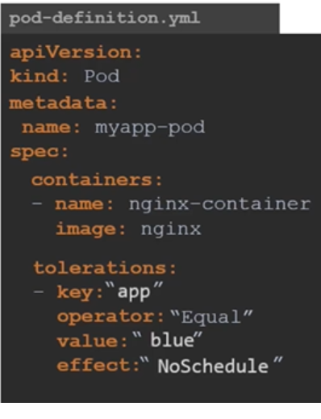

#### Taints and Tolerations do not tell the pod to go to a particular node. Instead, they tell the node to only accept pods with certain tolerations.

* taint is set on the master node automatically that prevents any pods from being scheduled on this node.

# Node Selectors

* We add new property called Node Selector to the spec section and specify the label.
* The scheduler uses these labels to match and identify the right node to place the pods on.

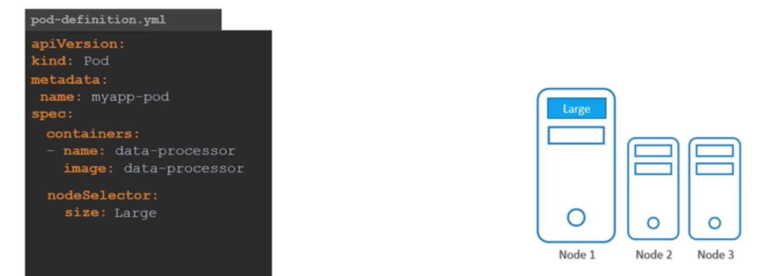

* To label node:

$ kubectl label nodes <node-name> <label-key>=<label-value>

## Node Selector - Limitations

* We used a single label and selector to achieve our goal here. But what if our requirement is much more complex.

**Node affinity**

* The primary purpose of node affinity feature is to ensure that pods are hosted on particular nodes.
* you cannot provide advanced expressions like or or not with node selectors.

## Node Affinity Types

https://technos.medium.com/node-affinity-in-kubernetes-320cfce0898e

* Available
  + requiredDuringSchedulingIgnoredDuringExecution
  + preferredDuringSchedulingIgnoredDuringExecution
* Planned
  + requiredDuringSchedulingRequiredDuringExecution
  + preferredDuringSchedulingRequiredDuringExecution

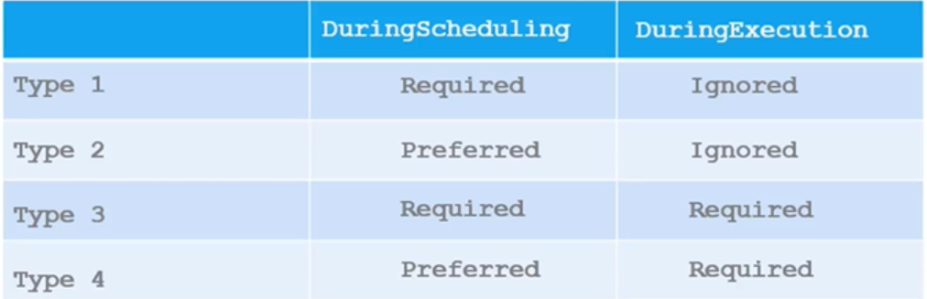

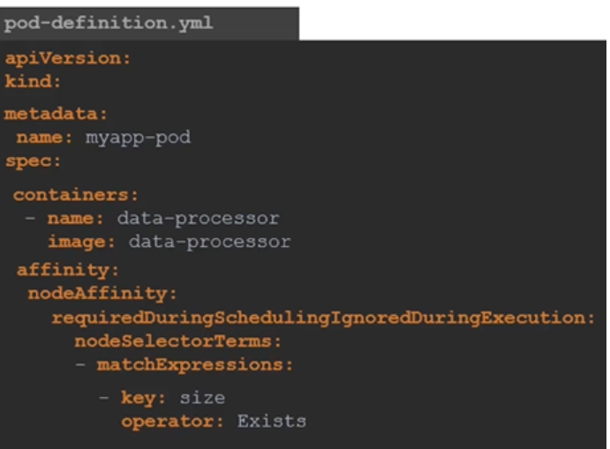

# **Taints and Tolerations vs Node Affinity**

* Taints and Tolerations do not guarantee that the pods will only prefer these nodes; in this case, the red pods may end up on one of the other nodes that do not have a taint or toleration set.

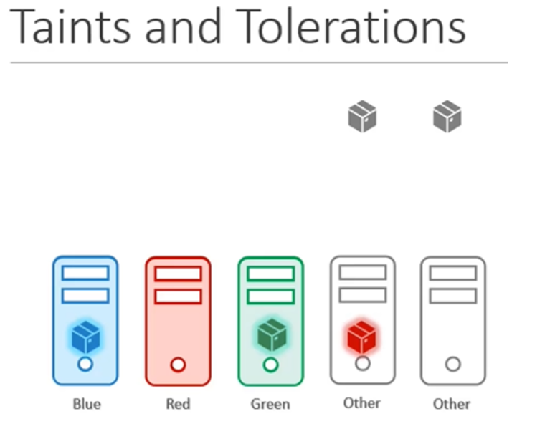

* Node affinity does not guarantee that other pods are not placed on our nodes.

In this case, there is a chance that one of the other pods may end up on our nodes.

* As such, a combination of taints and tolerations and node affinity rules can be used together to completely dedicate nodes for specific parts.

Resource Requirements and limits

* By default, Kubernetes assumes that a pod or a container within a pod requires 0.5 CPU and 256 mebibyte of memory. This is known as the resource request for a container.
* If your application within the pod requires more than the default resources, you need to set them in the pod definition file.

[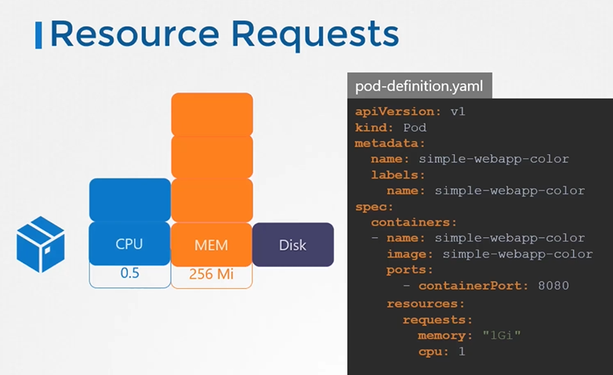](https://github.com/kodekloudhub/certified-kubernetes-administrator-course/blob/master/images/rr-pod.PNG)

## Resources - Limits

* By default, k8s sets resource limits to 1 CPU and 512Mi of memory
* You can set the resource limits in the pod definition file.

[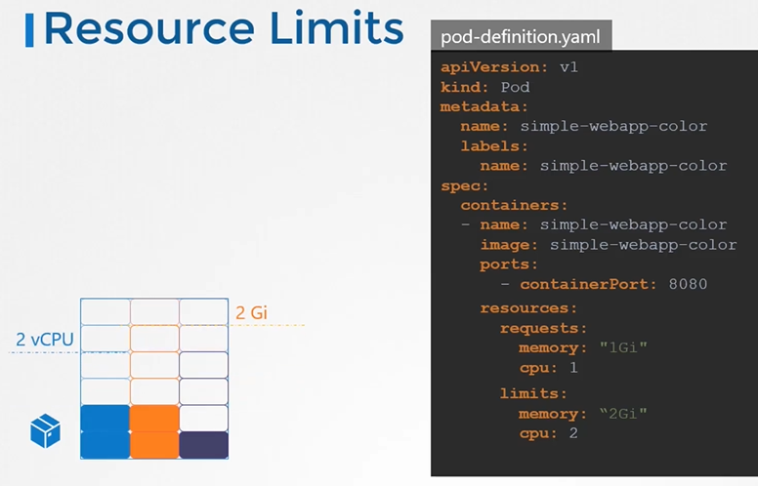](https://github.com/kodekloudhub/certified-kubernetes-administrator-course/blob/master/images/rsl1.PNG)

* if a pod tries to consume more memory than its limit constantly, the pod will be terminated.
* If the node where a Pod is running has enough of a resource available, it's possible (and allowed) for a container to use more resource than its request for that resource specifies. However, a container is not allowed to use more than its resource limit.
* When a pod is created the containers are assigned a default CPU request of .5 and memory of 256Mi". For the POD to pick up those defaults you must have first set those as default values for request and limit by creating a LimitRange in that namespace.

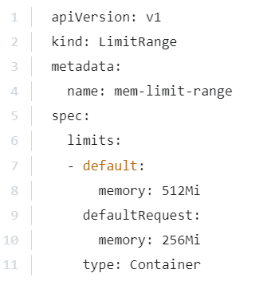 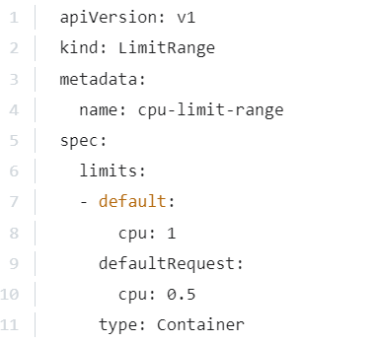

DeamonSeats

* DaemonSets are like ReplicaSets, as in it helps you deploy multiple instances of pods. But it runs one copy of your pod on each node in your cluster. Whenever a new node is added to the cluster, a replica of the pod is automatically added to that node. And when node is removed the pod is automatically removed.
* 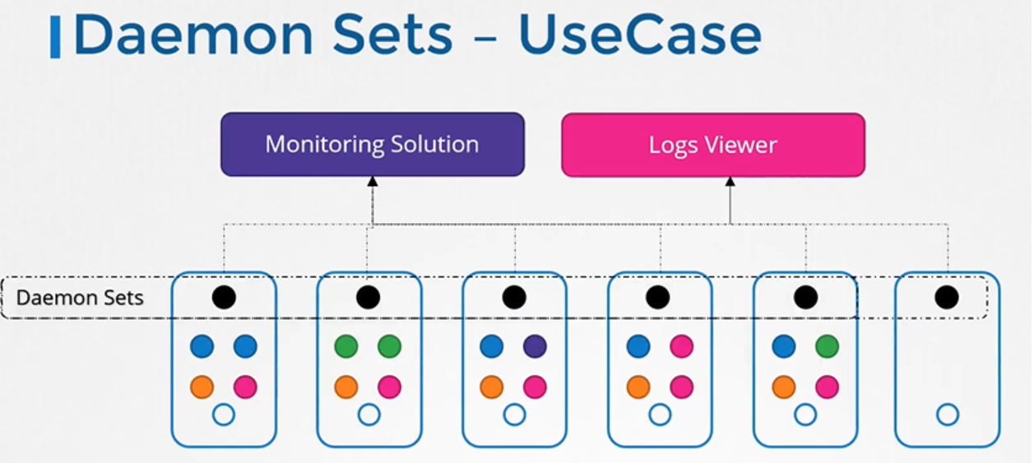
* we learned that one of the worker node components that is required on every node in the cluster is a kube-proxy. That is one good use case of DaemonSets.

The kube-proxy component can be deployed as a DaemonSet in the cluster.

* It's almost exactly like the ReplicaSet definition, except that the kind is a
* 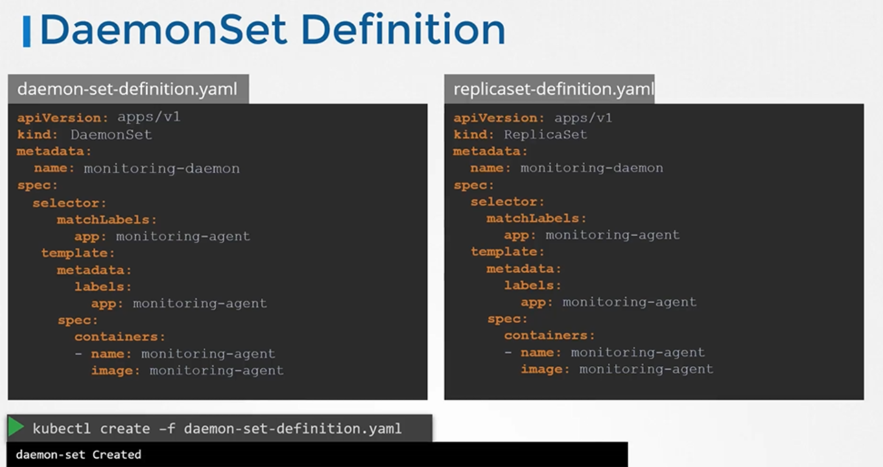
* An easy way to create a DaemonSet is to first generate a YAML file for a Deployment, Next, remove the replicas, strategy and status fields from the YAML file using a text editor. Also, change the kind from Deployment to DaemonSet.

# **Static Pods**

* The kubelet relies on the kube API server for instructions on what pods to load on its node, which was based on a decision made by the kube-scheduler. which was stored in the etcd data store.
* the kubelet can manage a node independently.
* On the ship host we have the kubelet installed, and of course we have Docker as well to run containers. There is no Kubernetes cluster, so there are no kube API server or anything like that. The one thing that the kubelet knows to do is create pods. But we don't have an API server here to provide pod details. By now we know that to create a pod you need the details of the pod in a pod definition file. But how do you provide the pod definition file to the kubelet without a kube API server? You can configure the kubelet to read the pod definition files from a directory on the server designated to store information about pods. Place the pod definition files in this directory. The kubelet periodically checks this directory for files, reads these files, and creates pods on the host. Not only does it create the pod, it can ensure that the pod stays alive. If the application crashes,the kubelet attempts to restart it. If you make a change to any of the file within this directory, the kubelet recreates the pod for those changes to take effect. If you remove a file from this directory, the pod is deleted automatically. So these pods that are created by the kubelet on its own, without the intervention from the API server or rest of the Kubernetes cluster components, are known as static pods.
* Remember, you can only create pods this way. You cannot create replica sets or deployments or services by placing a definition file in the designated directory.
* The designated directory can be any directory on the host and the location of that directory is passed in to the kubelet as an option while running the service.
* The option is named as **--pod-manifest-path**.

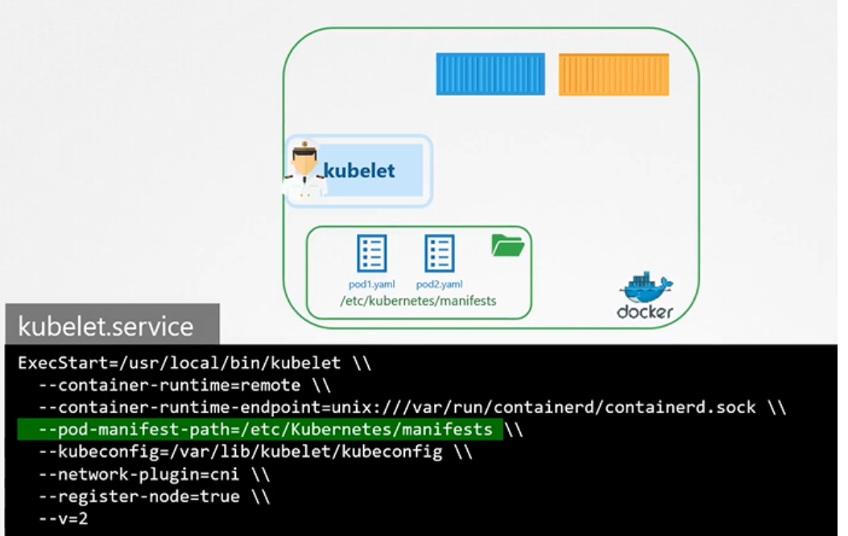

* Instead of specifying the option directly in the **kubelet.service** file, you could provide a path to another config file using the config option, and define the directory path as staticPodPath in the file.

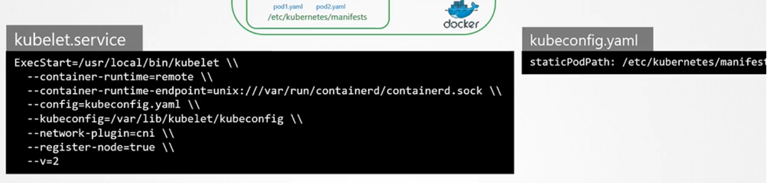

* To view the static pods

$ docker ps

* The kubelet can create both kinds of pods, the static pods and the ones from the API server at the same time.
* is the API server aware of the static pods created by the kubelet? Yes, it is. If you run the k ubectl get pods command on the master node, the static pods will be listed.
* When the kubelet creates a static pod, if it is a part of a cluster, it also creates a mirror object in the kube API server. What you see from the kube API server is just a read only mirror of the pod. You can view details about the pod but you cannot edit or delete it like the usual pods. You can only delete them by modifying the files from the nodes manifest folder. Note that the name of the pod is automatically appended with the node name.
* So then why would you want to use static pods? Since static pods are not dependent on the Kubernetes control plane, you can use static pods to deploy the control plane components itself as pods on a node. Well, start by installing kubelet on all the master nodes then create pod definition files that uses Docker images of the various control plane components such as the API server controller etcd. Place the definition files in the designated manifest folder, and the kubelet takes care of deploying the control plane components themselves as pods on the cluster. This way, you don't have to download the binaries configure services, or worry about the services crashing. If any of these services were to crash, since it's a static pod, it will automatically be restarted.
* That's how the kube admin tool sets up a Kubernetes cluster. Which is why when you list the pods in the kube system namespace, you see the control plane components as pods.

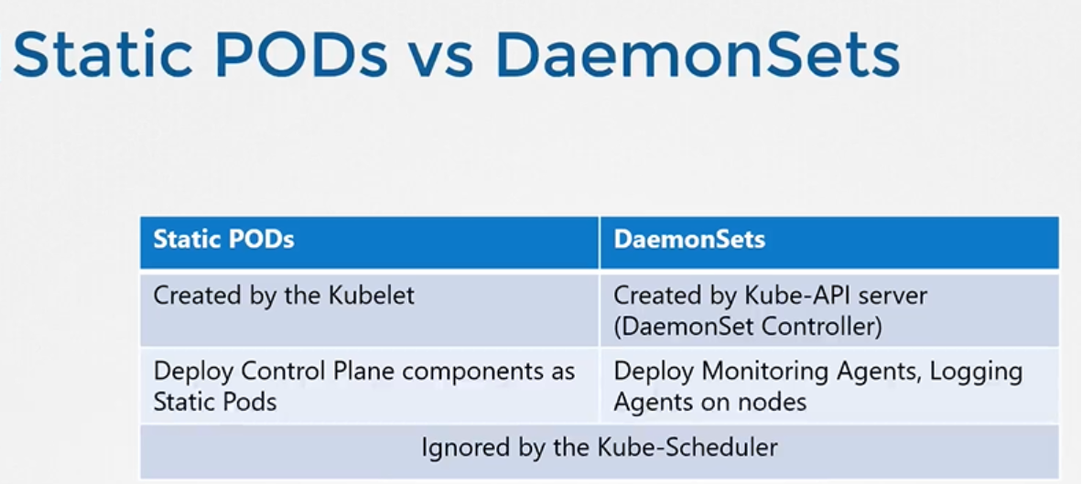

* How many static pods exist in this cluster in all namespaces?

Run the command kubectl get pods --all-namespaces and look for those with -controlplane appended in the name.

* run the “kubectl get pods --all-namespaces -o wide” and identify the node in which static pods are deployed.
* Create static pod with command

kubectl run --restart=Never --image=busybox static-busybox --dry-run=client -o yaml --command -- sleep 1000 > /etc/kubernetes/manifests/static-busybox.yaml

# **Multiple Schedulers**

* Your kubernetes cluster can schedule multiple schedulers at the same time.
* they must have different names so that we can identify them as separate schedulers. So the default scheduler is named default scheduler. And this name is configured in a kube-scheduler configuration file that looks like this. Now, the default scheduler doesn't really need one because if you don't specify a name,

it sets the name to a default scheduler.

* We download the kube-scheduler binary and run it as a service with a set of options. Now, to deploy an additional scheduler, you may use the same kube-scheduler binary or use one that you might have built for yourself, which is what you would do if you needed the scheduler to work differently. In this case, we're going to use the same binary to deploy the additional scheduler. And this time, we point the configuration to the custom configuration file that we created. So each scheduler uses a separate configuration file and with each file having its own scheduler name. And note that there are other options to be passed in, such as the kubeconfig file to authenticate into the Kubernetes API

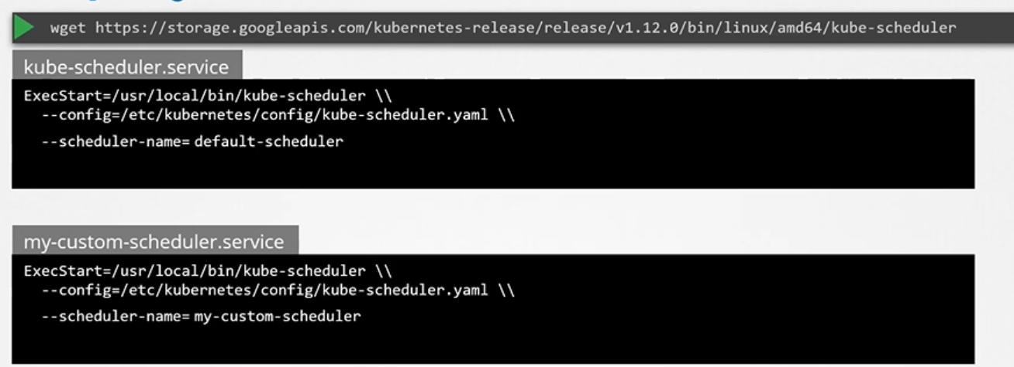

Note: the value of the config arg in the the custom schedule is wrong is should be separate configuration file.

* This is not how you would deploy a custom scheduler 99% of the time today because with kubeadm deployment, all the control plane components run as a pod or a deployment within the Kubernetes cluster not as a service.
* So we create a pod definition file and specify the kubeconfig property, which is the path to the scheduler conf file that has the authentication information to connect to the Kubernetes API server. We then pass in our custom kube-scheduler configuration file as a config option to the scheduler(not presented in the below screenshot). Note that we have the scheduler name specified in the file. So that's how the name gets picked up by the scheduler.  
  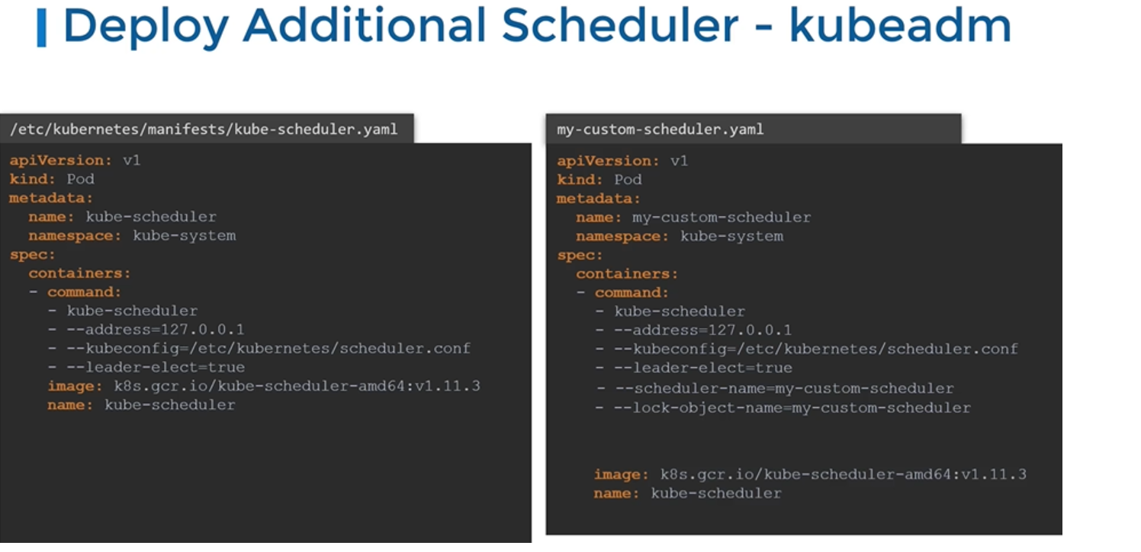
* To create a scheduler pod

$ kubectl create -f my-custom-scheduler.yaml

* leader elect option is used when you have multiple copies of the scheduler running on different master nodes as a high-availability setup where you have multiple master nodes with the Kubernetes scheduler process running on both of them. If multiple copies of the same scheduler are running on different nodes, only one can be active at a time, and that's where the leader elect option helps in choosing a leader who will lead the scheduling activities.

# **Configuring Kubernetes Schedulers**

So let's first recap how the Kubernetes scheduler works using this simple example of scheduling a pod to one of these four nodes that you can see here that are part of the Kubernetes cluster. So here, we have our pod definition file and there's our pod.

It is waiting to be scheduled on one of these four nodes. Now, it has a resource requirement of 10 CPU so it's only gonna be schedule on a node that has 10 CPU emaining. And you can see the available CPU on all of these nodes that are listed here.

Now, it is not alone, there are some other pods that are waiting to be scheduled as well.

So the first thing that happens is that when these pods are created, the pods end up in a scheduling queue. So this is where the pods wait to be scheduled. So at this stage, pods are sorted based on the priority defined on the pods. So in this case, our pod has a high priority set. So, to set a priority, you must first create a priority class that looks like this and you should set it a name and set it a priority value. In this case, it's set to 1 million so that's really high priority. So, this is how pods with higher priority gets to the beginning of the queue to be scheduled first. And so that sorting happens in this scheduling phase. Then, our pod enters the filter phase. This is where nodes that cannot run the pod are filtered out. So, in our case, the first two nodes do not have sufficient resources.

so do not have 10 CPU remaining so they are filtered out. The next phase is the scoring phase. So this is where nodes are scored with different weights. From the two remaining nodes, the scheduler associates a score to each node based on the free space that it will have after reserving the CPU required for that pod. So, in this case, the first one has two left and the second node will have six left. So, the second node gets a higher score. And so, that's the node that gets picked up. And finally, in the binding phase, this is where the pod is finally bound to a node with the highest score. Now, all of these operations are achieved with certain plugins. For example, while in the scheduling queue, it's the priority sort plugin that sorts the pods in an order based on the priority configured on the pods.

Monitoring

We will use external monitoring tool.

The kubelet contains a sub component known as the cAdvisor or Container advisor.

cAdvisor is responsible for retrieving performance metrics from pods and exposing them through the kubelet API to make the metrics available for the Metrics Server;

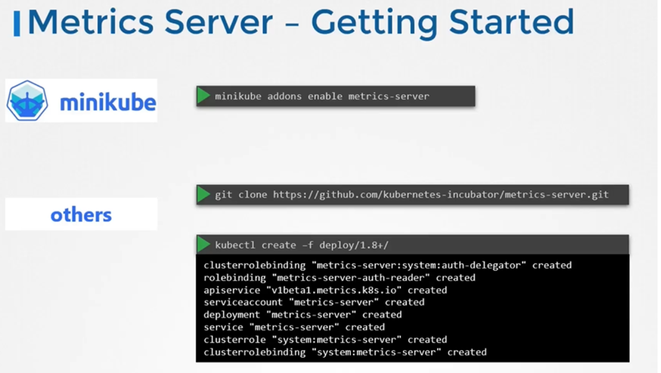

* Clone the metric server from github repo

$ git clone https://github.com/kubernetes-incubator/metrics-server.git

* Deploy the metric server

$ kubectl create -f metric-server/deploy/1.8+/

* View the cluster performance

$ kubectl top node

* View performance metrics of pod

$ kubectl top pod

* Let us start with logging In Docker. I run a Docker container called event-simulator, and all that it does is generate random events, simulating a web server. These are events streamed to the standard output by the application. Now, if I were to run the Docker container in the background in a detached mode using the -d option, I wouldn't see the logs. If I wanted to view the logs, I could use the docker logs command followed by the container id. The -f option helps us see the live log trail. Now back to Kubernetes, we create a pod with the same Docker image using the pod definition file. Once the pod is running, we can view the logs using the kubectl logs command with the pod name. Use the -f option to stream the log's life just like the Docker command. Now these logs are specific to the container running inside the pod. As we learned before, Kubernetes pods can have multiple Docker containers in them. In this case, I modify my pod definition file to include an additional container called image-processor.If you run the kubectl logs command now with the pod name, which containers logs would it show? If there are multiple containers within a pod, you must specify the name of the container explicitly in the command. Otherwise it would fail asking you to specify a name. In this case, I will specify the name of the first container event-simulator, and that prints the relevant log messages.Now that is the simple logging functionality implemented within Kubernetes, and that is all that an application developer really needs to know to get started with Kubernetes, and that is all you really need to know as part of the certification program.
* 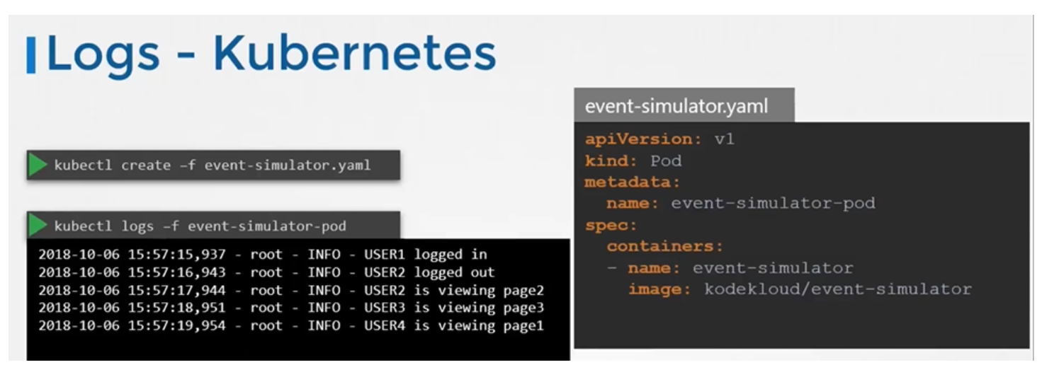
* To view the logs

$ kubectl logs -f event-simulator-pod

* If there are multiple containers in a pod then you must specify the name of the container explicitly in the command.

$ kubectl logs -f <pod-name> <container-name>

$ kubectl logs -f even-simulator-pod event-simulator

# **Rolling Updates and Rollback**

* let's try to understand rollouts and versioning in a deployment. When you first create a deployment, it triggers a rollout. A new rollout creates a new deployment revision. Let's call it revision one. In the future, when the application is upgraded, meaning when the container version is updated to a new one, a new rollout is triggered and a new deployment revision is created, named revision two. This helps us keep track of the changes made to our deployment and enables us to rollback to a previous version of deployment if necessary.

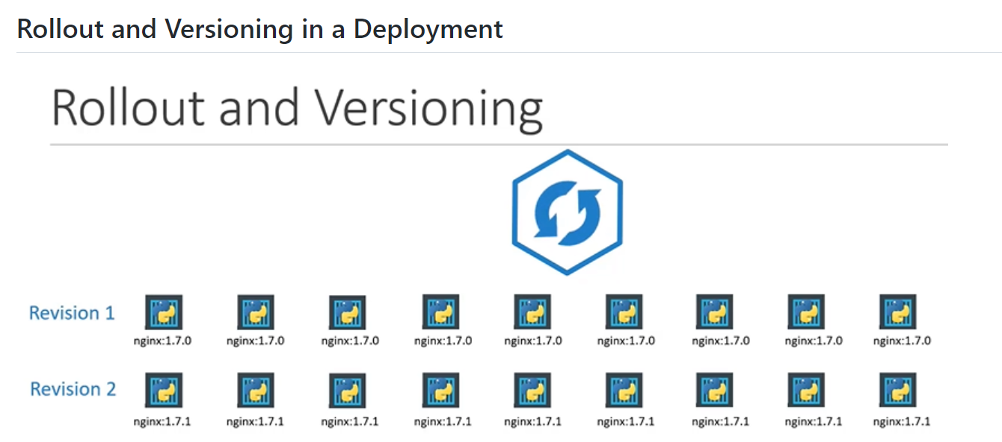

* You can see the status of the rollout by the below command

$ kubectl rollout status deployment/myapp-deployment

* To see the history and revisions

$ kubectl rollout history deployment/myapp-deployment

[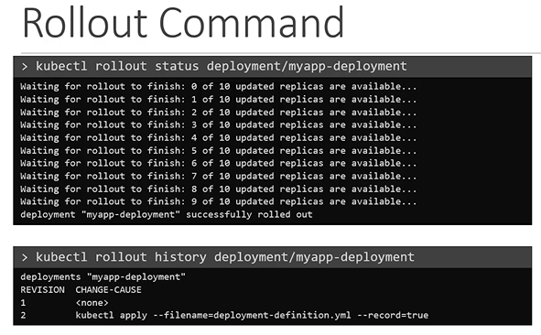](https://github.com/kodekloudhub/certified-kubernetes-administrator-course/blob/master/images/rollc.PNG)

* There are two types of deployment strategies.Say, for example, you have five replicas of your web application instance deployed. One way to upgrade these to a newer version is to destroy all of these and then create newer versions of application instances, meaning, first, destroy the five running instances and then deploy five new instances of the new application version. The problem with this, as you can imagine, is that during the period after the older versions are down and before any newer version is up, the application is down and inaccessible to users. This strategy is known as the recreate strategy and thankfully, this is not the default deployment strategy. The second strategy is where we do not destroy all of them at once. Instead, we take down the older version and bring up a newer version one by one. This way, the application never goes down and the upgrade is seamless. Remember, if you do not specify a strategy while creating the deployment, it will assume it to be rolling update.

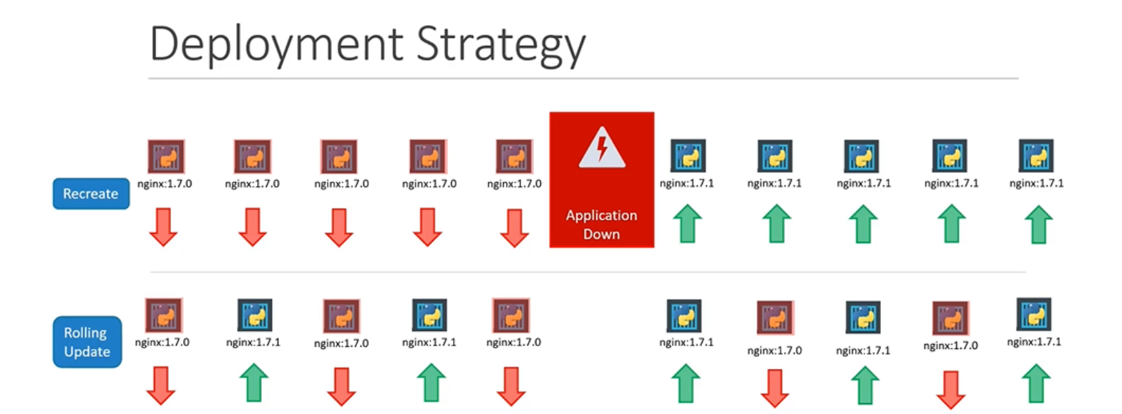

* How exactly do you update your deployment? When I say update, it could be different things, such as updating your application version by updating the version of docker containers used, updating their labels or updating the number of replicas.. , Since we already have a deployment definition file, it is easy for us to modify this file. Once we make the necessary changes, we kubectl command to Apply command to apply the changes.

$ kubectl apply -f deployment-definition.yaml

* A new rollout is triggered and a new revision of the deployment is created. But there is another way to do the same thing. You could use the kubectl Set Image command to update the image of your application,

$ kubectl apply -f deployment-definition.yaml

* but remember, doing it this way will result in the deployment definition file having a different configuration, so you must be careful when using the same definition file to make changes in the future. The difference between the recreate and rolling update strategies can also be seen when you view the deployments in detail. Run the kubectl describe Deployment command to see the detailed information regarding the deployments. You will notice when the recreate strategy was used, the events indicate that the old ReplicaSet was scaled down to zero first and then the new ReplicaSet scaled up to five. However, when the rolling update strategy was used, the old ReplicaSet was scaled down one at a time, simultaneously scaling up the new ReplicaSet one at a time.

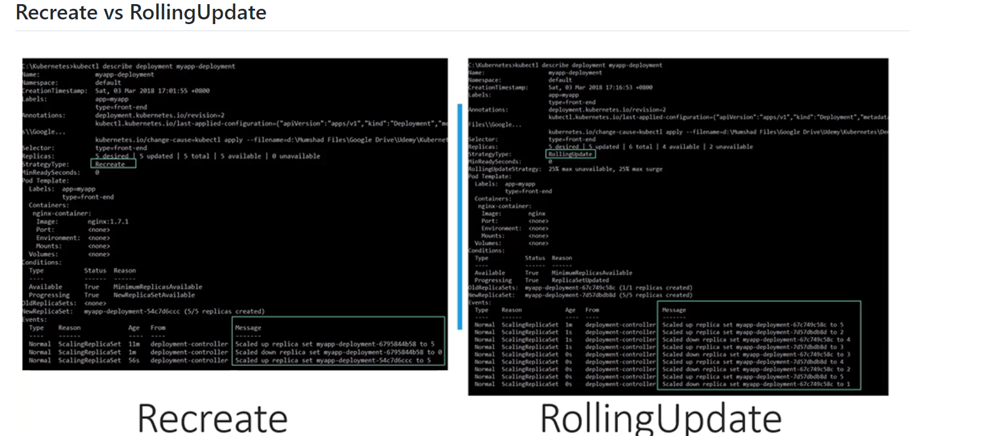

**Upgrades**

* Let's look at how a deployment performs an upgrade under the hood. When a new deployment is created, say to deploy five replicas, it first creates a ReplicaSet automatically, which in turn creates the number of pods required to meet the number of replicas. When you upgrade your application, the Kubernetes deployment object creates a new ReplicaSet under the hoods and starts deploying the containers there, at the same time taking down the pods in the old ReplicaSet following rolling update strategy. This can be seen when you try to list the ReplicaSets using the kubectl replicasets command.

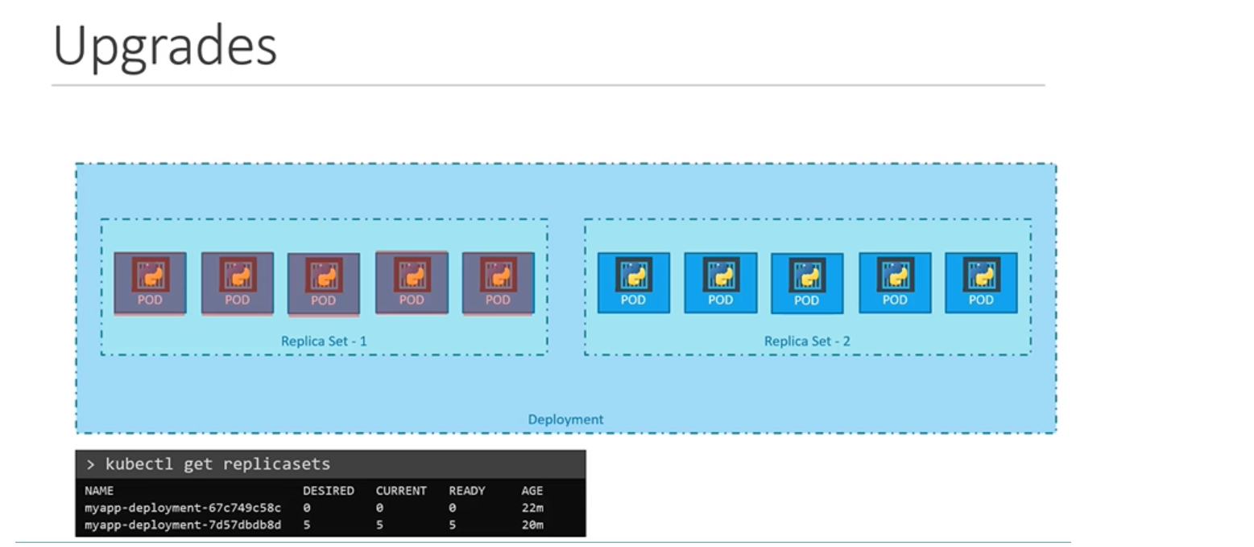

Rollback

* Say, for instance, once you upgrade your application, you realize something isn't very right. Something's wrong with the new version of build you used to upgrade, so you would like to rollback your update. To undo a change, run :

$ kubectl rollout undo deployment/myapp-deployment

* The deployment will then destroy the pods in the new ReplicaSet and bring the older ones up in the old ReplicaSet, and your application is back to its older format. When you compare the output of the kuebctl get ReplicaSets command before and after the rollback, you will be able to notice this difference. Before the rollback, the first ReplicaSet had zero pods and new ReplicaSet had five pods, and this is reversed after the rollback is finished.

## Summarize kubectl commands

$ kubectl create -f deployment-definition.yaml

$ kubectl get deployments

$ kubectl apply -f deployment-definition.yaml

$ kubectl set image deployment/myapp-deployment nginx=nginx:1.9.1

$ kubectl rollout status deployment/myapp-deployment

$ kubectl rollout history deployment/myapp-deployment

$ kubectl rollout undo deployment/myapp-deployment

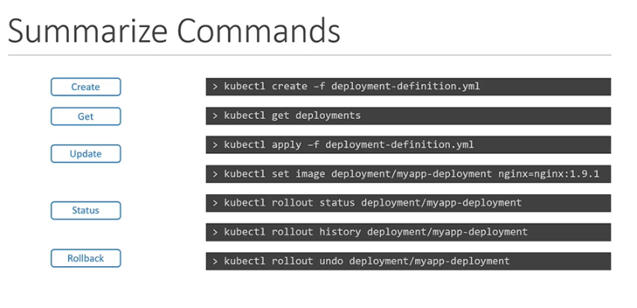

# **Commands and Arguments in Docker**

* To run a docker container

$ docker run ubuntu

* To list running containers

$ docker ps

* To list all containers including that are stopped

$ docker ps -a

[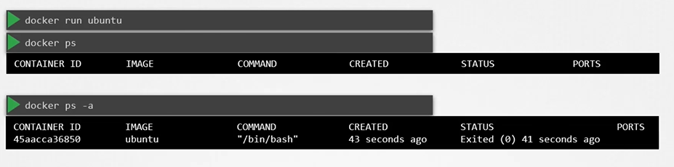](https://github.com/kodekloudhub/certified-kubernetes-administrator-course/blob/master/images/dc.PNG)

#### Unlike virtual machines, containers are not meant to host operating system.

* Containers are meant to run a specific task or process such as to host an instance of a webserver or application server or a database server etc.

#### How do you specify a different command to start the container?

* One Option is to append a command to the docker run command and that way it overrides the default command specified within the image.

$ docker run ubuntu sleep 5

* This way when the container starts it runs the sleep program, waits for 5 seconds and then exists. How do you make that change permanent?

[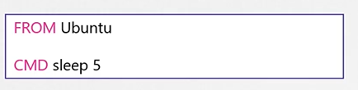](https://github.com/kodekloudhub/certified-kubernetes-administrator-course/blob/master/images/sleep.PNG)

* There are different ways of specifying the command either the command simply as is in a shell form or in a JSON array format.

[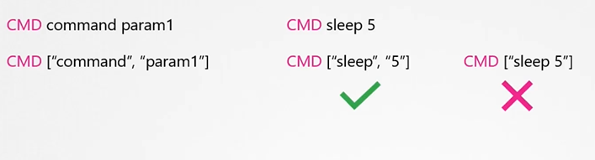](https://github.com/kodekloudhub/certified-kubernetes-administrator-course/blob/master/images/sleep1.PNG)

* Now, build the docker image

$ docker build -t ubuntu-sleeper .

* Run docker container

$ docker run ubuntu-sleeper

[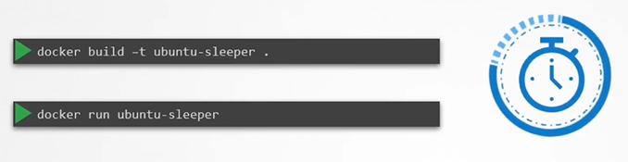](https://github.com/kodekloudhub/certified-kubernetes-administrator-course/blob/master/images/sleep2.PNG)

## Entrypoint Instruction

* The entrypoint instruction is like the command instruction as in you can specify the program that will be run when the container starts and whatever you specify on the command line.

# **Commands and Arguments in Kubernetes**

* Anything that is appended to the docker run command will go into the **args** property of the pod definition file in the form of an array.
* The command field corresponds to the entrypoint instruction in the Dockerfile so to summarize there are 2 fields that correspond to 2 instructions in the Dockerfile.

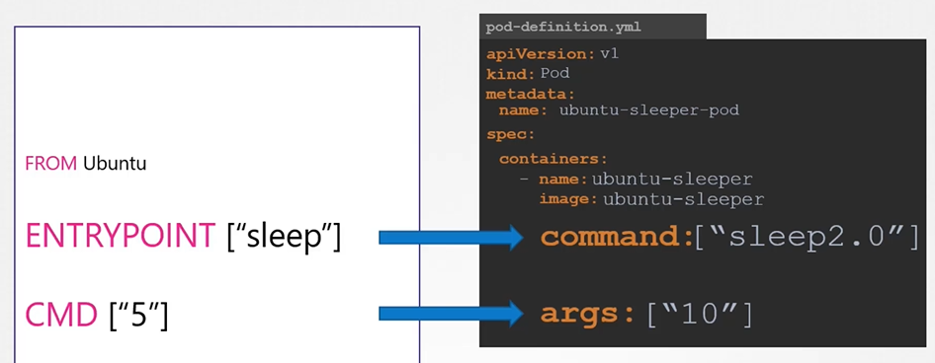

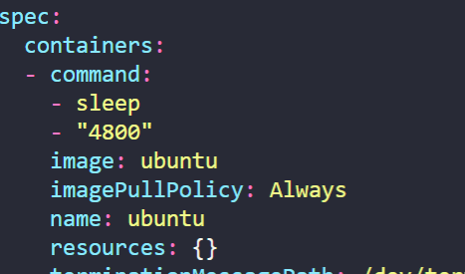

# **Configure Environment Variables In Applications**

#### ENV variables in Docker

$ docker run -e APP_COLOR=pink simple-webapp-color

#### ENV variables in Kubernetes

#### env

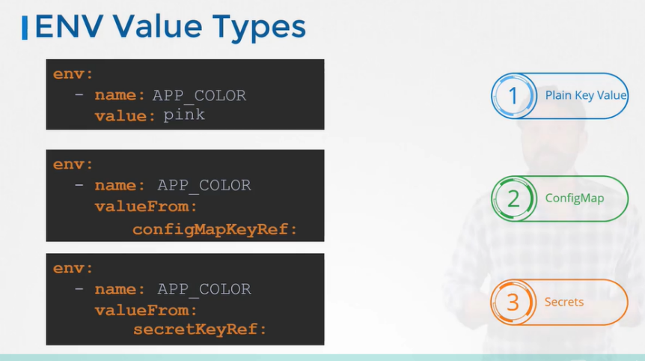

**ConfigMap**

Config maps are used to pass configuration data in the form of key value pairs in Kubernetes. When a pod is created, inject the config map into the pod so the key value pairs are available as environment variables.

* There are 2 phases involved in configuring ConfigMaps.
  + - First, create the configMaps
    - Second, Inject them into the pod.
* There are 2 ways of creating a configmap.

**The Imperative way**

* + - $ kubectl create configmap app-config --from-literal=APP_COLOR=blue --from-literal=APP_MODE=prod

Note: app-config is the name of the configmap

* + - $ kubectl create configmap app-config --from-file=app_config.properties (Another way)

**The Declarative way**

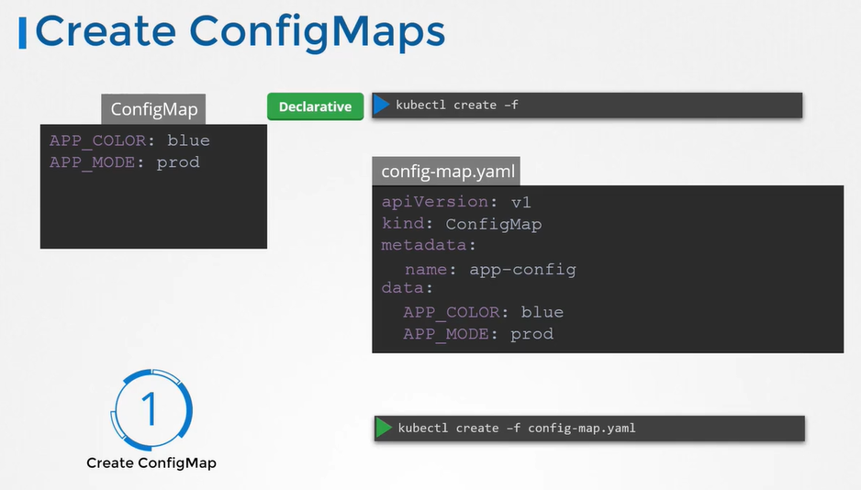

* You can create as many config maps as you need in the same way for various different purposes.
* To view configMaps

$ kubectl get configmaps (or)

$ kubectl get cm

* To describe configmaps

$ kubectl describe configmaps

* Injecting the configmap to the pod

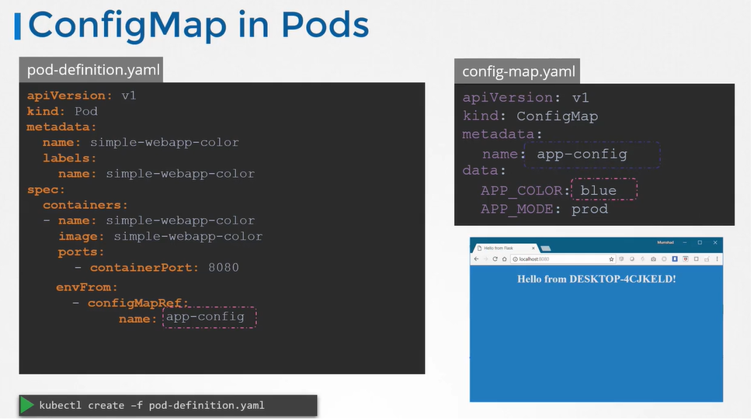

# Secrets

* One way is to move the app properties/envs into a configmap. But the configmap stores data into a plain text format. It is definitely not a right place to store a password.
* Secrets are used to store sensitive information. They are similar to configmaps but they are stored in an encrypted format or a hashed format.

#### There are 2 steps involved with secrets

* + First, Create a secret
  + Second, Inject the secret into a pod.

#### There are 2 ways of creating a secret

* The Imperative way

$ kubectl create secret generic app-secret --from-literal=DB_Host=mysql --from-literal=DB_User=root --from-literal=DB_Password=paswrd

$ kubectl create secret generic app-secret --from-file=app_secret.properties

* The Declarative way

Generate a hash value of the password and pass it to secret-data.yaml definition value as a value to DB_Password variable.

$ echo -n "mysql" | base64

$ echo -n "root" | base64

$ echo -n "paswrd"| base64

Create a secret definition file and run kubectl create to deploy it

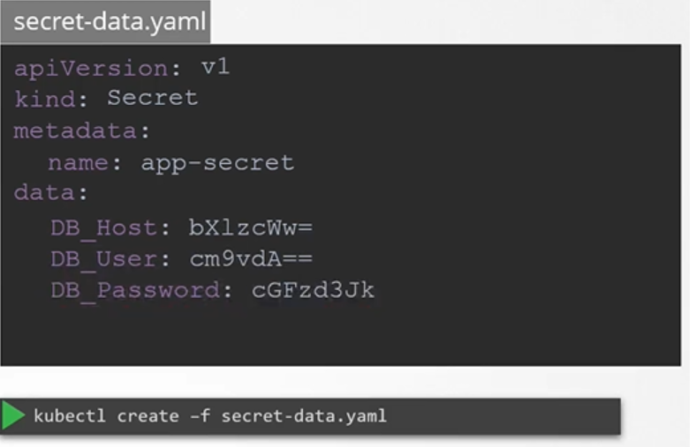

## View Secrets

* To view secrets

$ kubectl get secrets

* To describe secret

$ kubectl describe secret

* To view the values of the secret

$ kubectl get secret app-secret -o yaml

## Configuring secret with a pod

* To inject a secret to a pod add a new property **envFrom** followed by **secretRef** name and then create the pod-definition

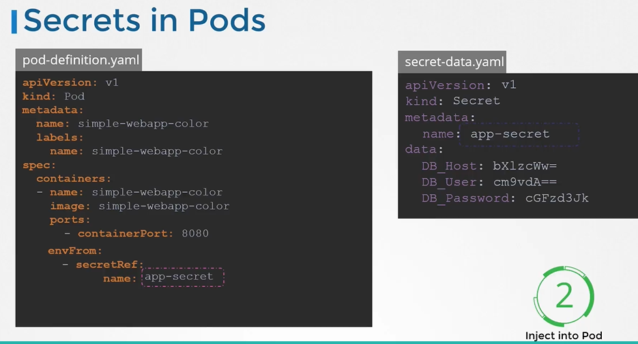

#### There are other ways to inject secrets into pods.

* You can inject as **Single ENV variable**
* You can inject as whole secret as files in a **Volume**

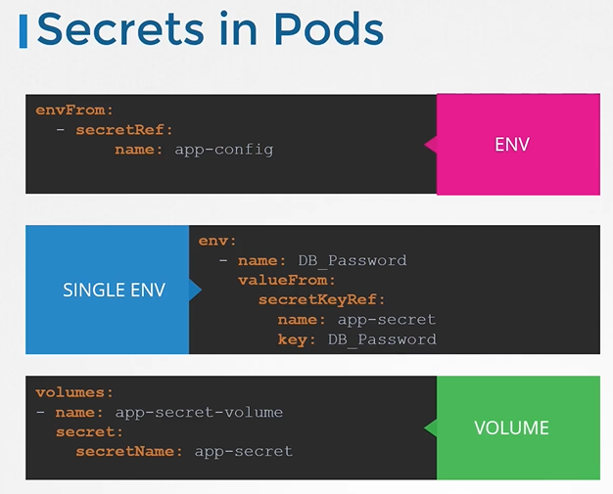

## Secrets in pods as volume

* Each attribute in the secret is created as a file with the value of the secret as its content.

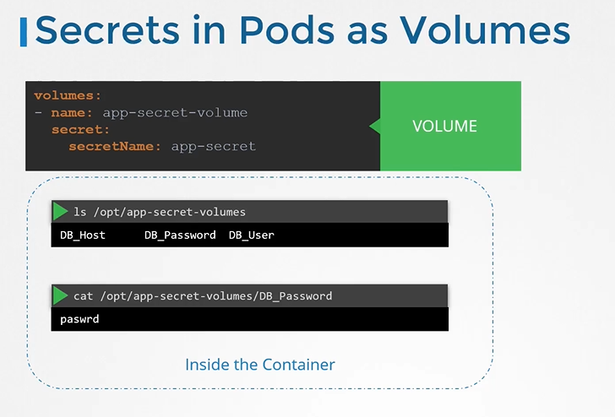

Remember that secrets encode data in base64 format (not encrypted). Anyone with the base64 encoded secret can easily decode it. As such the secrets can be considered as not very safe.

**Multi-container PODs Design Patterns**

There are 3 common patterns, when it comes to designing multi-container PODs. The first and what we just saw with the logging service example is known as a side car pattern. The others are the adapter and the ambassador pattern.

But these fall under the CKAD curriculum and are not required for the CKA exam. So we will be discuss these in more detail in the CKAD course.

**InitContainers**

In a multi-container pod, each container is expected to run a process that stays alive as long as the POD's lifecycle. For example in the multi-container pod that we talked about earlier that has a web application and logging agent, both the containers are expected to stay alive at all times. The process running in the log agent container is expected to stay alive as long as the web application is running. If any of them fails, the POD restarts.

But at times you may want to run a process that runs to completion in a container. For example a process that pulls a code or binary from a repository that will be used by the main web application. That is a task that will be run only  one time when the pod is first created. Or a process that waits  for an external service or database to be up before the actual application starts. That's where **initContainers**comes in.

An **initContainer**is configured in a pod like all other containers, except that it is specified inside a initContainers section,  like this:

1. apiVersion: v1
2. kind: Pod
3. metadata:
4. name: myapp-pod
5. labels:
6. app: myapp
7. spec:
8. containers:
9. - name: myapp-container
10. image: busybox:1.28
11. command: ['sh', '-c', 'echo The app is running! && sleep 3600']
12. initContainers:
13. - name: init-myservice
14. image: busybox
15. command: ['sh', '-c', 'git clone <some-repository-that-will-be-used-by-application> ; done;']

When a POD is first created the initContainer is run, and the process in the initContainer must run to a completion before the real container hosting the application starts.

You can configure multiple such initContainers as well, like how we did for multi-pod containers. In that case each init container is run **one at a time in sequential order**.

If any of the initContainers fail to complete, Kubernetes restarts the Pod repeatedly until the Init Container succeeds.

1. apiVersion: v1
2. kind: Pod
3. metadata:
4. name: myapp-pod
5. labels:
6. app: myapp
7. spec:
8. containers:
9. - name: myapp-container
10. image: busybox:1.28
11. command: ['sh', '-c', 'echo The app is running! && sleep 3600']
12. initContainers:
13. - name: init-myservice
14. image: busybox:1.28
15. command: ['sh', '-c', 'until nslookup myservice; do echo waiting for myservice; sleep 2; done;']
16. - name: init-mydb
17. image: busybox:1.28
18. command: ['sh', '-c', 'until nslookup mydb; do echo waiting for mydb; sleep 2; done;']

# **OS Upgrades**

we will discuss about scenarios where you might have to take down nodes as part of your cluster, say for maintenance purposes, like upgrading a based software or applying patches, like security patches, etc .., on your cluster. we will see the options available to handle such cases.So you have a cluster with a few nodes and pods serving applications. What happens when one of these nodes go down? Of course, the pods on them are not accessible. Now depending upon how you deployed those pods,

your users may be impacted. For example, since you have multiple replicas

of the blue pod, the users accessing the blue application are not impacted as they are being served through the other blue pod that's online. However, users accessing the green pod are impacted as that was the only pod running the green application.

Now, what does Kubernetes do in this case?

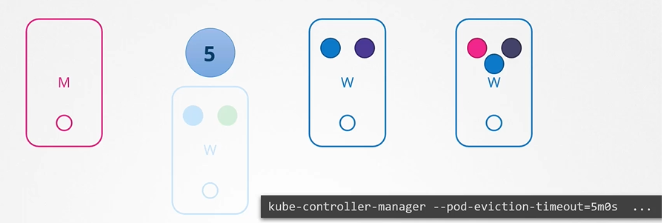

If the node came back online immediately, then the kubelet process starts and the pods come back online. However, if the node was down for more than five minutes, then the pods are terminated from that node. Well, Kubernetes considers them as dead. If the pods were part of your replicaset, then they are recreated on other nodes. The time it waits for a pod to come back online is known as the pod-eviction-timeout and is set on the controller manager with a default value of five minutes. So whenever a node goes offline, the master node waits for up to five minutes before considering the node dead.

When the node comes back online after the pod-eviction-timeout, it comes up blank without any pod scheduled on it. Since the blue pod was part of a replica set,

it had a new pod created on another node. However, since the green pod was not part

of a replica set, it's just gone. Thus, if you have maintenance tasks to be performed on a node, if you know that the workloads running on the node have other replicas, and if it's okay that they go down for a short period of time, and if you're sure the node will come back online within five minutes, you can make a quick upgrade and reboot. However, you do not for sure know if a node is going to be back online in five minutes.

Well, you cannot for sure say it is going to be back at all, so there is a safer way to do it.

You can purposefully drain the node of all the workloads so that the workloads are moved to other nodes in the cluster. Well, technically, they're not moved. When you drain a node, the pods are gracefully terminated from the node that they're on and recreated on another. The node is also cordoned or marked as unschedulable,

meaning no pods can be scheduled on this node until you specifically remove the restriction. Now that the pods are safe on the other nodes, you can reboot the first node. When it comes back online, it is still unschedulable. You then need to uncordon it so that the pods can be scheduled on it again. Now, remember, the pods that were moved to the other nodes don't automatically fall back. If any of those pods were deleted or if new pods were created in the cluster, then they would be created on this node. Apart from drain and uncordon, there is also another command called cordon.

Cordon simply marks a node unschedulable. Unlike drain, it does not terminate

or move the pods on an existing node. It simply makes sure that new pods

are not scheduled on that node.

* You can purposefully drain the node of all the workloads so that the workloads are moved to other nodes.

$ kubectl drain node-1

* The node is also cordoned or marked as unschedulable.
* When the node is back online after a maintenance, it is still unschedulable. You then need to uncordon it.

$ kubectl uncordon node-1

* There is also another command called cordon. Cordon simply marks a node unschedulable. Unlike drain it does not terminate or move the pods on an existing node.

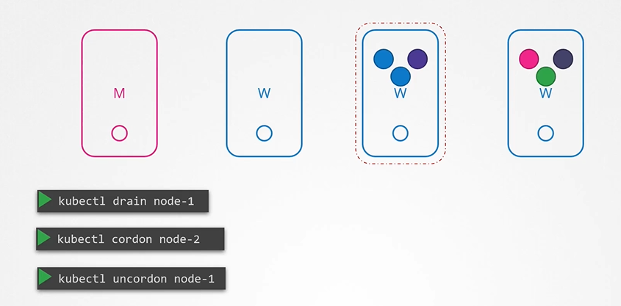

* If the pod is not part of a replicaset ..> drain node command will not be working without -f (force) after that the pod will be lost forever

# Kubernetes Software Versions

#### We can see the kubernetess version that we installed

$ kubectl get nodes

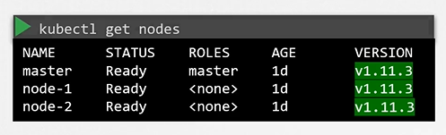

#### Let's take a closer look at the version number

* It consists of 3 parts
  + First is the major version
  + Second is the minor version
  + Finally, the patch version

[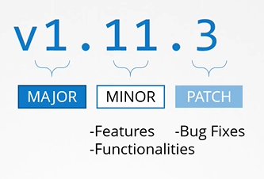](https://github.com/kodekloudhub/certified-kubernetes-administrator-course/blob/master/images/mmp.PNG)

* Downloaded package has all the kubernetes components in it except ETCD Cluster and CoreDNS as they are seperate projects.

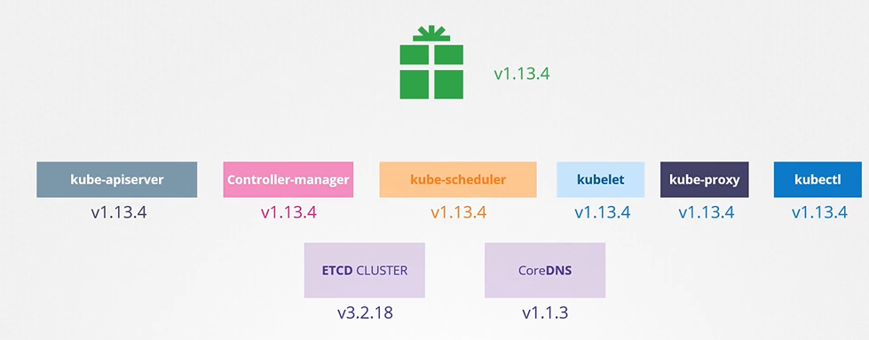

# Cluster Upgrade Introduction

#### Is it mandatory for all of the kubernetes components to have the same versions?

* No, The components can be at different release versions.

#### At any time, kubernetes supports only up to the recent 3 minor versions

* The recommended approach is to upgrade one minor version at a time.

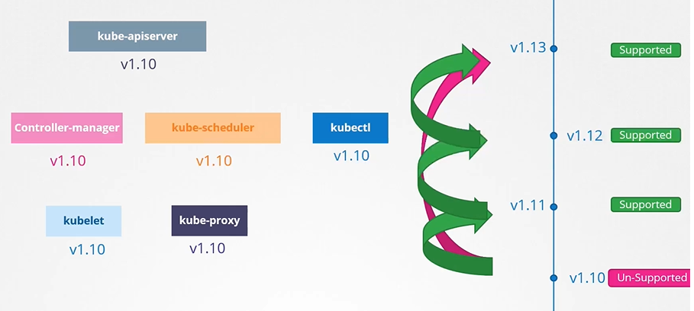

#### Options to upgrade k8s cluster

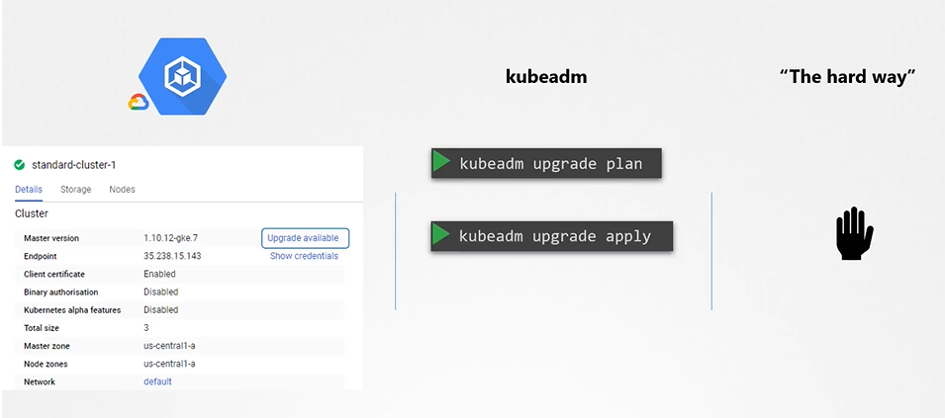

* First one on the cloud

## Upgrading a Cluster

* Upgrading a cluster involves 2 major steps
* First, you upgrade your master nodes and then upgrade the worker nodes. While the master is being upgraded, the control plane components such as the API server, scheduler, and controller managers go down briefly. The master going down does not mean your worker nodes and applications on the cluster are impacted. All workloads hosted on the worker nodes continue to serve users as normal, since the master is down, all management functions are down. You cannot access the cluster using kubectl or other Kubernetes API. You cannot deploy new applications or delete or modify existing ones. The controller managers don't function either. If a pod was to fail, a new pod won't be automatically created.

#### There are different strategies that are available to upgrade the worker nodes

* One is to upgrade all at once. But then your pods will be down and users will not be able to access the applications.

[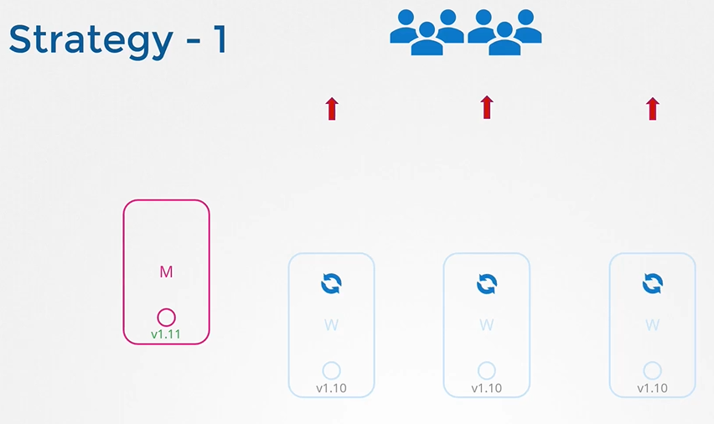](https://github.com/kodekloudhub/certified-kubernetes-administrator-course/blob/master/images/stg1.PNG)

* Second one is to upgrade one node at a time. We first upgrade the first node where the workloads move to the second and third node and users are served from there. Once the first node is upgraded and back up, we then update the second node where the workloads move to the first and third nodes.
* [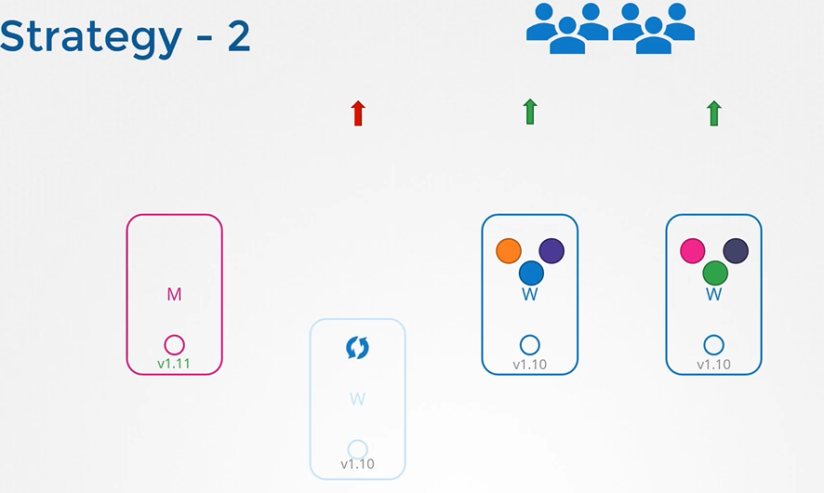](https://github.com/kodekloudhub/certified-kubernetes-administrator-course/blob/master/images/stg2.PNG)
* Third one would be to add new nodes to the cluster, nodes with newer software version.
* This is especially convenient if you're on a cloud environment where you can easily provision new nodes and decommission old ones. Nodes with the newer software version can be added to the cluster, move the workload over to the new, and remove the old node, until you finally have all new nodes with the new software version.
* Upgrade 'kubelet' on the master node

$ apt-get upgrade kubelet=1.12.0-00

* Restart the kubelet

$ systemctl restart kubelet

* [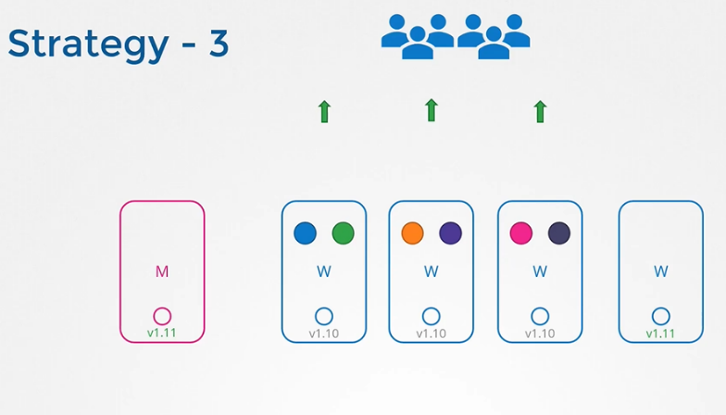](https://github.com/kodekloudhub/certified-kubernetes-administrator-course/blob/master/images/stg3.PNG)

Let us now see how it is done. Say we were to upgrade this cluster from 1.11 to 1.13, kubeadm has an upgrade command that helps:

$ kubeadm upgrade plan

* It'll give you a lot of good information. The current cluster version, the kubeadm tool version, the latest stable version of Kubernetes. Then it lists all the control plane components and their versions and what version these can be upgraded to. It also tells you that after we upgrade the control plane components, you must manually upgrade the kubelet versions on each node. Remember, kubeadm does not install or upgrade kubelet.

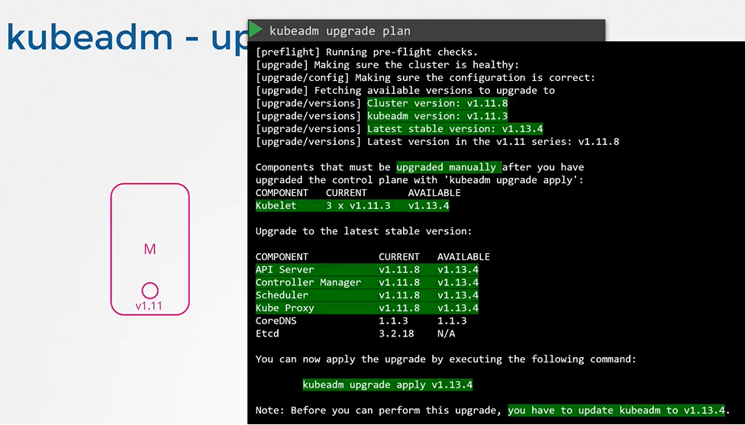

* Finally, it gives you the command to upgrade the cluster. Also, note that you must upgrade the kubeadm tool itself before you can upgrade the cluster.
* Upgrade kubeadm from v1.11 to v1.12

$ apt-get upgrade -y kubeadm=1.12.0-00

* Upgrade the cluster

$ kubeadm upgrade apply v1.12.0

* If you run the 'kubectl get nodes' command, you will see the older version. This is because in the output of the command it is showing the versions of kubelets on each of these nodes registered with the API Server and not the version of API Server itself.
* Upgrade 'kubelet' on the master node

$ apt-get upgrade kubelet=1.12.0-00

* Restart the kubelet

$ systemctl restart kubelet

## kubeadm - Upgrade worker nodes

* We need to first move the workloads from the first worker node to the other nodes.
* The kubectl drain command lets you safely terminate all the pods from a node and reschedules them on the other nodes.
* From master node, run 'kubectl drain' command to move the workloads to other nodes
* $ kubectl drain node-1
* Upgrade kubeadm and kubelet packages
* $ apt-get upgrade -y kubeadm=1.12.0-00

$ apt-get upgrade -y kubelet=1.12.0-00

* Update the node configuration for the new kubelet version

$ kubeadm upgrade node config --kubelet-version v1.12.0

* Restart the kubelet service

$ systemctl restart kubelet

* Mark the node back to schedulable

$ kubectl uncordon node-1

# Backup and Restore Methods

## Backup Candidates

[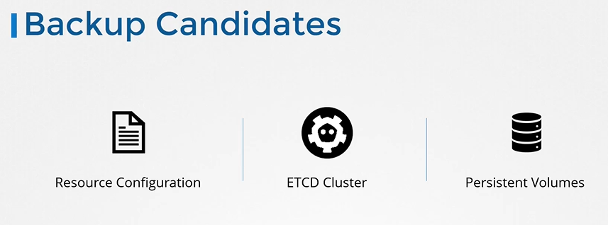](https://github.com/kodekloudhub/certified-kubernetes-administrator-course/blob/master/images/bc.PNG)

* A good practice is to store resource configurations on source code repositories like github.

[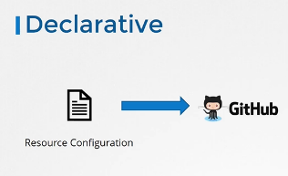](https://github.com/kodekloudhub/certified-kubernetes-administrator-course/blob/master/images/rcd1.PNG)

* better approach to backing up resource configuration is to query the Kube API server. Query the Kube API server using the kubectl, or by accessing the API server directly, and save all resource configurations for all objects created on the cluster as a copy. For example, one of the commands that can be used in a backup script is to get all pods, and deployments, and services in all namespaces
* $ kubectl get all --all-namespaces -o yaml > all-deploy-services.yaml (only for few resource groups)
* There are many other resource groups that must be considered. Of course, you don't have to develop that solution yourself. There are tools like Ark, or now called Velero, by Heptio, that can do this for you. It can help in taking backups of your Kubernetes cluster using the Kubernetes API
* Backup – ETCD
* the etcd cluster is hosted on the master nodes. While configuring etcd, we specified a location where all the data would be stored, the data directory. That is the directory that can be configured to be backed up by your backup tool.
* Etcd also comes with a builtin snapshot solution. You can take a snapshot of the etcd database by using the etcd control utility's snapshot save command.
* You can take a snapshot of the etcd database by using etcdctl utility snapshot save command.
* $ ETCDCTL_API=3 etcdctl snapshot save snapshot.db
* $ ETCDCTL_API=3 etcdctl snapshot status snapshot.db
* 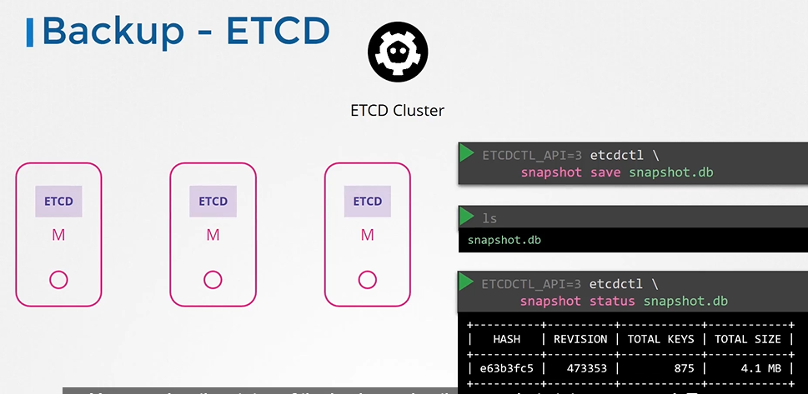
* To restore etcd from the backup at later in time. First stop kube-apiserver service
* $ service kube-apiserver stop
* Run the etcdctl snapshot restore command

$ ETCDCTL_API=3 etcdctl snapshot restore snapshot.db -–data-dir /var/lib/

* Update the etcd service
* Reload system configs

$ systemctl daemon-reload

* Restart etcd

$ service etcd restart

* With all the etcd commands, remember to specify the certificate files for authentication, specify the endpoint to the etcd cluster and the CS certificate, the etcd server certificate, and the key.

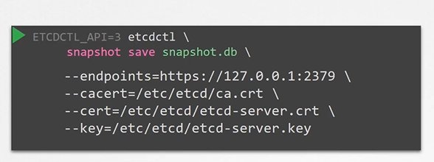

**Working with ETCDCTL**

etcdctl is a command line client for [**etcd**](https://github.com/coreos/etcd).

In all our Kubernetes Hands-on labs, the ETCD key-value database is deployed as a static pod on the master. The version used is v3.

To make use of etcdctl for tasks such as back up and restore, make sure that you set the ETCDCTL_API to 3.

You can do this by exporting the variable ETCDCTL_API prior to using the etcdctl client. This can be done as follows:

export ETCDCTL_API=3

On the **Master Node**:

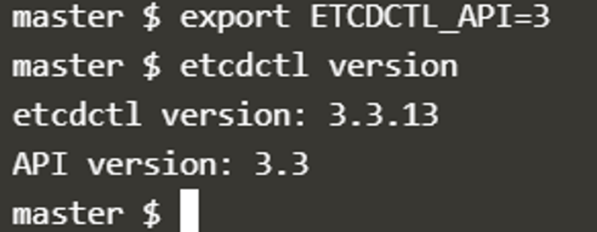

To see all the options for a specific sub-command, make use of the**-h or --help** flag.

For example, if you want to take a snapshot of etcd, use:

etcdctl snapshot save -h and keep a note of the mandatory global options.

Since our ETCD database is TLS-Enabled, the following options are mandatory:

--cacert                                                verify certificates of TLS-enabled secure servers using this CA bundle

--cert                                                    identify secure client using this TLS certificate file

--endpoints=[127.0.0.1:2379]          This is the default as ETCD is running on master node and exposed on localhost 2379.

--key                                                      identify secure client using this TLS key file

Similarly use the help option for **snapshot restore**to see all available options for restoring the backup.

etcdctl snapshot restore -h

For a detailed explanation on how to make use of the etcdctl command line tool and work with the -h flags, check out the solution video for the Backup and Restore Lab.

* View Clusters (cluster includes nodes)

$ kubectl config view

* Show current context

#kubectl config current-context

* Show available contexts

#kubectl config get-context

* Switch to another cluster

$ kubectl config use-context cluster1

* Inspect process

$ ps -ef | grep -i etcd

**Security**

**Authentication**

Different users that may be accessing the cluster security of end users who access the applications deployed on the cluster is managed by the applications themselves internally.

[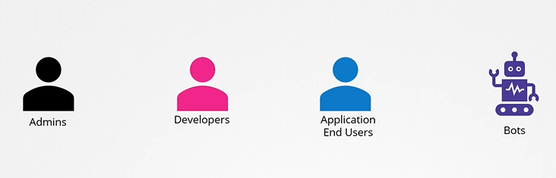](https://github.com/kodekloudhub/certified-kubernetes-administrator-course/blob/master/images/acc1.PNG)

* So, we left with 2 types of users
  + Humans, such as the Administrators and Developers
  + Robots such as other processes/services or applications that require access to the cluster.

[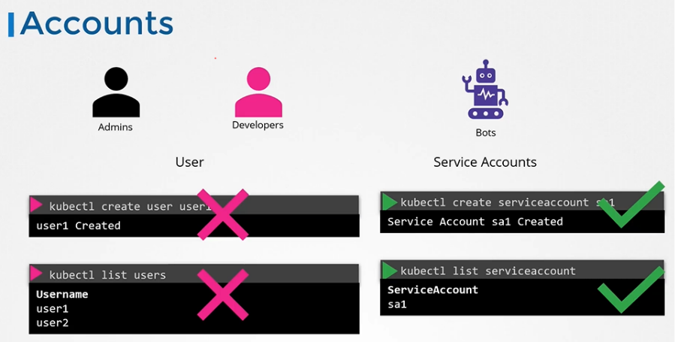](https://github.com/kodekloudhub/certified-kubernetes-administrator-course/blob/master/images/acc2.PNG)

* All user access is managed by apiserver and all of the requests goes through apiserver.

[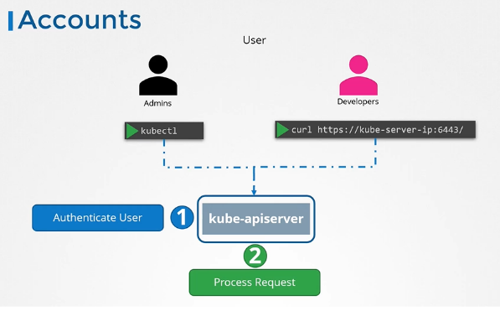](https://github.com/kodekloudhub/certified-kubernetes-administrator-course/blob/master/images/acc3.PNG)

## Authentication Mechanisms

* There are different authentication mechanisms that can be configured.

[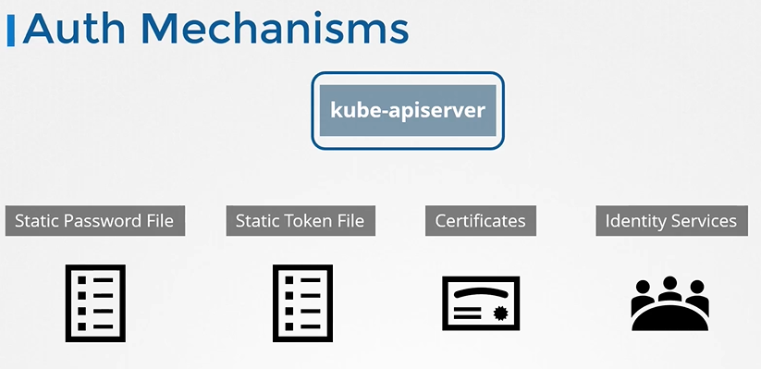](https://github.com/kodekloudhub/certified-kubernetes-administrator-course/blob/master/images/auth2.PNG)

* Static:

You can create a list of users and their passwords in a CSV file and use that as the source for user information.

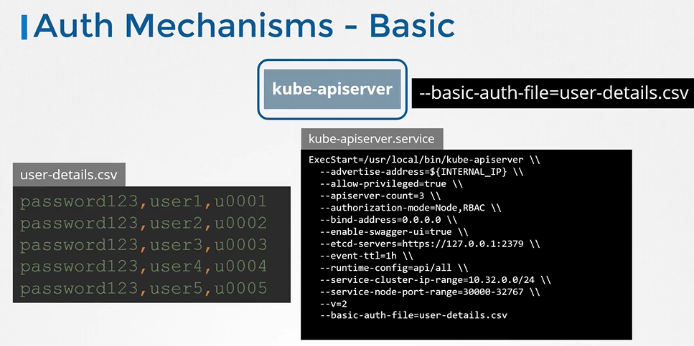

If you set up via kubeadm then update kube-apiserver.yaml manifest file with the option.

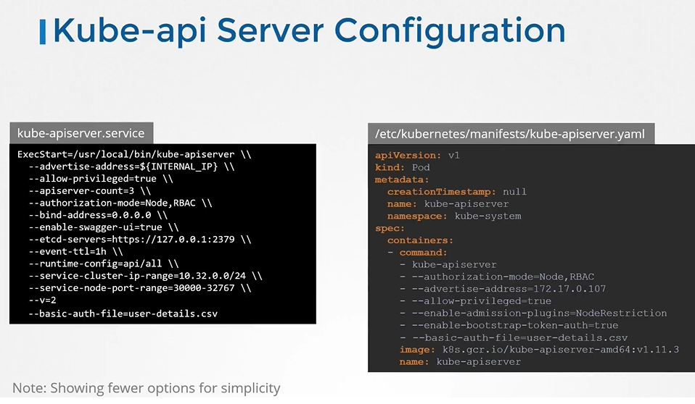

* will automatically restart the Kube API Server once you update this file.

## Authenticate User

* To authenticate using the basic credentials while accessing the API server specify the username and password in a curl command.

$ curl -v -k http://master-node-ip:6443/api/v1/pods -u "user1:password123"

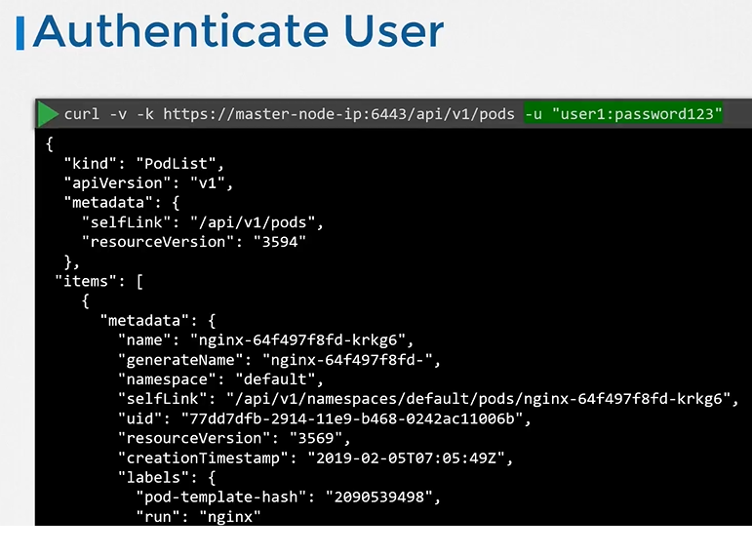

* In the CSV file with the user details that we saw, we can optionally have a fourth column with the group details to assign users to specific groups. Similarly, instead of a static password file, you can have a static token file here, instead of password, you specify a token. Pass the token file as an option token auth file.

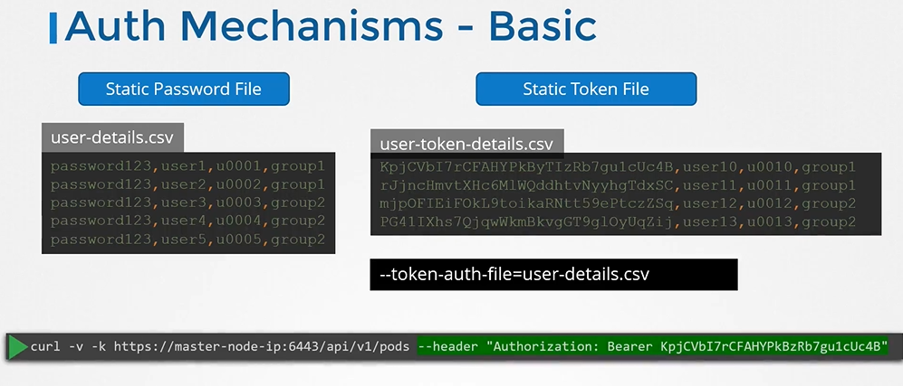

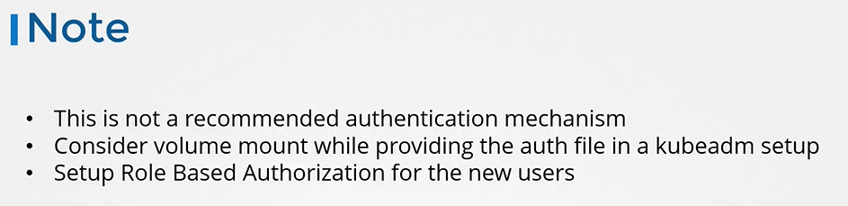

**Certificates**:

Sysmetric (one key for encryption and decryption)

Asymetric (two keys)

in the server level:

$ ssh-keygen will create a public and private keys

the public key will be in the server as lock

the private key will be with the user to be able to access the server with the private key

How do you secure more than one server with your key pair?

you can create copies of your public lock and place them on as many servers as you want.

You can use the same private key to SSH into all of your servers securely.

in the websites level:

the public key will be shared with the clients to encrypt the data (lock)

the private key will be in the server side to decrypt the data

When the server sends the key, it does not send the key alone, it sends a certificate that has the key on it.

You can do this using the open SSL command. This generates a My-Bank.CSR file, which is the certificate signing request

that should be sent to the CA for signing. It looks like this. The certificate authorities verify your details

and once it checks out, they sign the certificate and send it back to you.You now have a certificate signed by a CA

that the browsers trust. If hacker tried to get his certificate signed the same way,he would fail during the validation phase

the CA has its own set of public and private keepers that it uses to sign server certificates.

public keys: *.crt or *.pem

private keys: *.key or *-key.pem

* three types of certificates,

1. server certificates configured on the servers,
2. root certificate configured on the CA servers,
3. client certificates configured on the clients.

**TLS in Kubernetes**

* Communication between all the components within the Kubernetes cluster need to be secured. So the two primary requirements are to have all the various services within the cluster to use server certificates and all clients to use client certificates to verify they are who they say they are.
* As we know already, the API server exposes an HTTPS service that other components, as well as external users, use to manage the Kubernetes cluster.

So it is a server and it requires certificates to secure all communication with its clients.

* we generate a certificate and key pair.We call it APIserver.cert and APIserver.key. We will try to stick to this naming convention going forward.Anything with a .CRT extension is the certificate and .key extension is the private key. (server component)
* Another server in the cluster is the etcd server. The etcd server stores all information about the cluster. So it requires a pair of certificate and key for itself.We will call it etcdserver.crt and etcdserver.key. (server component)
* The other server component in the cluster is on the worker nodes. They are the kubelet services. They also expose an HTTPS API endpoint that the kube-apiserver talks to to interact with the worker nodes. Again, that requires a certificate and key pair. We call it kubelet.cert and kubelet.key. (server component)
* The clients who access the kube-apiserver are us, the administrators through kubectl REST API. The admin user requires a certificate and key pair to authenticate to the kube-API server. We will call it admin.crt, and admin.key.
* The scheduler talks to the kube-apiserver to look for pods that require scheduling

and then get the API server to schedule the pods on the right worker nodes.

The scheduler is a client that accesses the kube-apiserver. So it needs its own pair of certificate and keys. We will call it scheduler.cert and scheduler.key.

* The Kube Controller Manager is another client that accesses the kube-apiserver, so it also requires a certificate for authentication to the kube-apiserver. So we create a certificate pair for it.
* The last client component is the kube-proxy. The kube-proxy requires a client certificate to authenticate to the kube-apiserver, and so it requires its own pair of certificate and keys. We will call them kubeproxy.crt, and kubeproxy.key.
* the kube-apiserver is the only server that talks to the etcd server. So as far as the etcd server is concerned, the kube-apiserver is a client, so it needs to authenticate. The kube-apiserver can use the same keys that it used earlier for serving its own API service. The APIserver.crt, and the APIserver.key files. Or, you can generate a new pair of certificates specifically for the kube-apiserver to authenticate to the etcd server.
* The kube-apiserver also talks to the kubelet server on each of the individual nodes. That's how it monitors the worker nodes for this. Again, it can use the original certificates, or generate new ones specifically for this purpose.
* As we know already, we need a certificate authority to sign all of these certificates. Kubernetes requires you to have at least one certificate authority for your cluster. In fact, you can have more than one. One for all the components in the cluster and another one specifically for etcd. In that case, the etcd servers certificates and the etcd servers client certificates, which in this case is the API server client certificate, will be all signed by the etcd server CA. For now, we will stick to just one CA for our cluster.

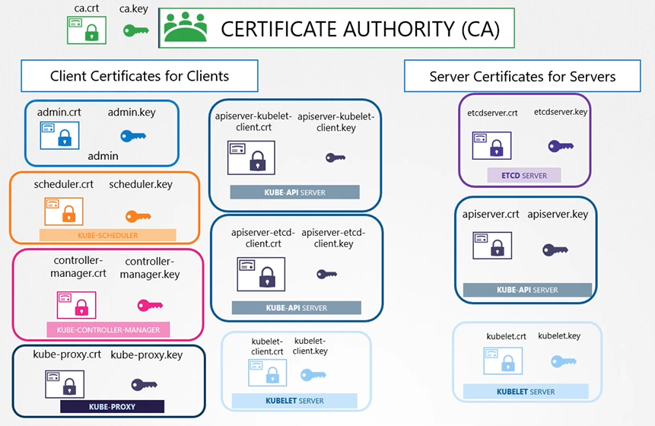

# **TLS in kubernetes - Certificate Creation**

## Generate Certificates

* There are different tools available such as easyrsa, openssl or cfssl etc. or many others for generating certificates.

## Generate Certificates

* There are different tools available such as easyrsa, openssl or cfssl etc. or many others for generating certificates.
* we will use OpenSSL tool to generate the certificates.

## Certificate Authority (CA)

* Generate Keys

First we create a private key

$ openssl genrsa -out ca.key 2048

* Generate CSR

Then we use the OpenSSL Request command along with the key we just created to generate a certificate signing request. The certificate signing request is like a certificate with all of your details, but with no signature. In the certificate signing request we specify the name of the component the certificate is for in the Common Name, or CN field.

In this case, since we are creating a certificate for the Kubernetes CA, we name it Kubernetes - CA.

$ openssl req -new -key ca.key -subj "/CN=KUBERNETES-CA" -out ca.csr

* Sign certificates

$ openssl x509 -req -in ca.csr -signkey ca.key -out ca.crt

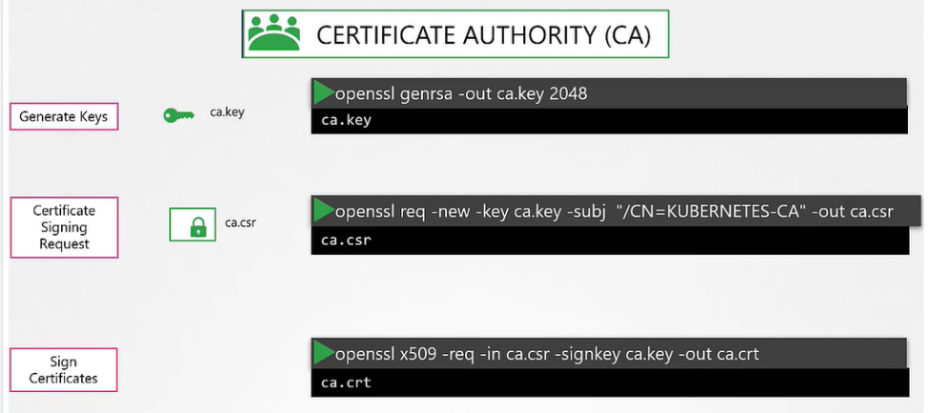

## Generating Client Certificates

#### Admin User Certificates

* Generate Keys

$ openssl genrsa -out admin.key 2048

* Generate CSR

$ openssl req -new -key admin.key -subj "/CN=kube-admin" -out admin.csr

A quick note about the name, it doesn't really have to be Kube Admin. It could be anything, but remember, this is the name that Kube Control client authenticates with and when you run the Kube Control command. So in the audit logs and elsewhere, this is the name that you will see. So provide a relevant name in this field.

* Sign certificates

$ openssl x509 -req -in admin.csr -CA ca.crt -CAkey ca.key -out admin.crt

this time you specify the CA certificate and the CA key. You're signing your certificate with the CA key pair. That makes this a valid certificate within your cluster.

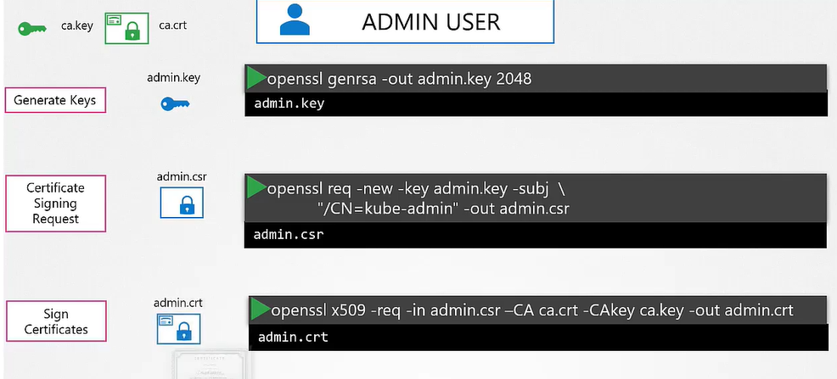

* If you look at it, this whole process of generating a key and a certificate pair is similar to creating a user account for a new user. The certificate is the validated User ID and the key is like the password. It's just that it's much more secure than a simple username and password.
* The user account needs to be identified as an admin user and not just another basic user. You do that by adding the group details for the user in the certificate. In this case, a group named System Masters exists on Kubernetes with administrative privileges.
* You can do this by adding group details with the OU parameter while generating a certificate signing request. Once it's signed, we now have our certificate for the admin user with admin privileges.
* Certificate with admin privilages

$ openssl req -new -key admin.key -subj "/CN=kube-admin/O=system:masters" -out admin.csr

#### We follow the same procedure to generate client certificate for all other components that access the kube-apiserver.

#### crt1

#### crt2

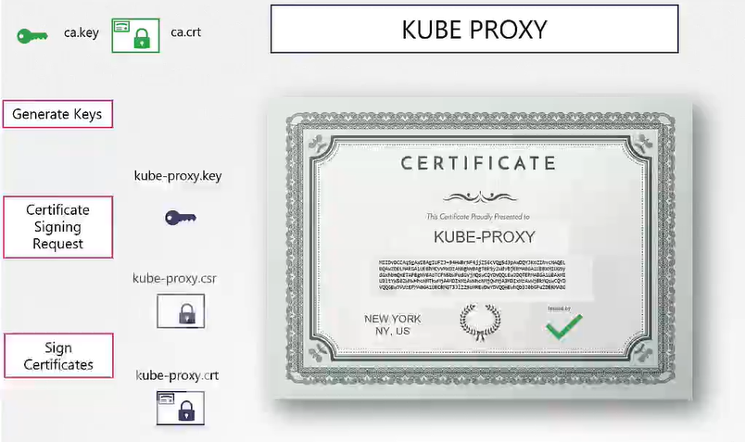

* what do you do with these certificates? Take the admin certificate, for instance,

to manage the cluster. You can use this certificate instead of a username and password in a REST API call you make to the Kube API server. You specify the key, the certificate,

and the CA certificate as options. That's one simple way. The other way is to move all of these parameters into a configuration file called kubeconfig.

* Remember in the prerequisite we mentioned that for clients to validate the certificates sent by the server and vice versa, they all need a copy of the certificate authorities public certificate. The one that we said is already installed within the user's browsers in case of a web application. Similarly in Kubernetes for these various components to verify each other, they all need a copy of the CA's root certificate. So whenever you configure a server or a client with certificates,

you will need to specify the CA root certificate as well.

**Generating Server Certificates**

ETCD Server certificate

* We follow the same procedure as before to generate a certificate for ETCD.

We will name it ETCD-server.

* ETCD server can be deployed as a cluster across multiple servers as in a high availability environment. In that case, to secure communication between the different members in the cluster, we must generate additional peer certificates.

Once the certificates are generated specify them while starting the ETCD server.

And finally, it requires the CA root certificate to verify that the clients connecting

to the ETCD server are valid.

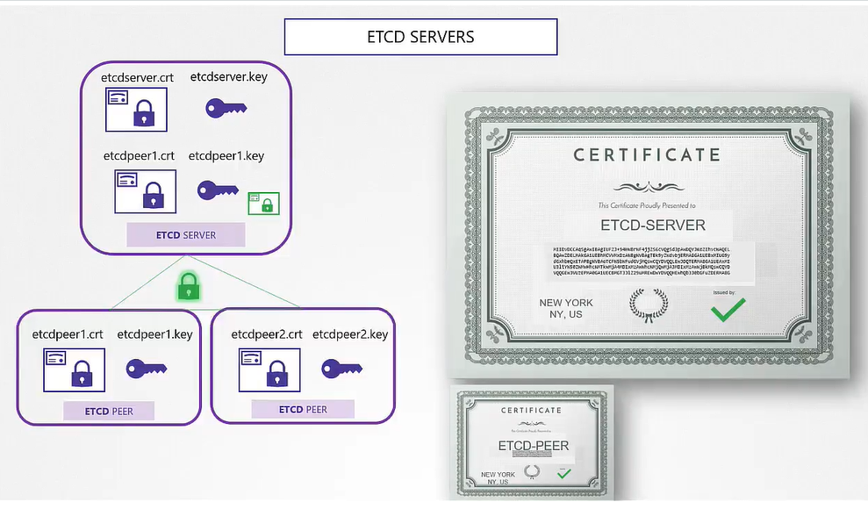

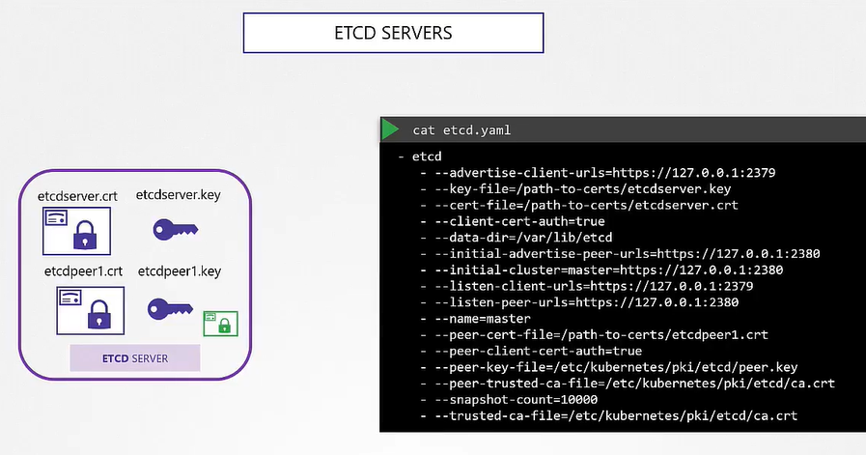

**Kube-apiserver certificate**

* Every operation goes through the Kube API server. Anything moves within the cluster, the API server knows about it. You need information, you talk to the API server. And so it goes by many names and aliases within the cluster. It's real name is Kube-API server but some call it Kubernetes because for a lot of people who don't really know.
* we use the same set of commands as earlier to generate a key. In the certificate signing request you specify the name Kube-API server. But how do you specify all the alternate names?

For that, you must create an OpenSSL config file. Create an OpenSSL dot CNF file

and specify the alternate names in the Alt Name section of the file. Include all the DNS names the API server goes by as well as the IP address. Pass this config file as an option while generating the certificate signing request. Finally, sign the certificate using the CA certificate end key.

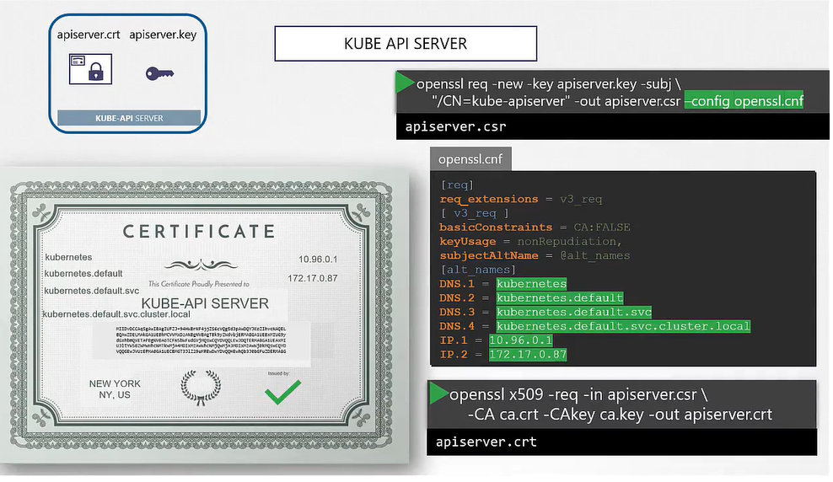

* It is time to look at where we are going to specify these keys. Remember to consider the API client certificates that are used by the API server while communicating as a client to the ETCD and kubelet servers. The location of these certificates are passed into the Kube-API servers executable or service configuration file. First, the CA file needs to be passed in, to remember every component needs the CA certificate to verify its clients. Then we provide the API server certificates under the TLS cert options. We then specify the client certificates used by Kube API server to connect to the ETCD server again with the CA file.And finally, the Kube API server client certificates to connect to the kubelets.

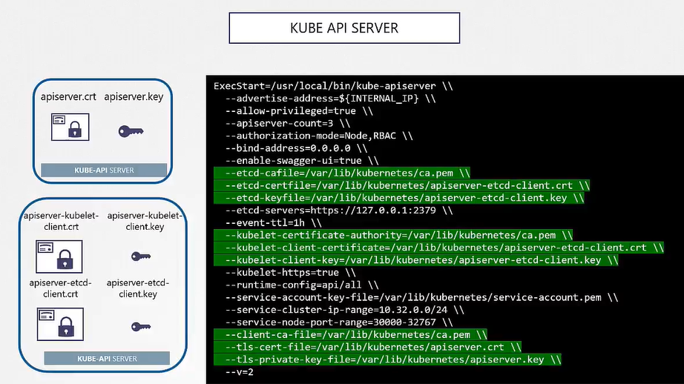

* Note: file names is wrong in the kubelet part in the above screenshot.

## Kubectl Nodes (Server Cert)

* you need a key certificate pair for each node in the cluster. Now, what do you name these certificates? Are they all going to be named kubelets? No.

They will be named after their nodes. Node zero one, node zero two, and node zero three. Once the certificates are created, use them in the kubelet config file. As always, you specify the root CS certificate and then provide the kubelet node certificates. You must do this for each node in the cluster.

**Kubectl Nodes (Client Cert)**

* kubelet needs to communicate with the Kube API server. These Certificates are used by the kubelet to authenticate into the Kube API server. They need to be generated as well. What do you name these certificates? The API server needs to know which node is authenticating and give it the right set of permissions. so it requires the nodes to have the right names in the right formats. Since the nodes are system components like the kube-scheduler and the controller-manager we talked about earlier, the format starts with the system keyword, followed by node, and then the node name. In this case, node zero one to node zero three. And how would the API server give it the right set of permissions? Remember we specified a group name for the admin user so the admin user gets administrative privileges? Similarly, the nodes must be added to a group named System Nodes.
* Once the certificates are generated, they go into the kubeconfig files as we discussed earlier.

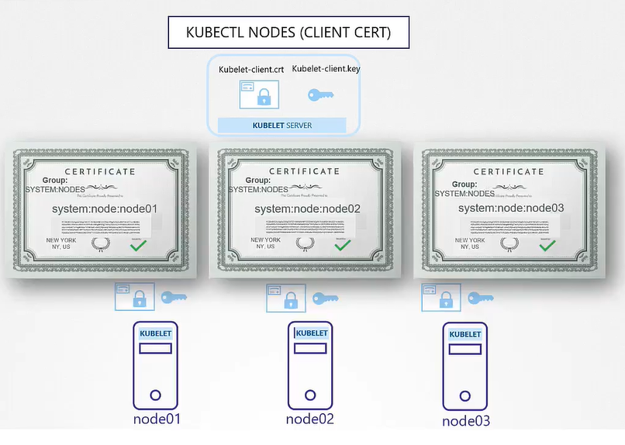

**View Certificate Details**

To view the details of the certificate

$ openssl x509 -in /etc/kubernetes/pki/apiserver.crt -text -noout

Inspect server logs using journalctl

$ journalctl -u etcd.service -l

View logs using kubectl

$ kubectl logs etcd-master

**CA (Certificate Authority)**

* The CA is really just the pair of key and certificate files that we have generated, whoever gains access to these pair of files can sign any certificate for the kubernetes environment.
* the master node is our CA server.
* The Kubeadm tool does the same thing. It creates a CA pair of files and stores that on the master node itself. So far we have been signing requests manually,

but as, and when the users increase and your team grows you need a better automated way to manage the certificates, signing requests, as well as to rotate certificates when they expire. Kubernetes has a built in certificates API

that can do this for you.

* With the certificates API, you now send a certificate signing request directly to Kubernetes through an API call.

How is that done?

* A user first creates a key

$ openssl genrsa -out jane.key 2048

* Generates a CSR

$ openssl req -new -key jane.key -subj "/CN=jane" -out jane.csr

* Sends the request to the administrator and the adminsitrator takes the key and creates a CSR object, with kind as "CertificateSigningRequest" and a encoded "jane.csr"
* The request field is where you specify the certificate signing request sent by the user but you don't specify it as plain text. Instead, it must be encoded using the base 64 command. Then, move the encoded text into the request field and then submit the request.

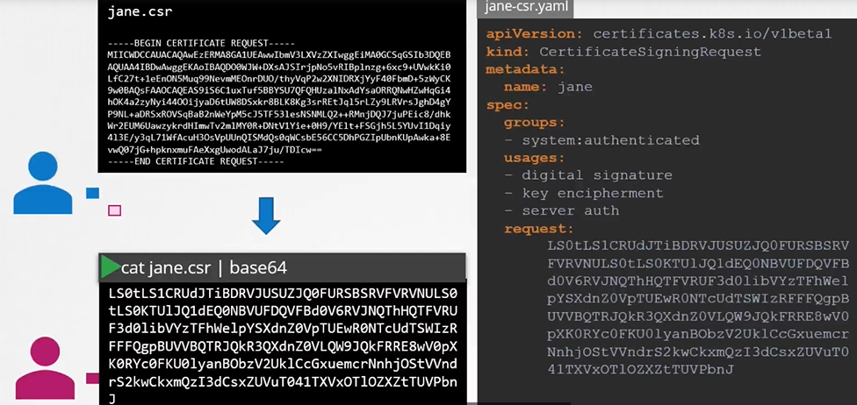

* Once the object is created all certificate signing requests can be seen by administrators by running :

$ kubectl get csr

* Approve the request

$ kubectl certificate approve jane

* To deny

$ kubectl certificate deny agent-smith

* To view the certificate

$ kubectl get csr jane -o yaml

* To decode it

$ echo "<certificate>" |base64 –decode

* If you want to delete certificate request

$ kubectl delete csr agent-smith

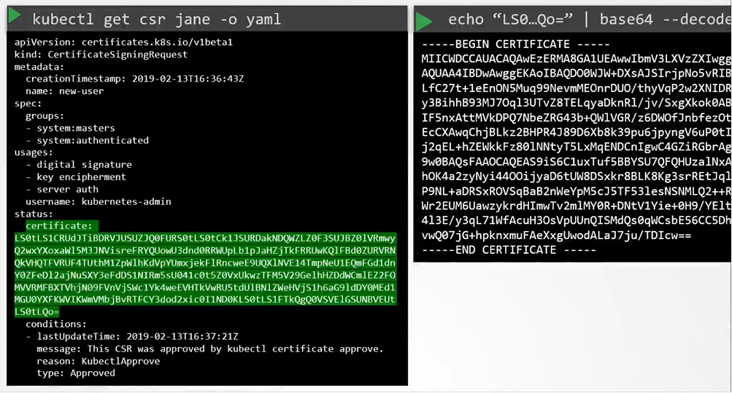

**All the certificate releated operations are carried out by the controller manager.**

* If anyone has to sign the certificates they need the CA Servers, route certificate and private key. The controller manager configuration has two options where you can specify this.

[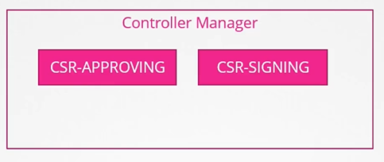](https://github.com/kodekloudhub/certified-kubernetes-administrator-course/blob/master/images/csr3.PNG)

[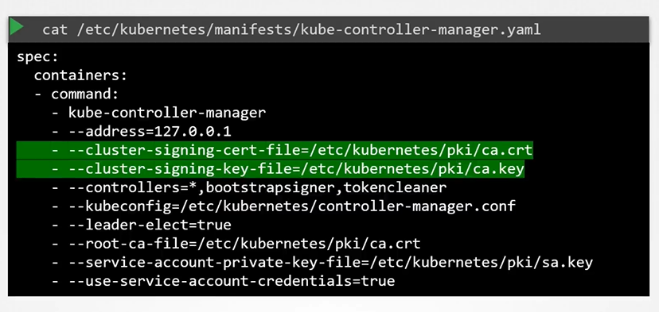](https://github.com/kodekloudhub/certified-kubernetes-administrator-course/blob/master/images/csr4.PNG)

**KubeConfig**

**Client uses the certificate file and key to query the kubernetes Rest API for a list of pods using curl.**

* You can specify the same using kubectl

[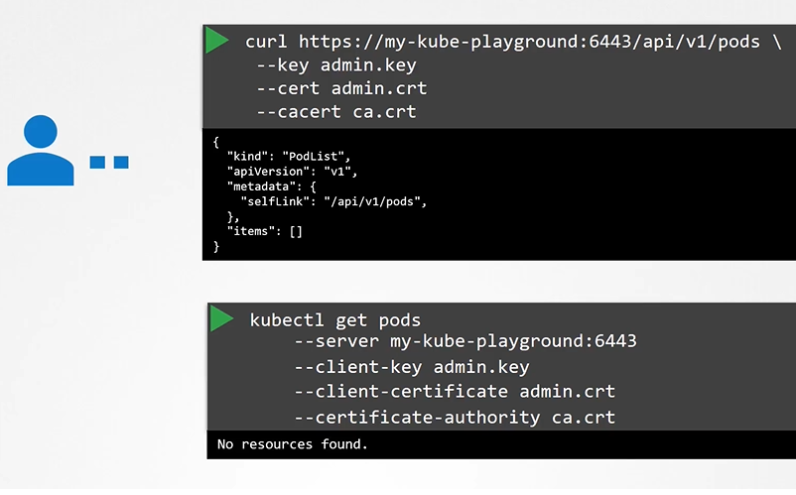](https://github.com/kodekloudhub/certified-kubernetes-administrator-course/blob/master/images/kc1.PNG)

* We can move these information to a configuration file called kubeconfig. And then specify this file as the kubeconfig option in the command.

$ kubectl get pods --kubeconfig config

* By default, the kubectl tool looks for a file named config under a directory.kube under the user's home directory. So if you clear the kubeconfig file there, you don't have to specify the path to the file explicitly in the kubectl command.
* The config file has three sections:

clusters, users, and contexts.

* Clusters are the various Kubernetes clusters that you need access to. Say you have multiple clusters for development environment or testing environment or prod or for different organizations or on different cloud providers All those go there.
* Users are the user accounts with which you have access to these clusters. For example, the admin user, a dev user, a prod user. These users may have different privileges on different clusters.
* Finally, contexts marry these together. Contexts define which user account will be used to access which cluster. For example, you could create a context named admin at production that will use the admin account to access a production cluster. Or I may want to access the cluster I have set up on Google with the dev user's credentials to test deploying the application I built.
* Remember, you're not creating any new users or configuring any kind of user access or authorization in the cluster with this process. You're using existing users with their existing privileges and defining what user you're going to use to access what cluster.
* So how does it fit into our example? The server specification (server and CA) in our command goes into the cluster section.
* The admin user's keys and certificates (client key and client cert) goes into the user section.
* You then create a context that specifies to use the my kube admin user to access the my kube playground cluster.

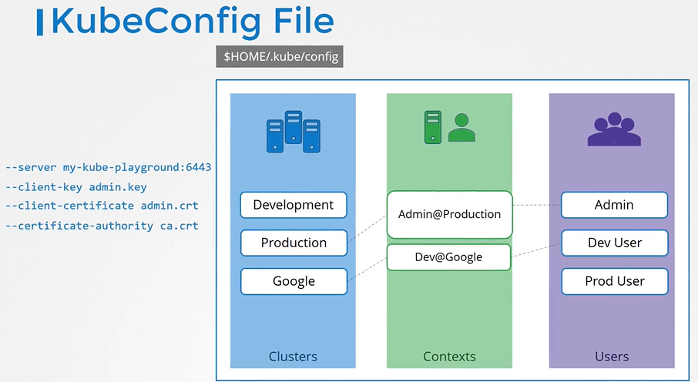

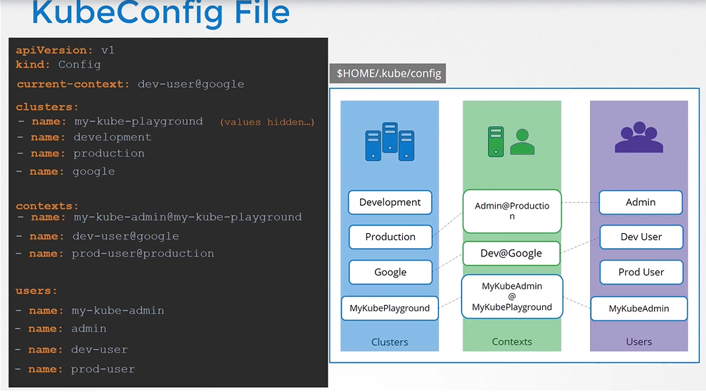

* The user certificate and key should be existed on the above photo as well as the server and CA.
* how does kubectl know which context to choose from? We've defined three contexts here. Which one should it start with? You can specify the default context used by adding a field current context to the kubeconfig file, specify the name of the context to use. In this case, kubectl will always use the context dev user at Google to access the Google clusters
* To view the current file being used

$ kubectl config view

* You can specify the kubeconfig file with kubectl config view with "--kubeconfig" flag

$ kubectl config veiw --kubeconfig=my-custom-config

* How do you update your current context? Or change the current context?

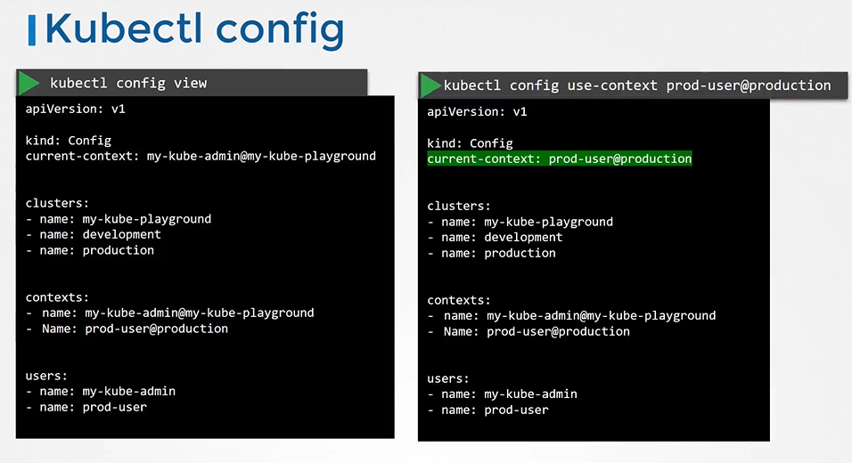

**What about namespaces?**

For example, each cluster may be configured with multiple namespaces within it.

Can you configure a context to switch to a particular namespace?

Yes. The context section in the kubeconfig file can take additional field called namespace where you can specify a particular namespace. This way, when you switch to that context, you will automatically be in a specific namespace.

**Certificates in kubeconfig**

[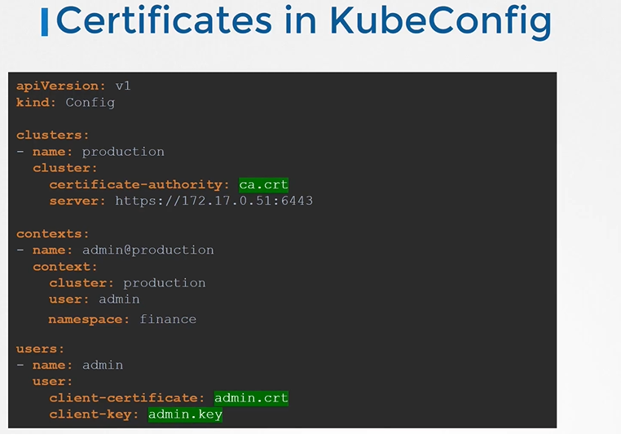](https://github.com/kodekloudhub/certified-kubernetes-administrator-course/blob/master/images/kc10.PNG)

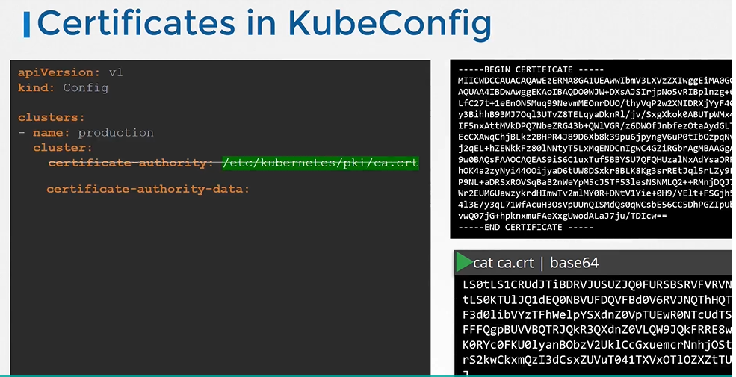

**API Groups**

**o return version and list pods via API's**

[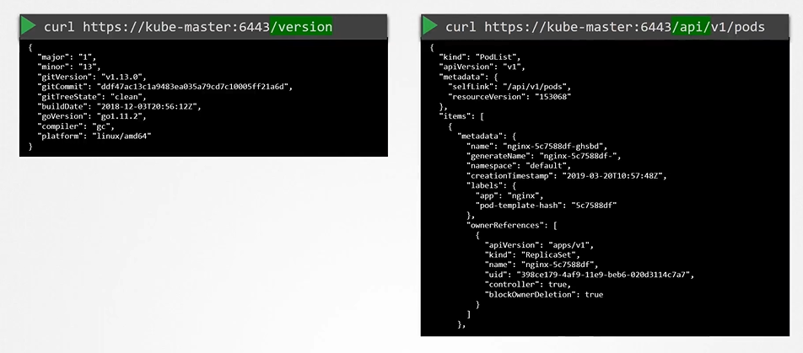](https://github.com/kodekloudhub/certified-kubernetes-administrator-course/blob/master/images/api3.PNG)

* The kubernetes API is grouped into multiple such groups based on thier purpose. Such as one for **APIs**, one for **healthz**, **metrics** and **logs** etc.

[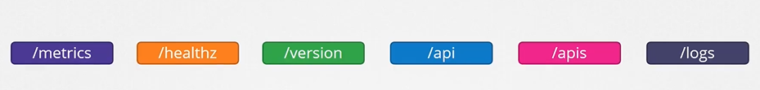](https://github.com/kodekloudhub/certified-kubernetes-administrator-course/blob/master/images/api4.PNG)

**API and APIs**

* These APIs are catagorized into two.
  + The core group - Where all the functionality exists

[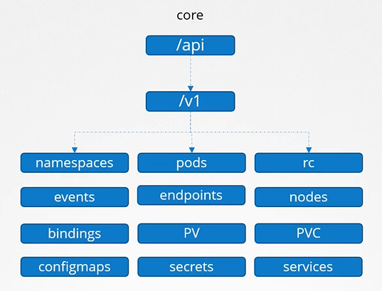](https://github.com/kodekloudhub/certified-kubernetes-administrator-course/blob/master/images/api5.PNG)

* The Named group - More organized and going forward all the newer features are going to be made available to these named groups.

[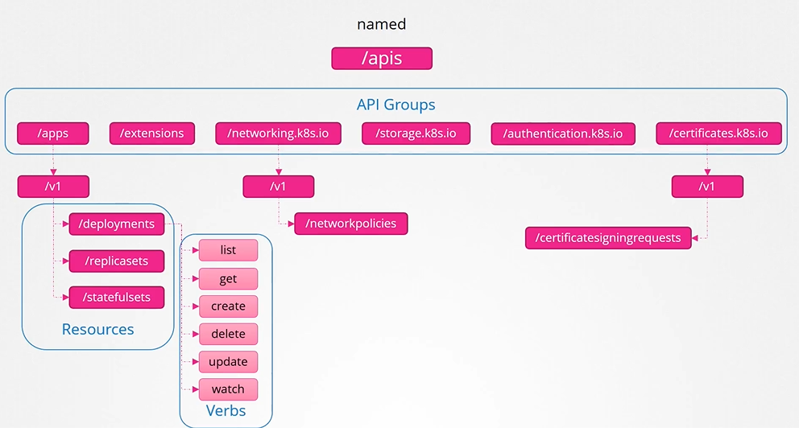](https://github.com/kodekloudhub/certified-kubernetes-administrator-course/blob/master/images/api6.PNG)

To list all the api groups :[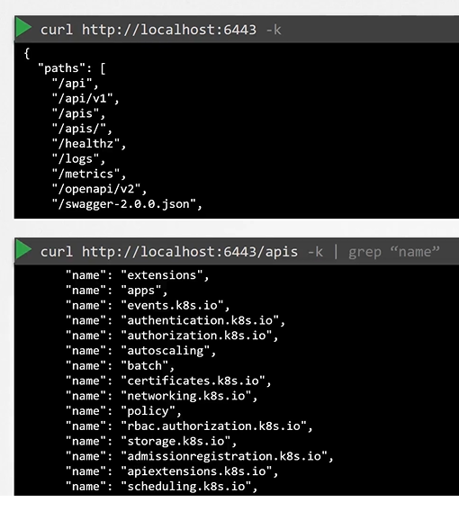](https://github.com/kodekloudhub/certified-kubernetes-administrator-course/blob/master/images/api7.PNG)

**Note on accessing the kube-apiserver**

* You have to authenticate by passing the certificate files.

[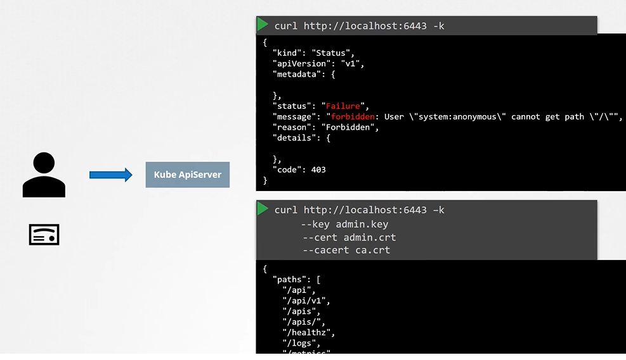](https://github.com/kodekloudhub/certified-kubernetes-administrator-course/blob/master/images/api8.PNG)

* An alternate is to start a kubeproxy client
* The Kube control proxy command launches a proxy service locally on port 8001 and uses credentials and certificates from your Kube config file to access the cluster. That way, you don't have to specify those in the cURL command.

[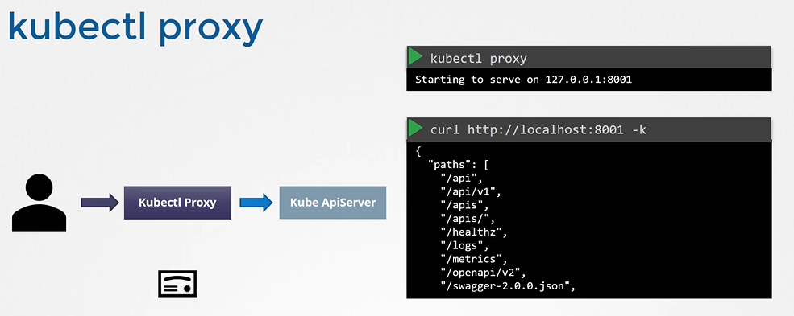](https://github.com/kodekloudhub/certified-kubernetes-administrator-course/blob/master/images/api9.PNG)

* So here are two terms that kind of sound the same; The Kube proxy and kubectl proxy. Well, they're not the same. We discussed about Kube proxy earlier. It is used to enable connectivity between pods and services across different nodes in the cluster. Whereas kubectl proxy is an http proxy service created by kubectl utility to access the Kube API server.

**Authorization**

**Authorization Mechanisms**

* There are different authorization mechanisms supported by kubernetes
  + Node Authorization
  + Attribute-based Authorization (ABAC)
  + Role-Based Authorization (RBAC)
  + Webhook

**Node Authorization**

* The kubelet accesses the API server to read information about services and points, nodes, and pods. The kubelet also reports to the Kube API Server with information about the node, such as its status. These requests are handled by a special authorizer known as the Node Authorizer. when we discussed about certificates, we discussed that the kubelets should be part of the system nodes group and have a name prefixed with system node. So any request coming from a user with the name system node and part of the system nodes group is authorized by the node authorizer, and are granted these privileges,

the privilege is required for a kubelet.

[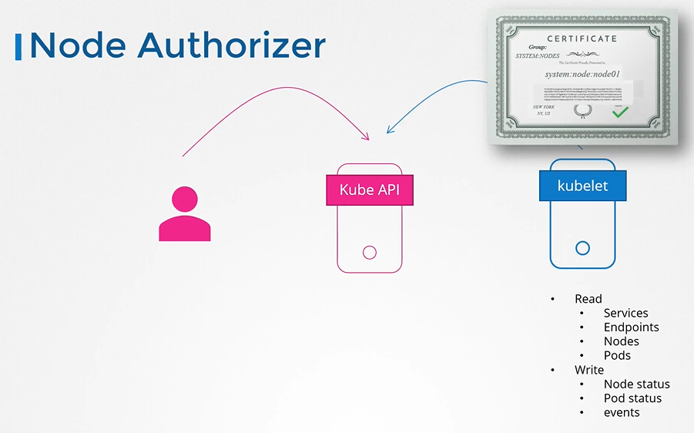](https://github.com/kodekloudhub/certified-kubernetes-administrator-course/blob/master/images/node-auth.png)

**ABAC**

* Attribute-based authorization is where you associate a user or a group of users with a set of permissions. In this case, we say the dev user can view, create and delete pods. You do this by creating a policy file with a set of policies defined in adjacent format this way you pass this file into the API server. Similarly, we create a policy definition file for each user or group in this file. Now, every time you need to add or make a change in the security, you must edit this policy file manually and restart the Kube API Server. As such, the attribute-based access control configurations are difficult to manage.

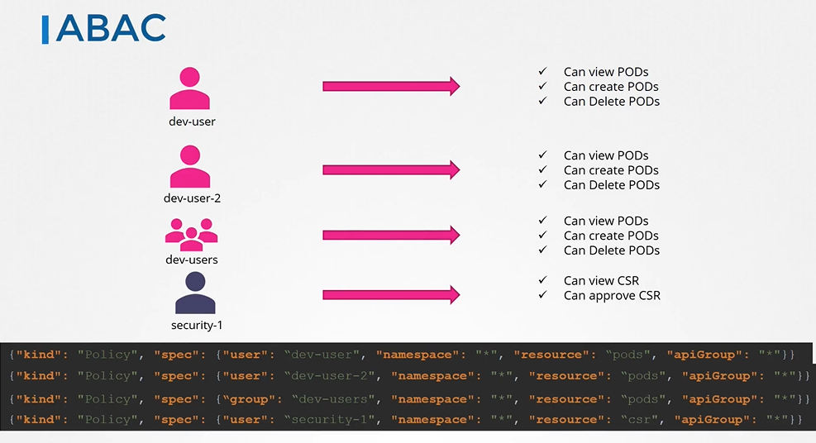

**RBAC**

* We create a role with the set of permissions required for developers then we associate all the developers to that role. Similarly, create a role for security users

with the right set of permissions required for them.

**WEBHOOK**

* Say you want to manage authorization externally and not through the built-in mechanisms that we just discussed.
* For instance, Open Policy Agent is a third-party tool

**Authorization Modes**

* The mode options can be defined on the kube-apiserver there are two more modes ,in addition to what we just saw. Always Allow and Always Deny. As the name states, Always Allow, allows all requests without performing any authorization checks. Always Deny, denies all requests.

So, where do you configure these modes?

Which of them are active by default?

Can you have more than one at a time?

How does authorization work ?

if you do have multiple ones configured?

The modes are set using the Authorization Mode Option on the Kube API Server.

If you don't specify this option, it is set to Always Allow by default. You may provide a comma separated list of multiple modes that you wish to use. In this case, I wanna set it to node-rbac and webhook. When you have multiple modes configured your request is authorized using each one in the order it is specified.

For example, when a user sends a request it's first handled by the Node Authorizer. The Node Authorizer handles only node requests, so it denies the request. Whenever a module denies a request it is forwarded to the next one in the chain. The role-based access control module performs its checks and grants the user permission. Authorization is complete and user is given access to the requested object. So, every time a module denies the request it goes to the next one in the chain and as soon as a module approves the request no more checks are done and the user is granted permission.

**RBAC**

**How do we create a role?**

* Each role has 3 sections
  + apiGroups
  + resources
  + verbs
* create the role with kubectl command
* $ kubectl create -f developer-role.yaml

**The next step is to link the user to that role.**

* For this we create another object called **RoleBinding**. This role binding object links a user object to a role.
* create the role binding using kubectl command

$ kubectl create -f devuser-developer-binding.yaml

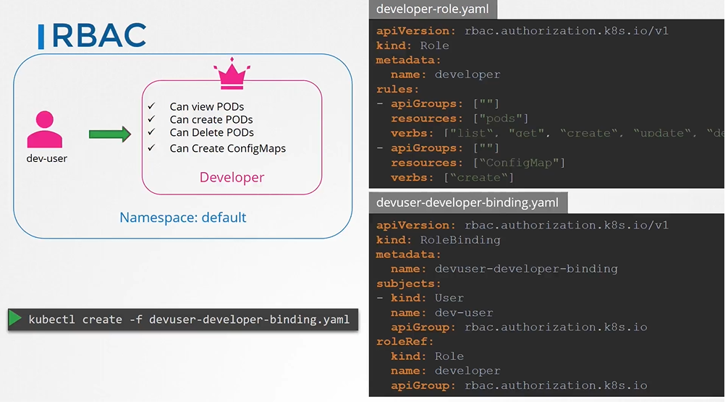

**View RBAC**

* To list roles
* $ kubectl get roles
* To list rolebindings
* $ kubectl get rolebindings
* To describe role
* $ kubectl describe role developer

[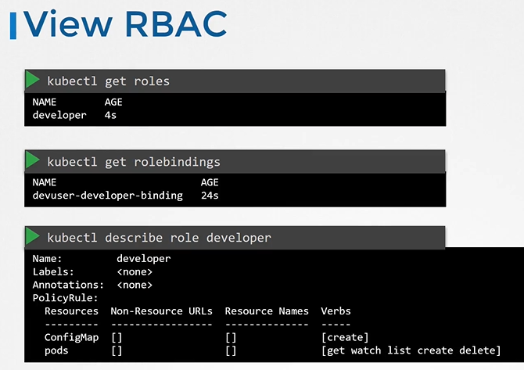](https://github.com/kodekloudhub/certified-kubernetes-administrator-course/blob/master/images/rbac2.PNG)

* To describe rolebinding
* $ kubectl describe rolebinding devuser-developer-binding

[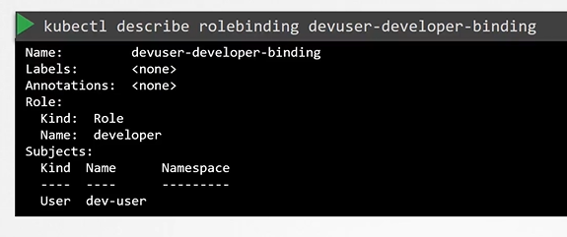](https://github.com/kodekloudhub/certified-kubernetes-administrator-course/blob/master/images/rbac3.PNG)

**What if you being a user would like to see if you have access to a particular resource in the cluster.**

**Check Access**

* You can use the kubectl auth command
* $ kubectl auth can-i create deployments
* $ kubectl auth can-i delete nodes
* $ kubectl auth can-i create deployments --as dev-user
* $ kubectl auth can-i create pods --as dev-user
* $ kubectl auth can-i create pods --as dev-user --namespace test

[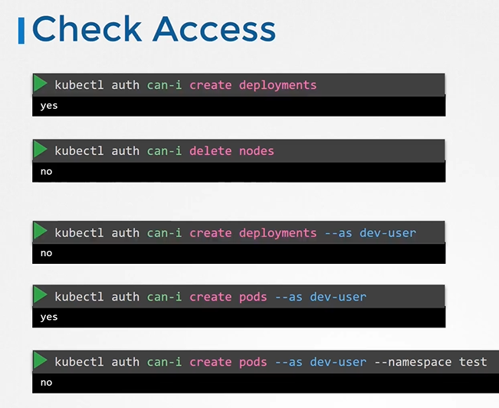](https://github.com/kodekloudhub/certified-kubernetes-administrator-course/blob/master/images/rbac5.PNG)

**Resource Names**

* Note on resource names we just saw how you can provide access to users for resources like pods within the namespace.

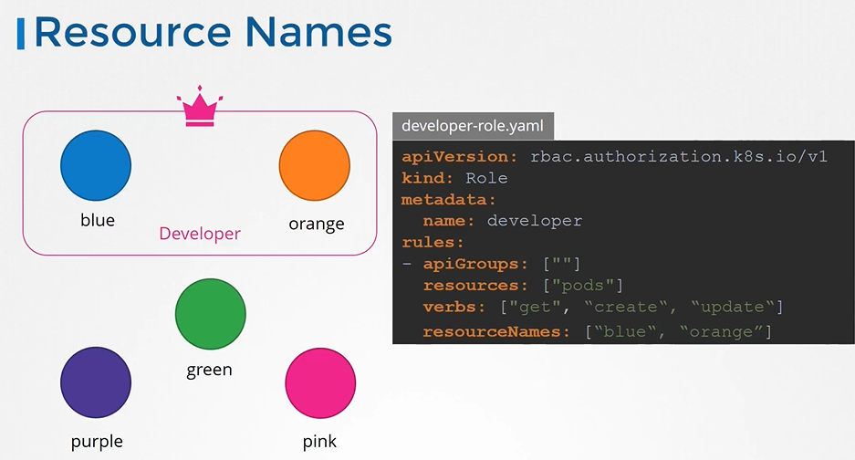

$kubectl create role developer --verb=list,create,delete --resource=pods

**Cluster Roles**

* Roles and Rolebindings are namespaced meaning they are created within namespaces.
* If you don't specify a namespace,they are created in the default namespace

[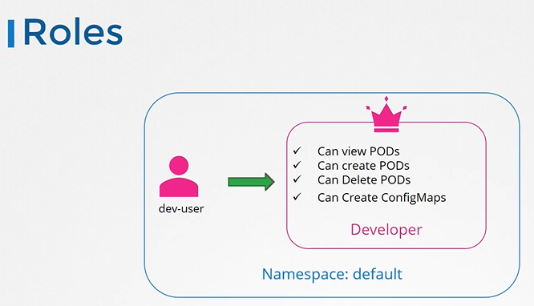](https://github.com/kodekloudhub/certified-kubernetes-administrator-course/blob/master/images/roles.PNG)

**Namespaces**

* Can you group or isolate nodes within a namespace?
  + No, those are cluster wide or cluster scoped resources. They cannot be associated to any particular namespace.

[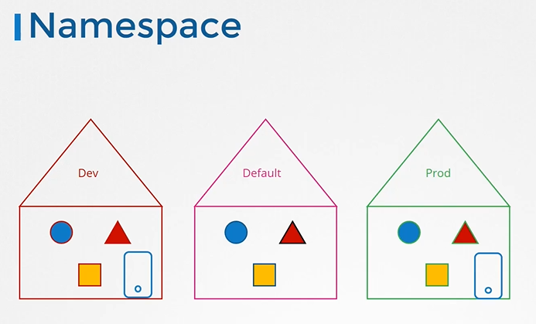](https://github.com/kodekloudhub/certified-kubernetes-administrator-course/blob/master/images/namespace.PNG)

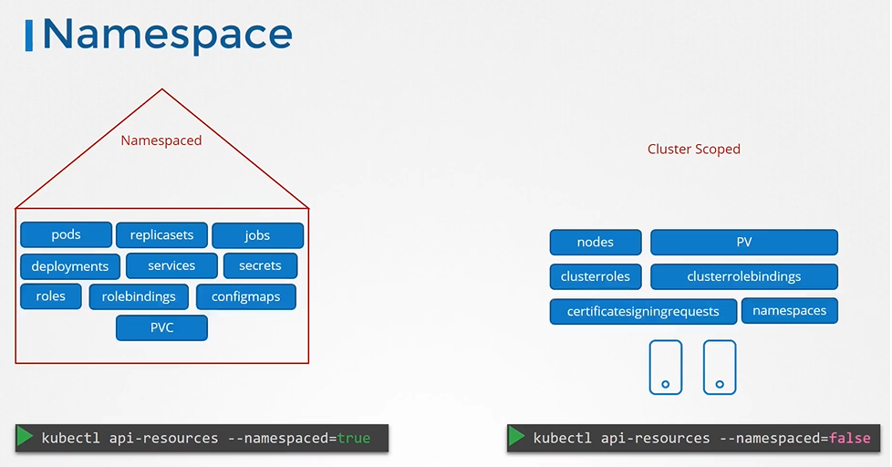

* So the resources are categorized as either namespaced or cluster scoped.
* To see namespaced resources

$ kubectl api-resources --namespaced=true

* To see non-namespaced resources

$ kubectl api-resources --namespaced=false

**Cluster Roles and Cluster Role Bindings**

* we saw how to authorize a user to namespace resources. We used roles and role bindings for that. But how do we authorize users to cluster-wide resources

like nodes or persistent volumes. That is where you use cluster roles and cluster role bindings. Cluster roles are just like roles, except they are for cluster-scoped resources. For example, a cluster admin role can be created to provide a cluster administrator permissions to view, create, or delete nodes in a cluster. Similarly, a storage administrator role can be created to authorize a storage admin.

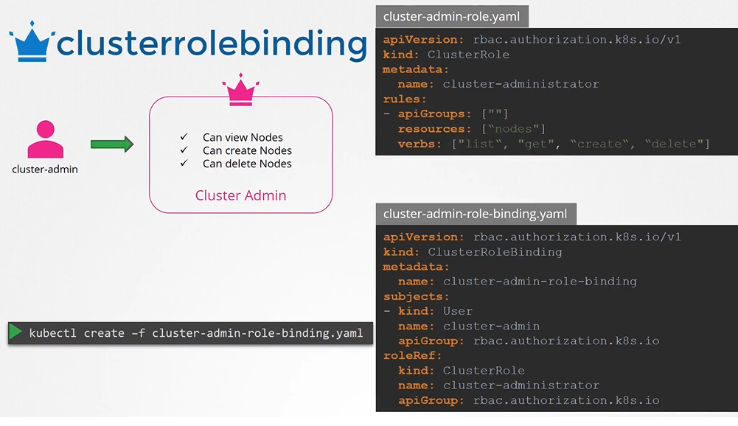

* You can create a cluster role for namespace resources as well. When you do that user will have access to these resources across all namespaces.
* Earlier, when we created a role to authorize a user to access pod, the user had access to pods in a particular namespace alone. With cluster roles, when you authorize a user to access the pods, the user gets access to all pods across the cluster.

# Image Security

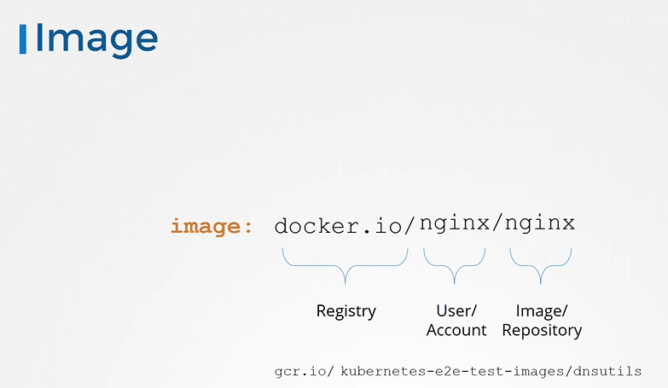

* Going back to our pod definition file, to use an image from our private registry, we replace the image name with the full path to the one in the private registry. But how do we implement the authentication, the login part? How does Kubernetes get the credentials to access the private registry? Within Kubernetes, we know that the images are pulled and run by the Docker run time on the worker nodes. How do you pass the credentials to the docker run times on the worker nodes? For that, we first create a secret object with the credentials in it. The secret is of type docker registry and we name it regcred. Docker registry is a built in secret type that was built for storing Docker credentials. We then specify the registry server name, the username to access the registry, the password, and the email address of the user. we then specify the secret inside our pod definition file under the image pull secret section. When the pod is created, Kubernetes or the kubelets on the worker node uses the credentials from the secret to pull images.

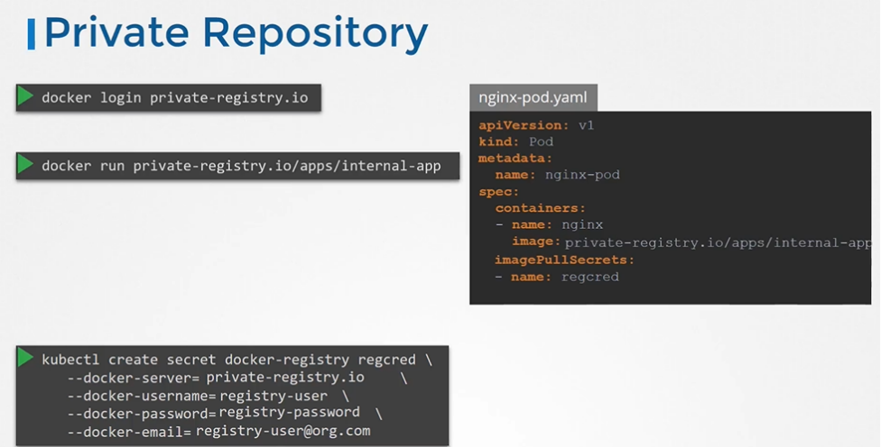

**Docker Security-pre:**

Let us start with a host with Docker installed on it. This host has a set of its own processes running, such as a number of operating system processes, the Docker daemon itself, the SSH server, et cetera. We will now run an Ubuntu Docker container that runs a process that sleeps for an hour. We have learned that unlike virtual machines, containers are not completely isolated from their host. Containers and the host share the same kernel. Containers are isolated using namespaces in Linux. The host has a namespace and the containers have their own namespace. All the processes run by the containers are in fact run on the host itself but in their own namespace. As far as the Docker container is concerned, it is in its own namespace and it can see its own processes only. It cannot see anything outside of it or in any other namespace. So when you list the processes from within the Docker container, you see the sleep process with a process ID of one. For the Docker host, all processes of its own, as well as those in the child namespaces are visible as just another process in the system. So when you list the processes on the host, you see a list of processes, including the sleep command but with a different process ID. This is because the processes can have different process IDs in different namespaces, and that's how Docker isolates containers within a system.

* Let us take a step back. What happens when you run containers as the root user? Is the root user within the container the same as the root user on the host? Can the process inside the container do anything that the root user can do on the system? If so, isn't that dangerous? Well, Docker implements a set of security features that limits the abilities of the root user within the container. So the root user within the container isn't really like the root user on the host. Docker uses Linux capabilities to implement this.
* By default, Docker runs a container with a limited set of capabilities. And so the processes running within the container do not have the privileges to say reboot the host or perform operations that can disrupt the host or other containers running on the same host. If you wish to override this behavior and provide additional privileges than what is available, use the cap add option in the Docker run command. Similarly, you can drop privileges as well using the cap drop option. Or in case you wish to run the container with all privileges enabled,

use the privileged flag. Well, that's it on Docker security for now.

* when you run a Docker container, you have the option to define a set of security standards, such as the ID of the user used to run the container, the Linux capabilities that can be added or removed from the container.

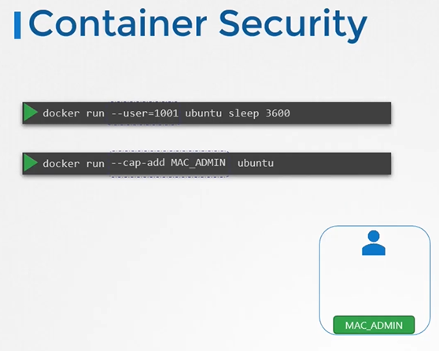

# Security Context

* You may choose to configure the security settings at a container level or at a Pod level. If you configure it at a Pod level, the settings will carry over to all the containers within the Pod. If you configure it at both the Pod and the container, the settings on the container will override the settings on the Pod.
* To add security context on the container and a field called **securityContext** under the spec section.

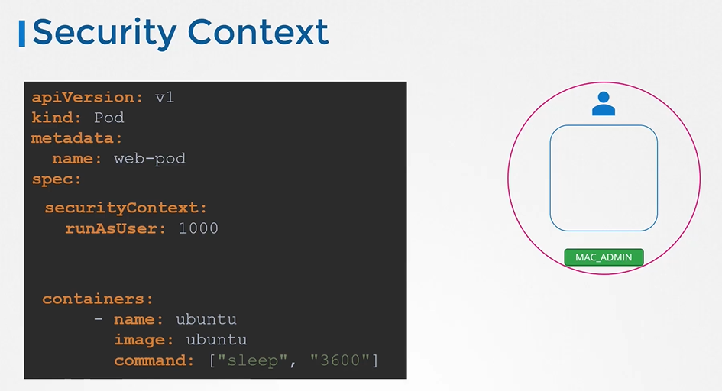

* To set the same context at the container level, then move the whole section under container section.

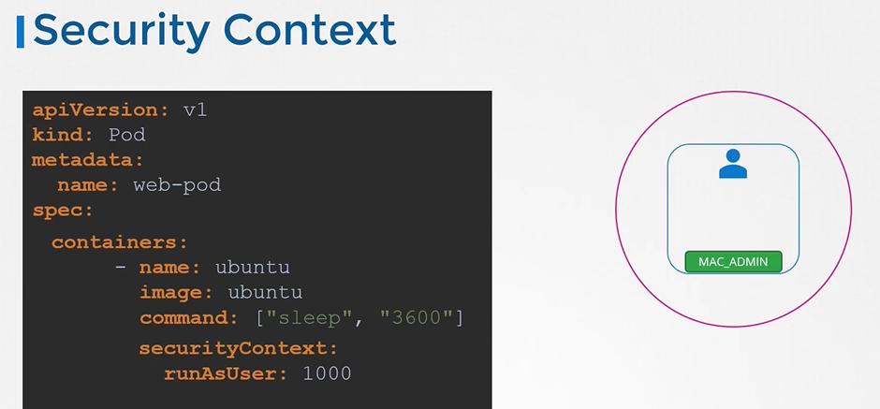

* To add capabilities use the **capabilities** option

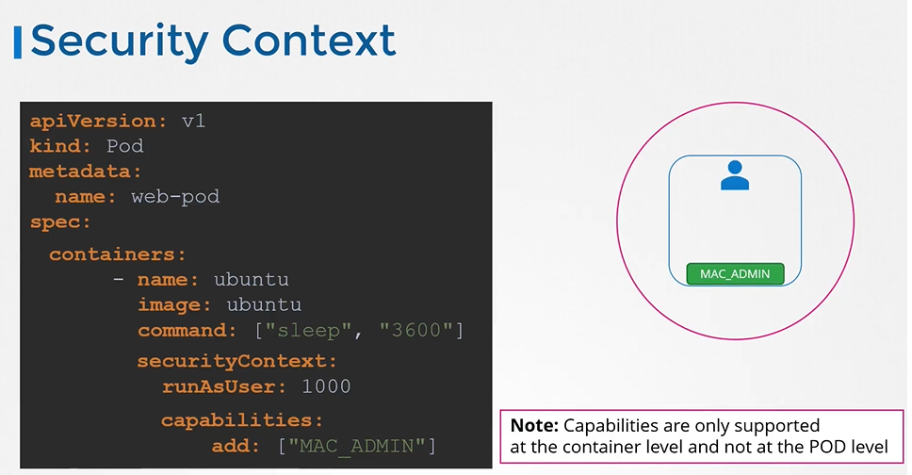

**Network Policies**

* the network policy is another object in the Kubernetes namespace just like pods, replicasets or services.
* you link a network policy to one or more pods.
* You can define rules within the network policy.
* Now note that ingress or egress isolation only comes into effect if you have ingress or egress in the policy types. In this example, there's only ingress in the policy type which means only ingress traffic is isolated and all egress traffic is unaffected. Meaning the pod is able to make any egress calls and they're not blocked. So for an egress or ingress isolation to take place, note that you have to add them under the policy types as seen here. Otherwise, there is no isolation.

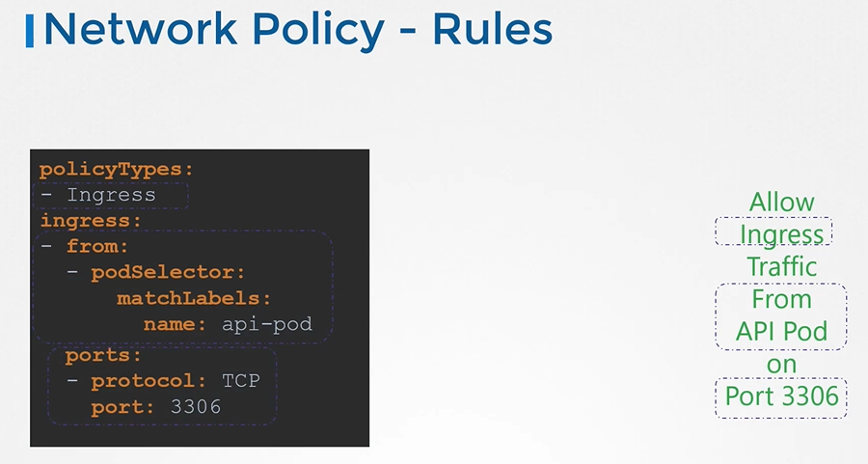

* From the DB pods perspective, we want to allow incoming traffic from the API pod. So that is incoming, so that is ingress. The API pod makes database queries and the database pods returns the results. So what about the results? Do you need a separate rule for the results to go back to the API pod? No, because once you allow incoming traffic, the response or reply to that traffic is allowed back automatically. We don't need a separate rule for that.
* However, this rule does not mean that the database pod will be able to connect to the API pod or make calls to the API. Say, for example, the database pod tries to make an API call to the API pod, then that would not be allowed because that is now an egress traffic originating from the database pod and would require a specific egress rule to be defined.

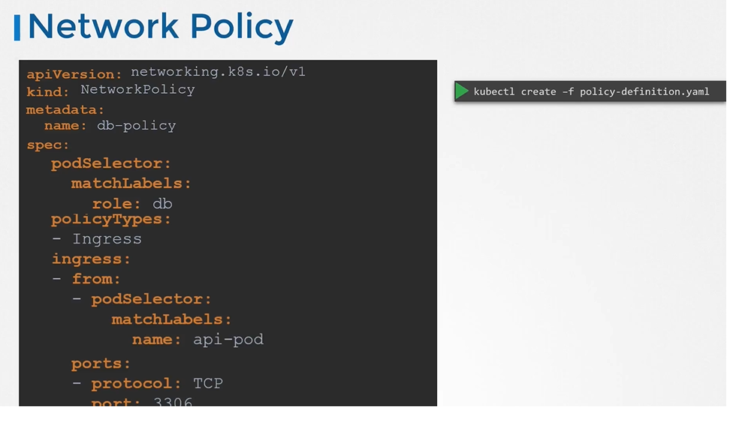

* if you are creating a network policy for the prod namespace, which is a namespace other than the default namespace, then it should have the namespace defined as prod on the network policy object definition. Now by default, this policy will only allow the pod in the prod namespace, which is the same namespace as that of the network policy, but matching labels to reach the database pod. But what if for some reason we want the pod in the staging namespace, which is another namespace, to reach the database in the production namespace? For this, we add a namespace selector property, as well along with the pod selector property. Under this, we use match labels again to provide a label set on the namespace. Remember, you must have this label set on the namespace first for this to work. So just note that. So that's what the namespace selector does. It helps in defining from what namespace traffic is allowed to reach to the database pod.
* We could configure a network policy allow traffic originating from certain IP addresses. For this, we add a new type of from definition known as the IP block definition. IP block allows you to specify a range of IP addresses from which you could allow traffic to hit the database pod. Ex: external backup server
* ipBlock

cidr: 192.168.1.10/32

**Docker Storage**

* There are two concepts comes into the docker, Storage drivers and Volume drivers plugins.

[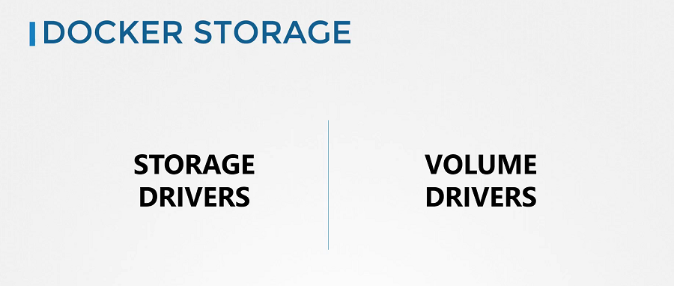](https://github.com/kodekloudhub/certified-kubernetes-administrator-course/blob/master/images/class1.PNG)

**Storage in Docker**

**Filesystem**

* Let's see how Docker stores data on the local file system. At the first time, When you install Docker on a system, it creates this directory structures at /var/lib/docker.

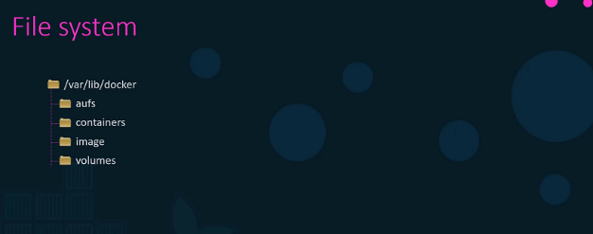

* You have multiple directories under it called aufs, containers, image, volumes etc.
* This is where Docker stores all its data by default.
* All files related to containers are stored under the containers directory and the files related to images are stored under the image directory. Any volumes created by the Docker containers are created under the volumes directory.

**Layered Architecture**

* When docker builds images, it builds these in a layered architecture. Each line of instruction in the Docker file creates a new layer in the Docker image with just the changes from the previous layer.
* As you can see in the image, layer-1 is the Ubuntu base layer, layer-2 install the packages, layer-3 install the python packages, layer-4 update the source code, layer-5 updates the entry point of the image. Since each layer only stores the changes from the previous layer. It is reflected in the size as well.

[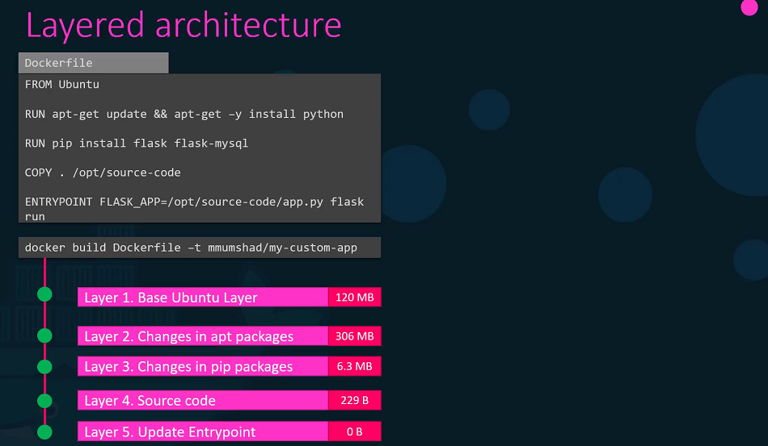](https://github.com/kodekloudhub/certified-kubernetes-administrator-course/blob/master/images/class3.PNG)

* For better understanding the advantages of this layered architecture, Let's take a different Dockerfile, this is very similar to our first application. only source code and entry point is differnet to create this application.
* When image builds, docker is not going to build first three layers instead of it reuses the same three layers it built for the first application from the cache. Only creates the last two layers with the new sources and the new entry point.
* This way, Docker builds images faster and efficiently saves disk spaces. This is also applicable, if you were to update your application code. Docker simply reuses all the previous layers from the cache and quickly rebuild the application image by updating the latest source code.

[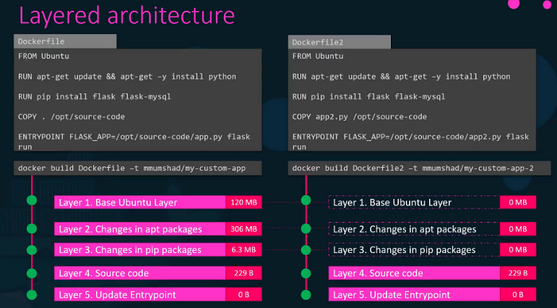](https://github.com/kodekloudhub/certified-kubernetes-administrator-course/blob/master/images/class4.PNG)

* Let's rearrange the layers bottom up so we can understand it better. All of these layers are created when we run the Docker build command to form the final Docker image. Once the build is complete, you cannot modify the contents of these layers and so they are read-only and you can only modify them by initiating a new build.

[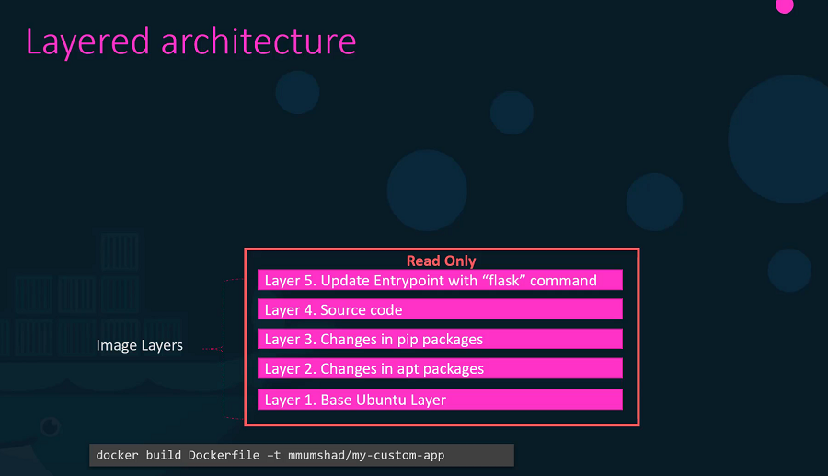](https://github.com/kodekloudhub/certified-kubernetes-administrator-course/blob/master/images/class5.PNG)

* When you run a container based off of this image, using the **Docker run** command Docker creates a container based off of these layers and creates a new writeable layer on top of the image layer. The writeable layer is used to store data created by the container such as log files written by the applications, any temporary files generated by the container.

[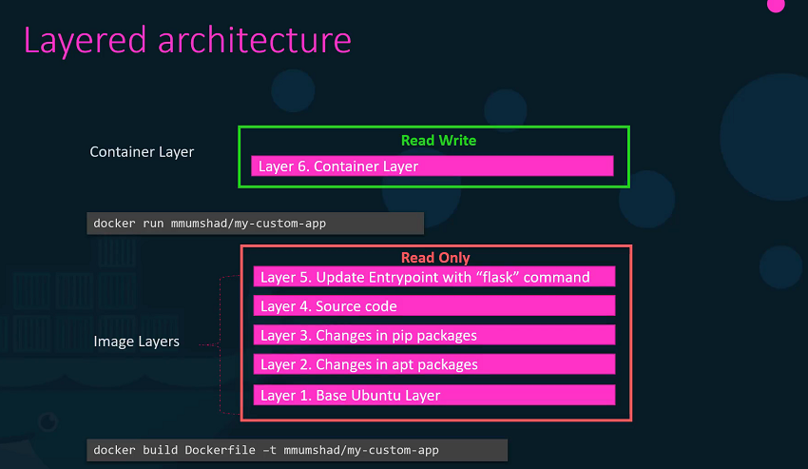](https://github.com/kodekloudhub/certified-kubernetes-administrator-course/blob/master/images/class6.PNG)

* When the container is destroyed, this layer and all of the changes stored in it are also destroyed. Remember that the same image layer is shared by all containers created using this image.
* If I will create a new file called temp.txt in the newly created container, which is read and write.
* The files in the image layer are read-only meaning you cannot edit anything in those layers.

[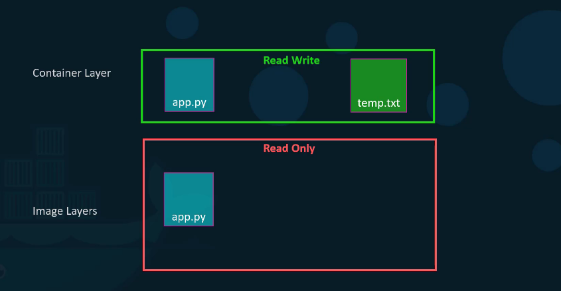](https://github.com/kodekloudhub/certified-kubernetes-administrator-course/blob/master/images/class7.PNG)

* Let's take an example of our application code. Since we bake our code into the image, the code is part of the image and as such, its read-only. After running a container, what if I wish to modify the source code.
* Yes, I can still modify this file, but before I saved the modified file, Docker automatically creates a copy of the file in the read-write layer and I will then be modifying a different version of the file in the read-write layer. All future modifications will be done on this copy of the file in the read-write layer. This is called copy-on-right mechanism.
* The Image layer being a read-only just means that the files in these layers will not be modified in the image itself. So, the image will remain the same all the time until you rebuild the image using the Docker build command. If container destroyed then all of the data that was stored in the container layer also gets deleted.

**Volumes**

* To get a persistent data in the containers, we need to create a volume using the docker volume create command. So, when I run the docker volume create data_volume command, it creates a directory called data_volume under the /var/lib/docker/ volumes directory.

$ docker volume create data_volume

$ ls -l /var/lib/docker/volumes/

drwxr-xr-x 3 root root 4096 Aug 01 17:53 data_volume

$ docker volume ls

DRIVER VOLUME NAME

local data_volume

* When I run the Docker container using the docker run command, I could mount this volume inside the Docker containers, with -v options.
* So when I do a docker run -v then specify my newly created volume name followed by a colon(:) and the location inside my container, which is the default location where MySQL stores data and that is /var/lib/mysql and at the last image name of MySQL. This will create a new container and mount the data volume.

$ docker run -v data_volume:/var/lib/mysql mysql

* Even if the container is destroyed, the data is still available.
* What if you didn't create the Docker volume before the Docker run command. In this image, Docker will automatically create a volume named data_volume2 and mount it to the container.

$ docker run -v data_volume2:/var/lib/mysql mysql

$ docker volume ls

DRIVER VOLUME NAME

local data_volume

local data_volume2

* You should be able to see all these volumes if you list the contents of the /var/lib/docker volumes directory. This is called **Volume mounting**.
* What if we had our data already at another location?
* Let's say we have some external storage on the Docker host at /data path and we would like to store database data on that volume and not in the default /var/lib/docker/volumes directory. In that case, we would run a container using the command docker run -v. But in this case, we will provide the complete path to the directory we would like to mount. That is /data/mysql and so it will create a container and mount the directory to the container. This is called **Bind mounting**.
* So there are two types of mounts, volume mount and bind mount.
  + Volume mount, mounts of volume from the volumes directory
  + bind mount, mounts indirectly from any location on the Docker host.
* Instead of -v option, we can preferred --mount option.

$ mkdir -p /data/mysql

$ docker run --mount type=bind,source=/data/mysql,target=/var/lib/mysql mysql

* So, who is responsible for doing all of these Operations?
* Maintaining of layered architecture, creating a writeable layer, moving files across layers to enable copy and write etc. It's the **Storage Drivers**.
* Docker uses storage drivers to enable layered architecture.

[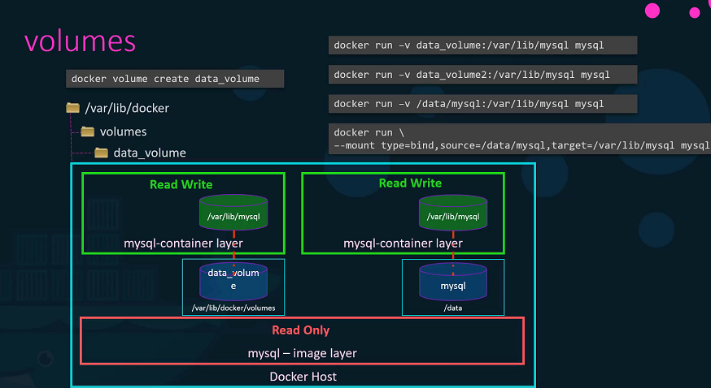](https://github.com/kodekloudhub/certified-kubernetes-administrator-course/blob/master/images/class8.PNG)

**Common Storage Drivers**

* AUFS
* ZFS
* BTRFS
* Device Mapper
* Overlay
* Overlay2
* To Selection of the storage drivers depends on the underlying OS. Docker will choose the best storage driver available automatically based on the operating system.

**Volume Driver Plugins in Docker**

* We discussed about Storage drivers. Storage drivers help to manage storage on images and containers.
* We have already seen that if you want to persist storage, you must create volumes. Volumes are not handled by the storage drivers. Volumes are handled by volume driver plugins. The default volume driver plugin is local.
* The local volume plugin helps to create a volume on Docker host and store its data under the /var/lib/docker/volumes/ directory.
* There are many other volume driver plugins that allow you to create a volume on third-party solutions like Azure file storage, DigitalOcean Block Storage, Portworx, Google Compute Persistent Disks etc.

[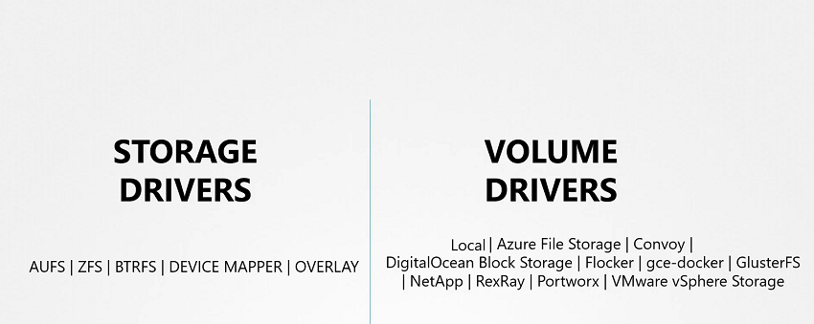](https://github.com/kodekloudhub/certified-kubernetes-administrator-course/blob/master/images/class9.PNG)

* When you run a Docker container, you can choose to use a specific volume driver, such as the RexRay EBS to provision a volume from the Amazon EBS. This will create a container and attach a volume from the AWS cloud. When the container exits, your data is safe in the cloud.

$ docker run -it --name mysql --volume-driver rexray/ebs --mount src=ebs-vol,target=/var/lib/mysql mysql

[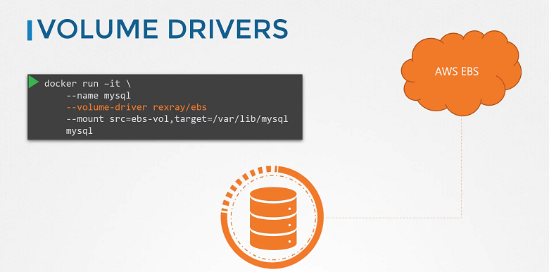](https://github.com/kodekloudhub/certified-kubernetes-administrator-course/blob/master/images/class10.PNG)

**Container Storage Interface**

* Take me to [Lecture](https://kodekloud.com/topic/container-storage-interface/)

In this section, we will take a look at **Container Storage Interface**

**Container Runtime Interface**

* Kubernetes used Docker alone as the container runtime engine, and all the code to work with Docker was embedded within the Kubernetes source code. Other container runtimes, such as rkt and CRI-O.
* The Container Runtime Interface is a standard that defines how an orchestration solution like Kubernetes would communicate with container runtimes like Docker. If any new container runtime interace is developed, they can simply follow the CRI standards.

[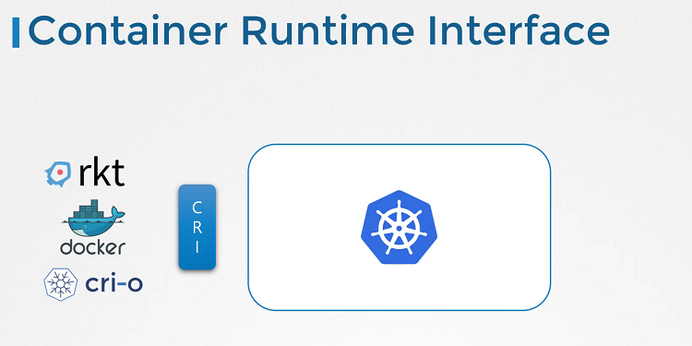](https://github.com/kodekloudhub/certified-kubernetes-administrator-course/blob/master/images/class11.PNG)

**Container Networking Interface**

* To support different networking solutions, the container networking interface was introduced. Any new networking vendors could simply develop their plugin based on the CNI standards and make their solution work with Kubernetes.

[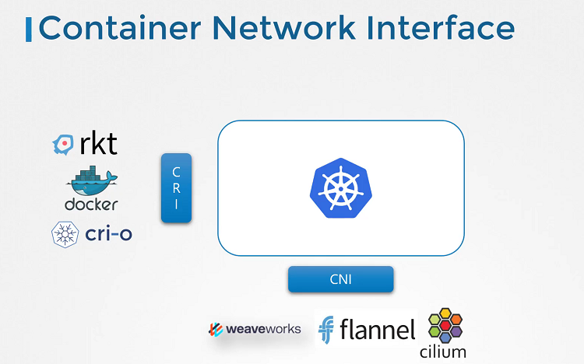](https://github.com/kodekloudhub/certified-kubernetes-administrator-course/blob/master/images/class12.PNG)

**Container Storage Interface**

* The container storage interface was developed to support multiple storage solutions. With CSI, you can now write your own drivers for your own storage to work with Kubernetes. Portworx, Amazon EBS, Azure Disk, GlusterFS etc.
* CSI is not a Kubernetes specific standard. It is meant to be a universal standard and if implemented, allows any container orchestration tool to work with any storage vendor with a supported plugin. Kubernetes, Cloud Foundry and Mesos are onboard with CSI.
* It defines a set of RPCs or remote procedure calls that will be called by the container orchestrator. These must be implemented by the storage drivers.

[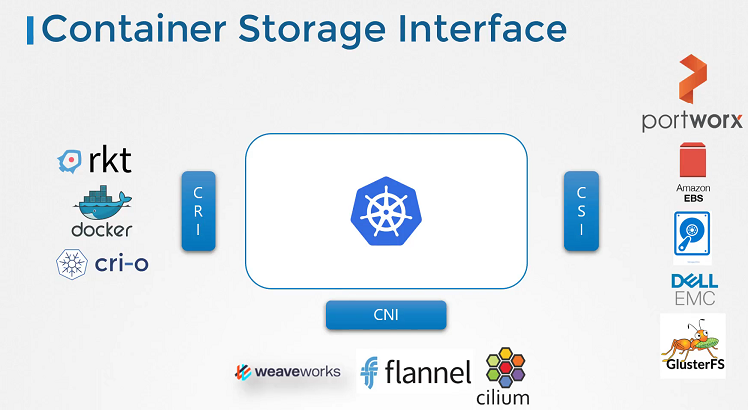](https://github.com/kodekloudhub/certified-kubernetes-administrator-course/blob/master/images/class13.PNG)

**Volumes**

* We discussed about Docker storage, If we don't attach the volume in the container runtime, when container destroyed and then all data will be lost. So, We need to persist data into the Docker container so we attach a volume to the containers when they are created.
* The data are processed by the container is now placed in this volume thereby retaining it permanently. Even if the container is deleted the data remains in the volume.
* In the Kubernetes world, the PODs created in Kubernetes are transient in nature. When a POD is created to process data and then deleted, the data processed by it gets deleted as well.
* For example, We create a simple POD that generated a random between 1 and 100 and writes that to a file at /opt/number.out. To persist into the volume.
* We create a volume for that. In this case I specify a path /data on the host. Files are stored in the directory data on my node. We use the volumeMounts field in each container to mount the data-volume to the directory /opt within the container. The random number will now be written to /opt mount inside the container, which happens to be on the data-volume which is in fact /data directory on the host. When the pod gets deleted, the file with the random number still lives on the host.

[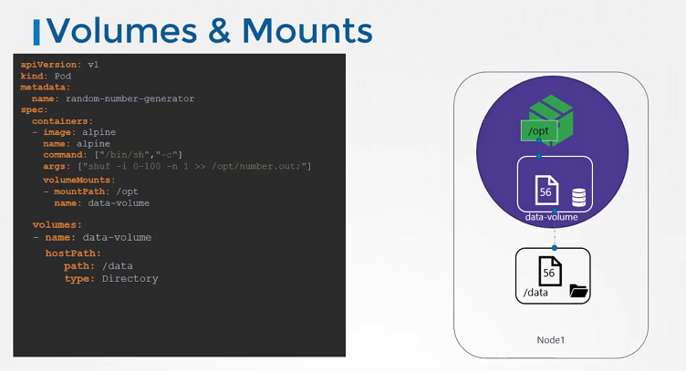](https://github.com/kodekloudhub/certified-kubernetes-administrator-course/blob/master/images/class14.PNG)

**Volume Storage Options**

* In the volumes, hostPath volume type is fine with the single node. It's not recomended for use with the multi node cluster.
* In the Kubernetes, it supports several types of standard storage solutions such as NFS, GlusterFS, CephFS or public cloud solutions like AWS EBS, Azure Disk or Google's Persistent Disk.

[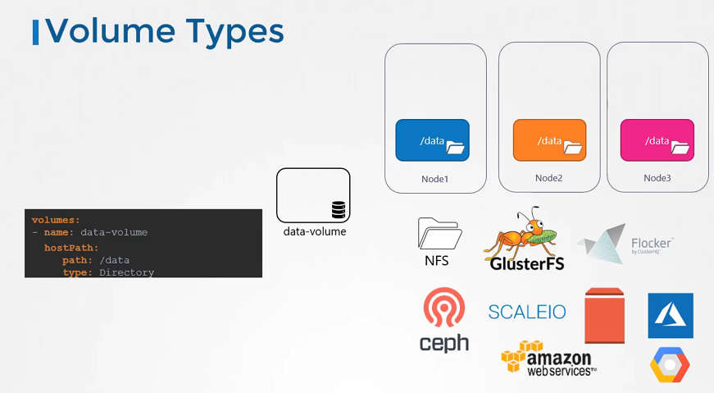](https://github.com/kodekloudhub/certified-kubernetes-administrator-course/blob/master/images/class15.PNG)

volumes:

- name: data-volume

awsElasticBlockStore:

volumeID: <volume-id>

fsType: ext4

**Persistent Volumes**

* Take me to [Lecture](https://kodekloud.com/topic/persistent-volumes-4/)

In this section, we will take a look at **Persistent Volumes**

* In the large evnironment, with a lot of users deploying a lot of pods, the users would have to configure storage every time for each Pod.
* Whatever storage solution is used, the users who deploys the pods would have to configure that on all pod definition files in his environment. Every time a change is to be made, the user would have to make them on all of his pods.

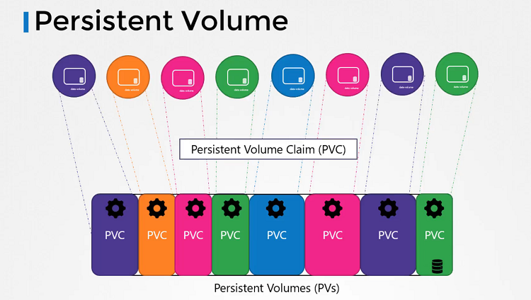

* A Persistent Volume is a cluster-wide pool of storage volumes configured by an administrator to be used by users deploying application on the cluster. The users can now select storage from this pool using Persistent Volume Claims.

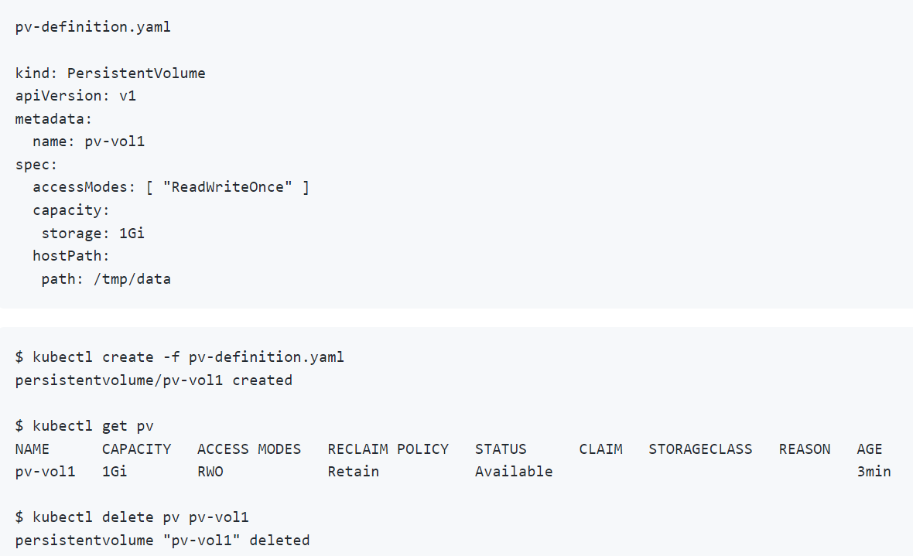

**Persistent Volume Claims**

* Take me to [Lecture](https://kodekloud.com/topic/persistent-volume-claims-4/)

In this section, we will take a look at **Persistent Volume Claim**

* Now we will create a Persistent Volume Claim to make the storage available to the node.
* Volumes and Persistent Volume Claim are two separate objects in the Kubernetes namespace.
* Once the Persistent Volume Claim created, Kubernetes binds the Persistent Volumes to claim based on the request and properties set on the volume.

[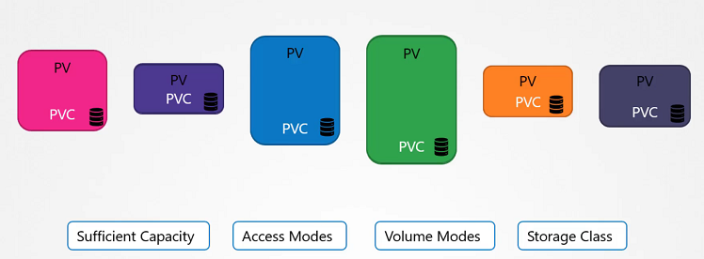](https://github.com/kodekloudhub/certified-kubernetes-administrator-course/blob/master/images/class17.PNG)

* If properties not matches or Persistent Volume is not available for the Persistent Volume Claim then it will display the pending state.

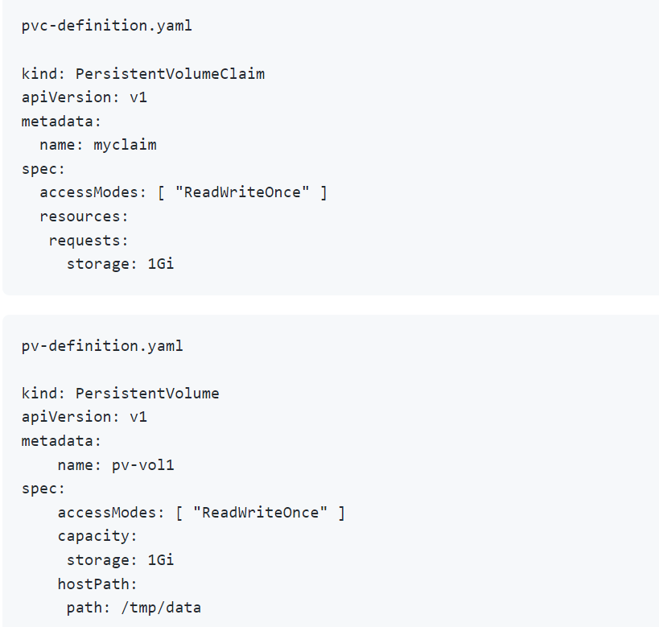

**Create the Persistent Volume**

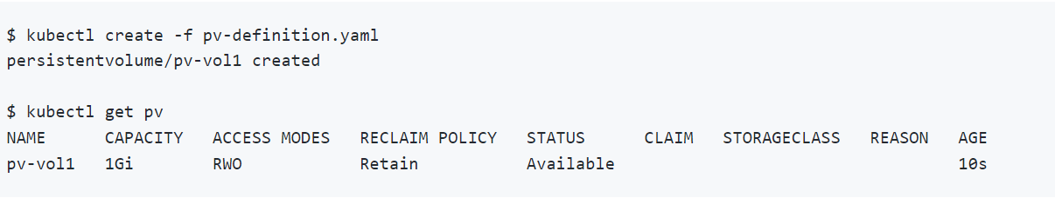

**Create the Persistent Volume Claim**

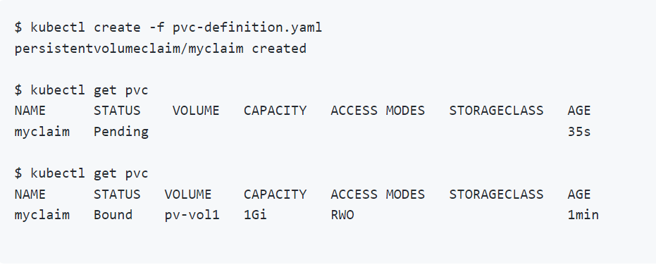

**Delete the Persistent Volume Claim**

$ kubectl delete pvc myclaim

**Delete the Persistent Volume**

$ kubectl delete pv pv-vol1

**Using PVCs in PODs**

Once you create a PVC use it in a POD definition file by specifying the PVC Claim name under persistentVolumeClaim section in the volumes section like this:

1. apiVersion: v1
2. kind: Pod
3. metadata:
4. name: mypod
5. spec:
6. containers:
7. - name: myfrontend
8. image: nginx
9. volumeMounts:
10. - mountPath: "/var/www/html"
11. name: mypd
12. volumes:
13. - name: mypd
14. persistentVolumeClaim:
15. claimName: myclaim

The same is true for ReplicaSets or Deployments. Add this to the pod template section of a Deployment on ReplicaSet.

**Storage Class**

* We discussed about how to create Persistent Volume and Persistent Volume Claim and We also saw that how to use into the Pod's volume to claim that volume space.
* We created Persistent Volume but before this if we are taking a volume from Cloud providers like GCP, AWS, Azure. We need to first create disk in the Google Cloud as an example.
* We need to create manually each time when we define in the Pod definition file. that's called **Static Provisioning**.

**Static Provisioning**

[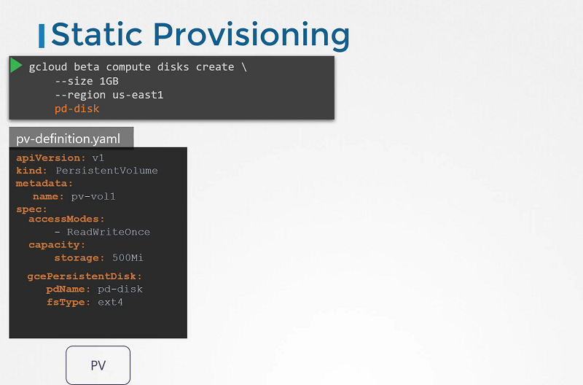](https://github.com/kodekloudhub/certified-kubernetes-administrator-course/blob/master/images/class18.PNG)

**Dynamic Provisioning**

[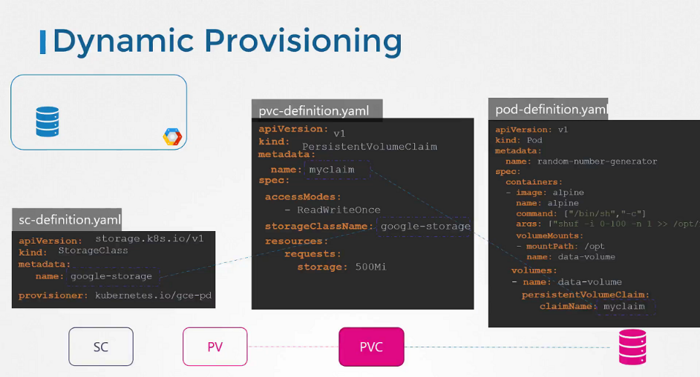](https://github.com/kodekloudhub/certified-kubernetes-administrator-course/blob/master/images/class19.PNG)

* No we have a Storage Class, So we no longer to define Persistent Volume. It will create automatically when a Storage Class is created. It's called **Dynamic Provisioning**.

sc-definition.yaml

apiVersion: storage.k8s.io/v1

kind: StorageClass

metadata:

name: google-storage

provisioner: kubernetes.io/gce-pd

**Create a Storage Class**

$ kubectl create -f sc-definition.yaml

storageclass.storage.k8s.io/google-storage created

**List the Storage Class**

$ kubectl get sc

NAME PROVISIONER RECLAIMPOLICY VOLUMEBINDINGMODE ALLOWVOLUMEEXPANSION AGE

google-storage kubernetes.io/gce-pd Delete Immediate false 20s

**Create a Persistent Volume Claim**

pvc-definition.yaml

kind: PersistentVolumeClaim

apiVersion: v1

metadata:

name: myclaim

spec:

accessModes: [ "ReadWriteOnce" ]

storageClassName: google-storage

resources:

requests:

storage: 500Mi

$ kubectl create -f pvc-definition.yaml

**Create a Pod**

pod-definition.yaml

apiVersion: v1

kind: Pod

metadata:

name: mypod

spec:

containers:

- name: frontend

image: nginx

volumeMounts:

- mountPath: "/var/www/html"

name: web

volumes:

- name: web

persistentVolumeClaim:

claimName: myclaim

$ kubectl create -f pod-definition.yaml

**Provisioner**

[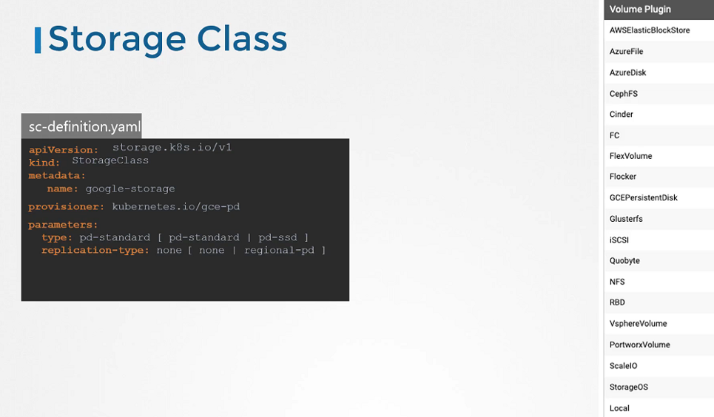](https://github.com/kodekloudhub/certified-kubernetes-administrator-course/blob/master/images/class20.PNG)

**Network**

**Docker Networking**

None Network ..> docker container will not attach to any network

Running docker container with none network

$ docker run --network none nginx

Host Network ..> docker container will attach to the host network

Running docker container with host network

$ docker run --network host nginx

Bridge Network ..> new virtual network in the docker host

Running docker container with bridge network

$ docker run --network bridge nginx

List the Docker Network

* When Docker is installed on the host, it creates an internal private network called Bridge by default.

$ docker network ls

NETWORK ID NAME DRIVER SCOPE

4974cba36c8e bridge bridge local

0e7b30a6c996 host host local

a4b19b17d2c5 none null local

* Docker calls the network by the name Bridge, but on the host, the network is created by the name Docker0.

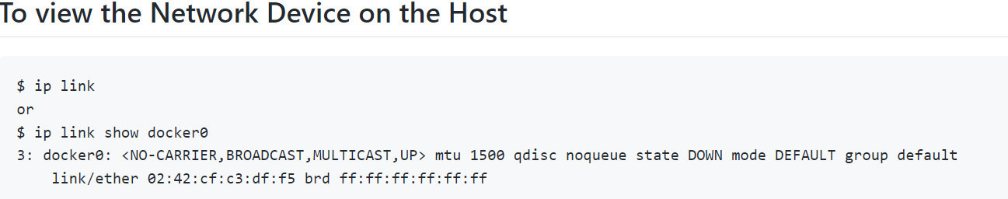

* the bridge network is like an interface to the host but a switch to the namespaces or containers within the host.
* Whenever a container is created, Docker creates a network namespace for it. Just like how we created network namespaces

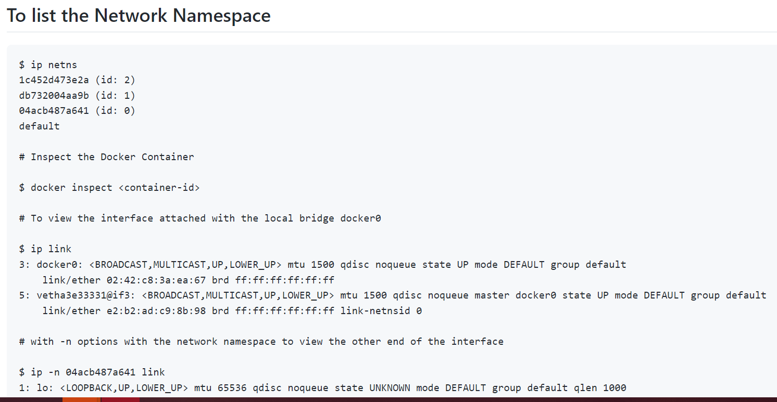

* how does Docker attach the container to the bridge?

it creates a cable, a virtual cable, with two interfaces on each end.

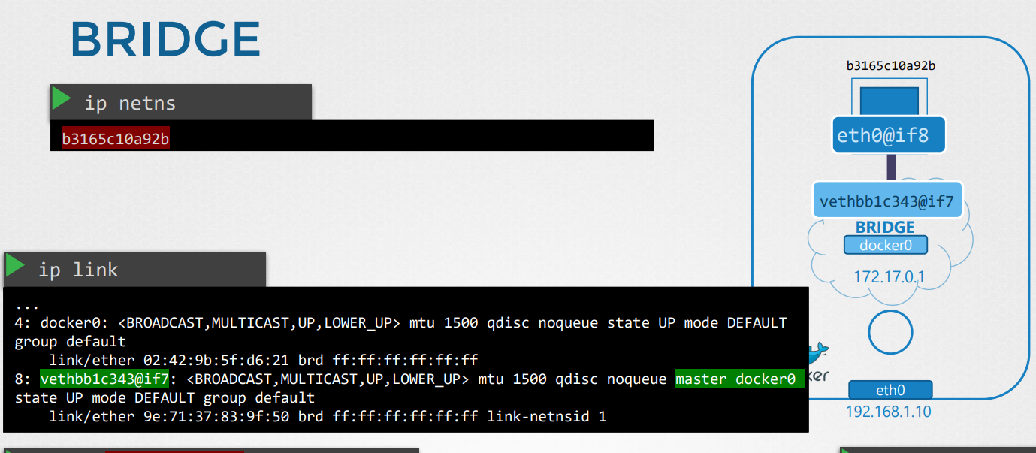

Let's find out what Docker has created here. If you run the IP link command on the Docker host, you see one end of the interface which is attached to the local bridge, Docker0. If you run the same command again, this time with the -n option with a namespace.

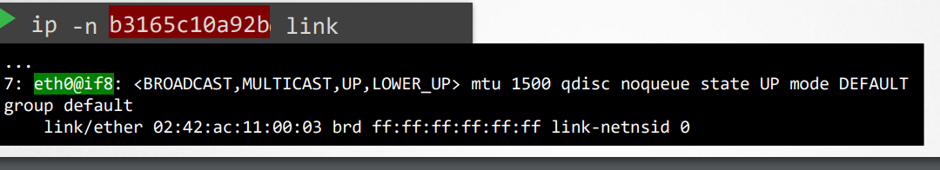

then it lists the other end of the interface within the container namespace. The interface also gets an IP assigned within the network. You can view this by running the IP ADDR command, but within the container's namespace.

The container gets assigned 172.17.0.3.

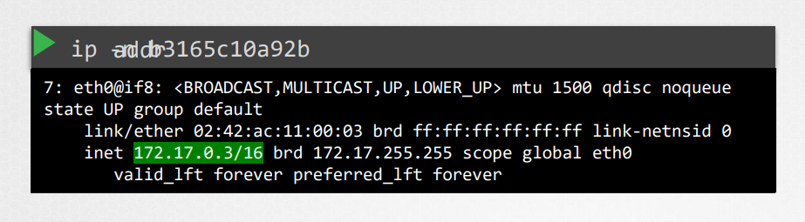

You can also view this by attaching to the container and looking at the IP address assigned to it that way. The same procedure is followed every time a new container is created.

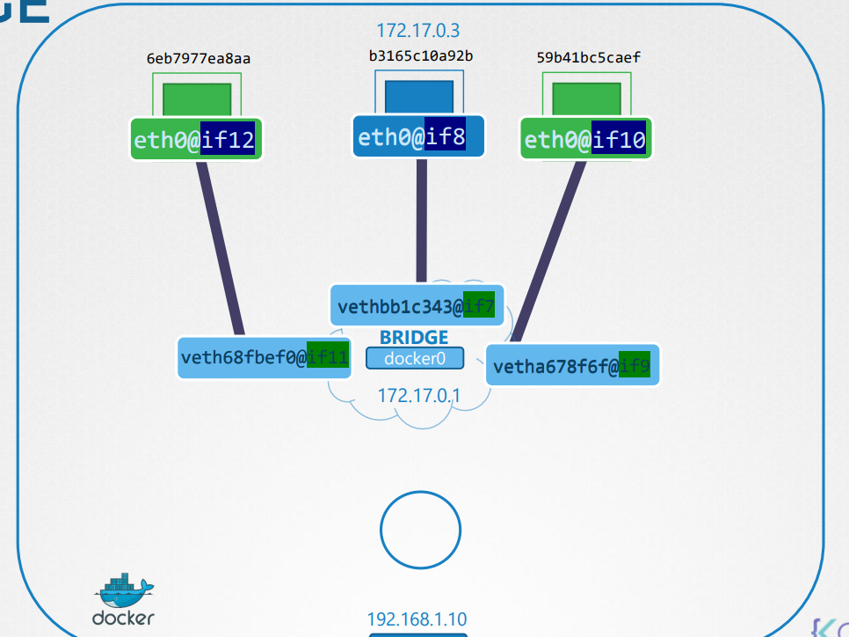

Port mapping

* To allow external users to access the applications hosted on containers, Docker provides a port publishing, or port mapping, option. When you run containers, tell Docker to map port 8080 on the Docker host to port 80 on the container.

With that done, you could access the web application using the IP of the Docker host and port 8080. Any traffic to port 8080 on the Docker host will be forwarded to port 80 on the container.

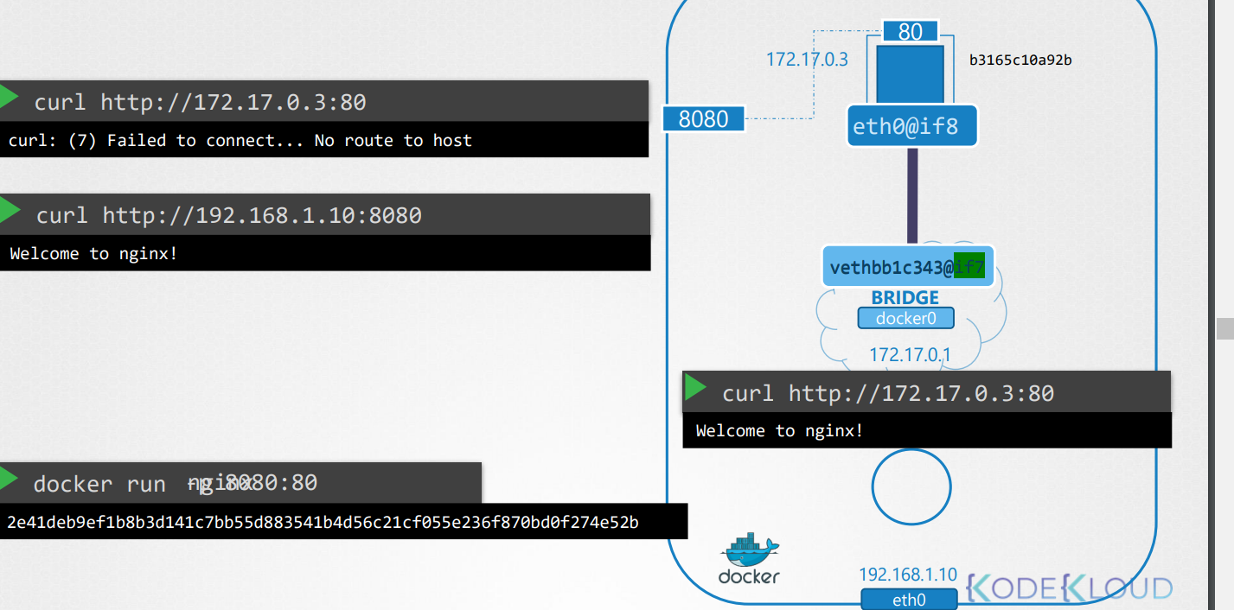

* How does it forward traffic from one port to another? Well, what would you do? Let's forget about Docker and everything else for a second. The requirement is to forward traffic coming in on one port to another port on the server. We create a NAT rule for that. Using IP tables, we create an entry into the NATs table to append the rules to the prerouting chain to change the destination port from 8080 to 80. Docker does it the same way. Docker adds the rule to the Docker chain and sets destination to include the container's IP as well.

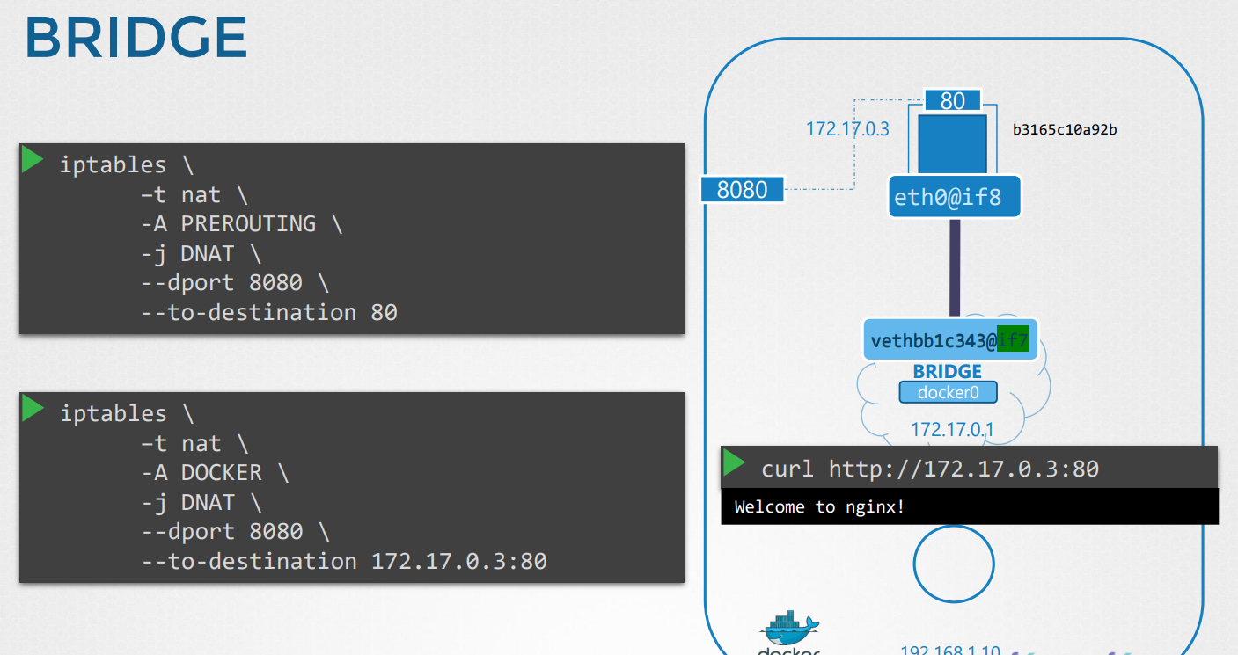

**CNI (container network interface)**

* we created a program or script that performs all the required tasks to get the container attached to a bridge network. For example, you could run this program

using its name, Bridge and specify that you want to add this container to a particular network name space. The Bridge program takes care of the rest

so that the container runtime environments are relieved of those tasks. For example, when Rocket or Kubernetes creates a new container, they call the Bridge Program and pass the container ID and namespace to get networking configured for that container.

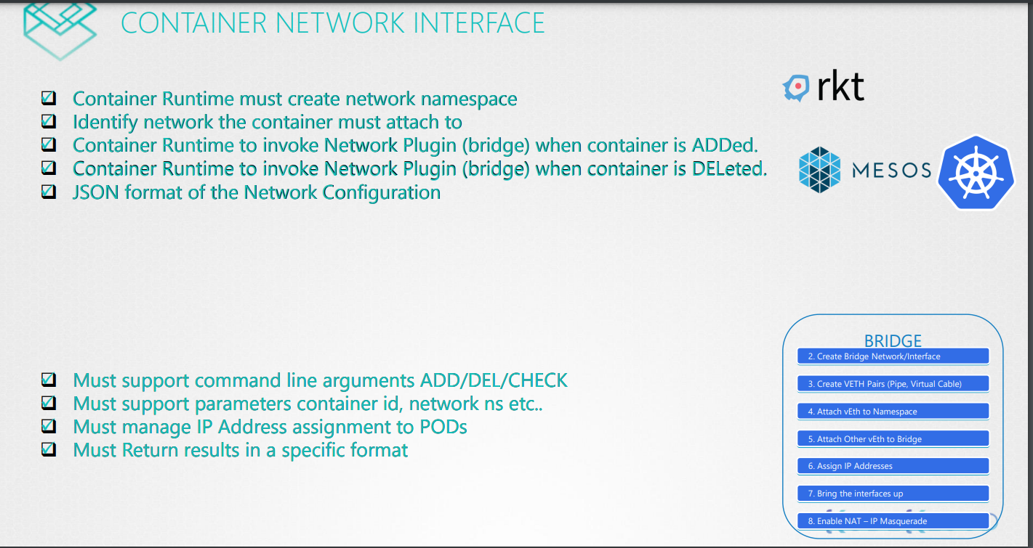

**Network Cluster**

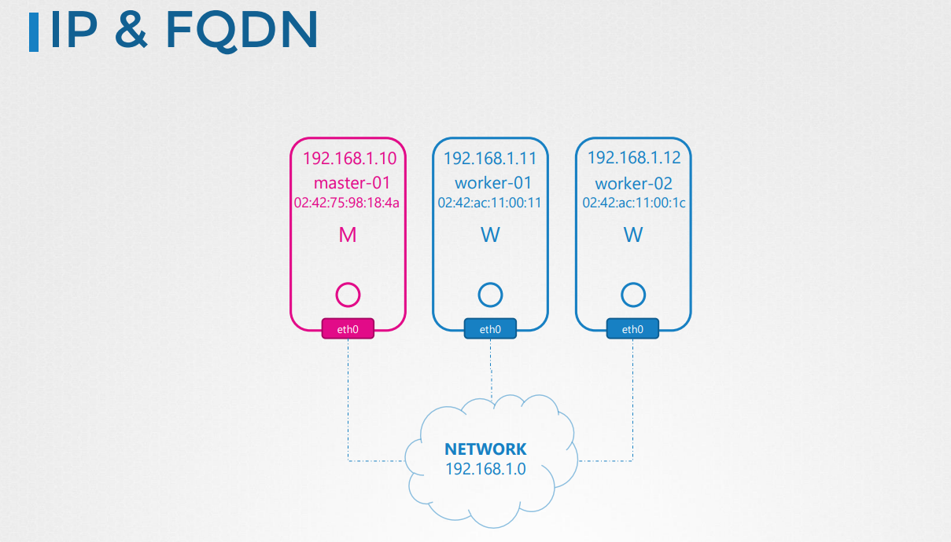

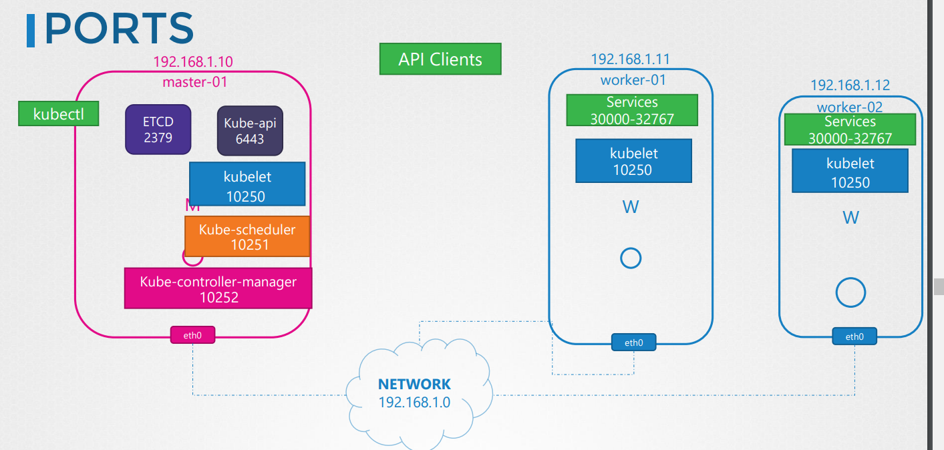

**Pod Networking**

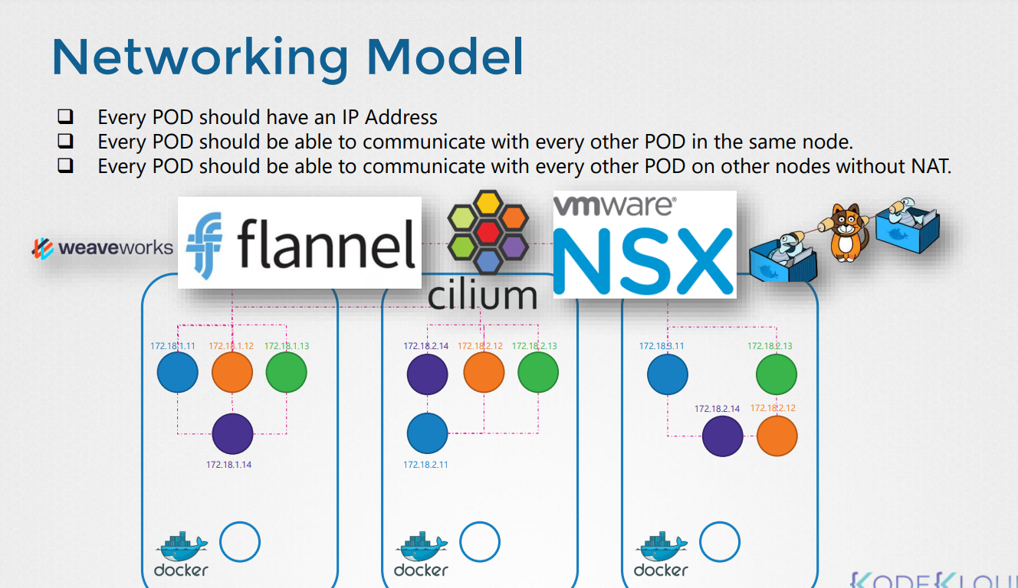

* Kubernetes does not come with a built-in solution for this. It expects you to implement a networking solution that solves these challenges. However, Kubernetes have laid out clearly the requirements for Pod networking.

Let's take a look at what they are. Kubernetes expects every Pod

to get its own unique IP address, and that every Pod should be able to reach every other Pod within the same node using that IP address. And every Pod should be able to reach every other Pod on other nodes as well, using the same IP address. It doesn't care what IP address that is and what range or subnet it belongs to. As long as you can implement a solution that takes care of automatically assigning IP addresses and establish connectivity between the Pods in a node as well as parts on different nodes, you're good, without having to configure any net rules.

* how do you implement a model that solves these requirements?

Now, there are many networking solutions available out there that does these,

but we've already learned about networking concepts, routing, IP address management, namespaces, and CNI.

So let's try to use that knowledge

* to solve this problem by ourselves first. This will help in understanding how other solutions work. I know there is a bit of repetition, but I'm trying to relate the same concept and approach all the way from plain network namespaces on Linux,

all the way to Kubernetes.

* So we have a three node cluster. It doesn't matter which one is master or worker.

They all run Pods, either for management or workload purposes. As far as networking is concerned, we're going to consider all of them as the same. So first, let's plan what we are going to do.

* The nodes are part of an external network, and has IP addresses in the 192.168.1. series. Node one is assigned 11, node two is 12,and node three is 13.
* Next step, when containers are created, Kubernetes creates network namespaces for them. To enable communication between them, we attach these namespaces to a network. But what network?
* We've learned about bridge networks that can be created within nodes to attach namespaces.
* So we create a bridge network on each node and then bring them up.

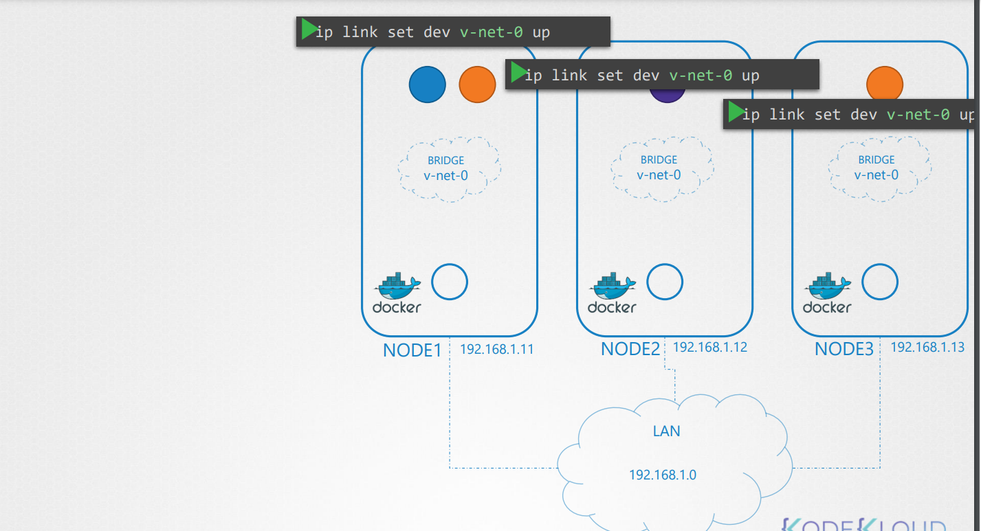

* To add bridge network on each node

node01

$ ip link add v-net-0 type bridge

$ ip link set dev v-net-0 up

* It's time to assign an IP address to the bridge interfaces, or networks.
* But what IP address? We decide that each bridge network will be on its own subnet. Choose any private address range, say, 10.244.1.0, 10.244.2.0, and 10.244.3.0
* Next, we set the IP address for the bridge interface. So we have built our base.
* Set the IP Addr for the bridge interface

node01

$ ip addr add 10.244.1.1/24 dev v-net-0

node02

$ ip addr add 10.244.2.1/24 dev v-net-0

node03

$ ip addr add 10.244.3.1/24 dev v-net-0

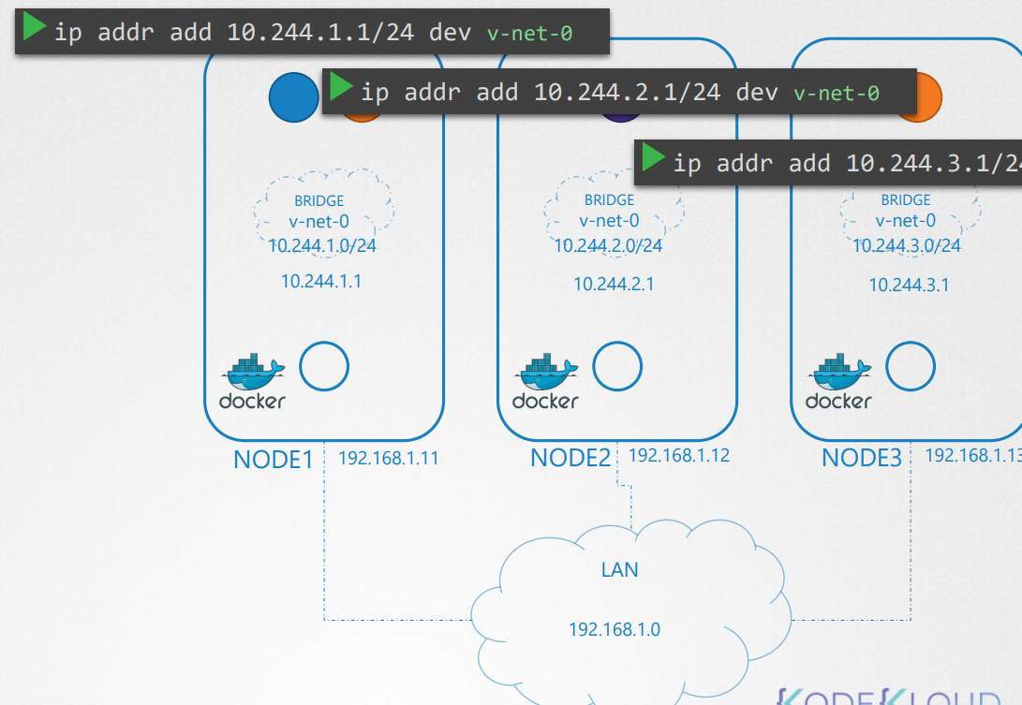

* The remaining steps are to be performed for each container, and every time a new container is created. So we write a script for it.
* Now, you don't have to know any kind of complicated scripting. It's just a file that has all commands we will be using, and we can run this multiple times for each container going forward.
* To attach a container to the network we need a pipe, or virtual network cable.

We create that using the ip link add command

* then attach one end to the container, and another end to the bridge using the ip link set command.
* We then assign IP address using the ip addr command.
* add a route to the default gateway.

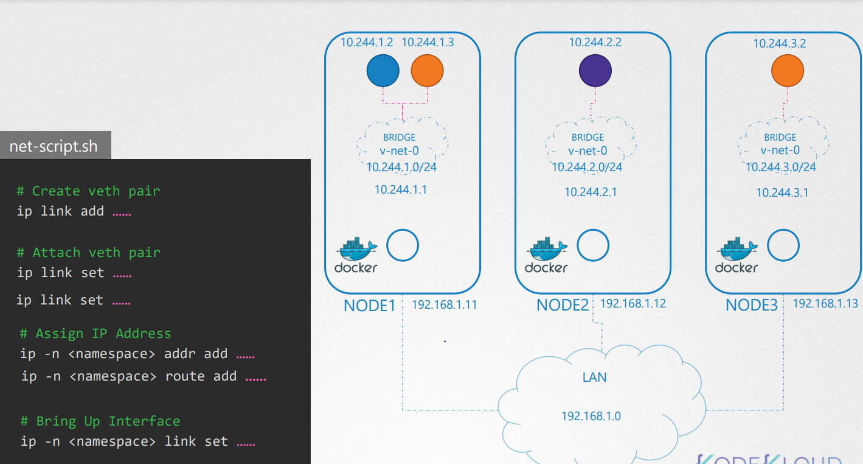

* But what IP do we add? We either manage that ourselves or store that information in some kind of database. For now, we will assume it is 10.244.1.2, which is a free IP in the subnet. We discuss about IP address management in details.
* Finally bring up the interface. So we have solved the first part of the challenge. The Pods all get their own unique IP address, and are able to communicate with each other on their own nodes.
* The next part is to enable them to reach other Pods on other nodes. a better solution is to do that on a router, if you have one in your network, and point all hosts to use that as the default gateway. That way you can easily manage routes to all networks in the routing table on the router.With that, the individual virtual networks we created with the address 10.244.1.0/24 on each node now form a single large network with the address 10.244.0.0/16.

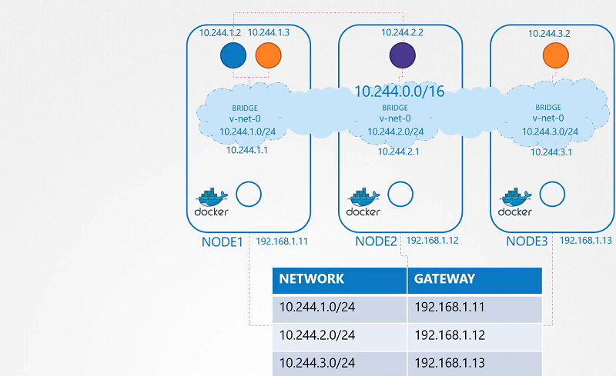

* So how do we run the script automatically when a Pod is created on Kubernetes?

That's where CNI comes in, acting as the middleman. CNI tells Kubernetes

that this is how you should call a script as soon as you create a container.

And CNI tells us this is how your script should look like.

* So we need to modify the script a little bit to meet CNI standards. It should have an add section that will take care of adding a container to the network,

and a delete section that will take care of deleting container interfaces from the network, and freeing the IP address, et cetera. So our script is ready.

* The kubelet on each node is responsible for creating containers. Whenever a container is created, the kubelet looks at the CNI configuration, passed as a command line argument when it was run, and identifies our script's name.

It then looks in the CNI's bin directory to find our script and then executes the script with the add command and the name and namespace ID of the container.

And then our script takes care of the rest.

* We will look at how and where the CNI is configured in Kubernetes.

CNI in Kubernetes

we will take a look at Container Networking Interface (CNI) in Kubernetes

Configuring CNI

[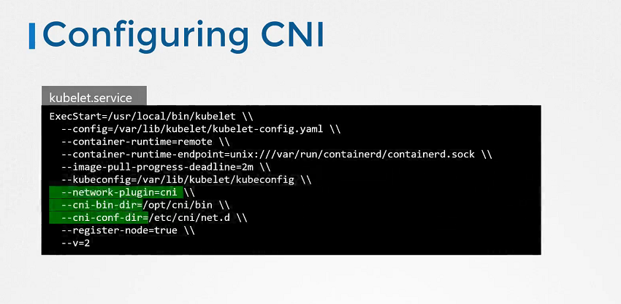](https://github.com/kodekloudhub/certified-kubernetes-administrator-course/blob/master/images/net1.PNG)

* Check the status of the Kubelet Service

$ systemctl status kubelet.service

View Kubelet Options

$ ps -aux | grep kubelet

Check the Supportable Plugins

* To check the all supportable plugins available in the /opt/cni/bin directory.

$ ls /opt/cni/bin

* The CNI bin directory has all the supported CNA plugins as executables,

such as the bridge, dscp, flannel, et cetera. The CNI config directory has a set of configuration files. This is where kubelet looks to find out which plugin needs to be used. In this case, it finds the bridge configuration file. If there are multiple files here it will choose the one in alphabetical order.

Check the CNI Plugins

* To check the cni plugins which kubelet needs to be used.

ls /etc/cni/net.d

Format of Configuration File

[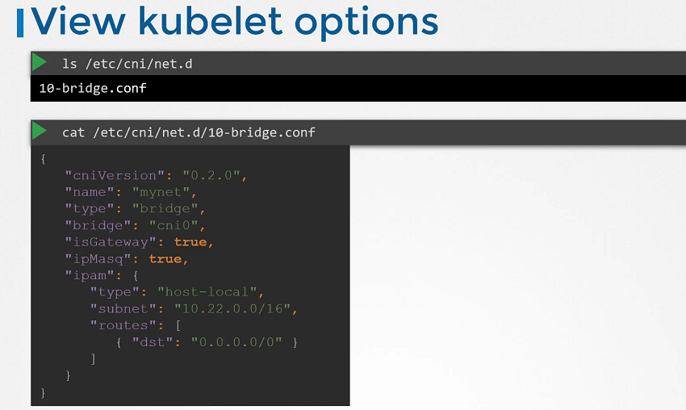](https://github.com/kodekloudhub/certified-kubernetes-administrator-course/blob/master/images/net2.PNG)

* If you look at the bridge con file, it looks like this. This is a format defined by the CNI standard for a plug-in configuration file. It's name is MyNet. Type is bridge.
* It also has a set of other configurations which can be related to the concepts we discussed.
* on bridging routing, and masquerading. In that the IS gateway defines whether the bridge network should get an IP address assigned to it so that it can act as a gateway.
* The IP masquerade defines if a NAT rule should be added for IP masquerading.
* The IPAM section defines IPAM configuration.
* This is where you specify the subnet or the range of IP addresses that will be assigned to pods and any necessary routes. The type host local indicates that the IP addresses are managed locally on this host unlike DHCP server, maintaining it remotely. The type can also be set to DHCP to configure an external DHCP server.
* the networking solution we set up manually had a routing table which mapped

what networks are on what hosts. So when a packet is sent from one pod to the other, it goes out to the network, to the router and finds it's way to the node that hosts that pod.

* Now that works for a small environment and in a simple network, but in larger environments with hundreds of nodes in a cluster and hundreds of pods on each node, this is not practical. The routing table may not support so many entries

and that is where you need to get creative and look for other solutions.

**CNI weave**

* How weaves works?
* the Weave CNI plugin is deployed on a cluster, it deploys an agent or service on each node. They communicate with each other to exchange information regarding the nodes and networks and pods within them.
* Each agent or peer stores (indistinct) of the entire setup that way they know the pods and their IPs on the other nodes. Weave creates its own bridge on the nodes and names.
* Weave then assigns IP address to each network.
* Remember that a single pod may be attached to multiple bridge networks. For example, you could have a pod attached to the Weave Bridge as well as the Docker bridge created by Docker. What path a packet takes to reach destination depends on the route configured on the container. We've made sure that pods gets the correct route configured to reach the agent and the agent then takes care of other pods. Now, when a packet is sent from one pod to another on another node, Weave intercepts the packet and identifies that it's on a separate network. It then encapsulates this packet into a new one with new source and destination and sends it across the network. Once on the other side the other Weave agent retrieves the packet, decapsulates it and routes the packet to the right pod.
* If you deployed your cluster with a Cube ADM tool and Weave plugin, you can see the Weave peers as parts deployed on each node.
* Installing [weave net](https://www.weave.works/docs/net/latest/kubernetes/kube-addon/) onto the Kubernetes cluster with a single command.

$ kubectl apply -f "https://cloud.weave.works/k8s/net?k8s-version=$(kubectl version | base64 | tr -d '\n')"

## View the logs of Weave Pod's

$ kubectl logs weave-net-tb9tz weave -n kube-system

**IPAM weave (IP Address Management)**

* we discuss about IP address management. So how does IP address management work and Kubernetes? This section does not concern the IP address assigned to the nodes in the network. You can manage that on your own or with your own external IPAM solutions. What this section covers is how are the virtual bridge networks in the nodes assigned an IP subnet and how are the pods assigned an IP? Where is this information stored? And who is responsible for ensuring there are no duplicate IP's assigned? Let's start with the who.
* Let's ask CNI as they're the ones who define the standards. CNI says, it is the responsibility of the CNI plugin the network solution provider to take care of assigning IP's to the containers.
* Remember the basic plugin we built earlier? We actually took care of assigning IP addresses within this plugin. There was a section for assigning IP to the container network namespace.

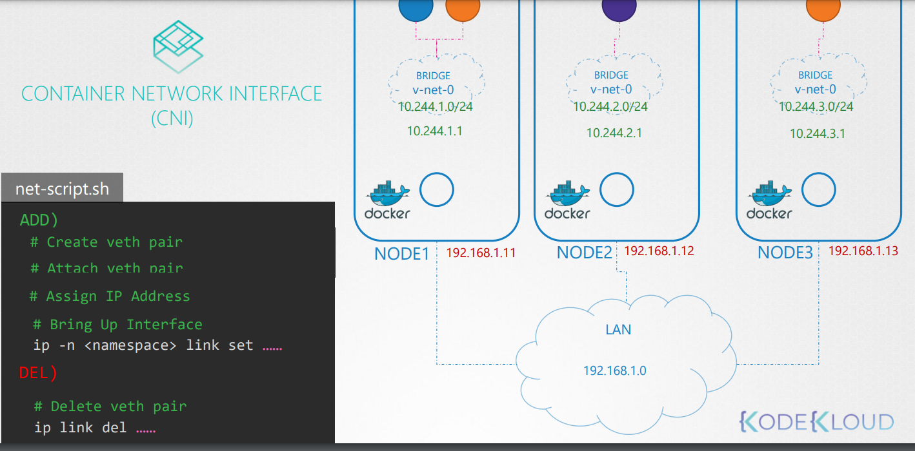

* But how do we manage these IP's?
* Now, Kubernetes doesn't care how we do it. We just need to do it by making sure we don't assign any duplicate IP's and manage it properly. And easy way to do it is to store the list of IP's in a file and make sure we have necessary code in our script to manage this file properly.
* This file will be placed on each host and manages the IP's of parts on those nodes.

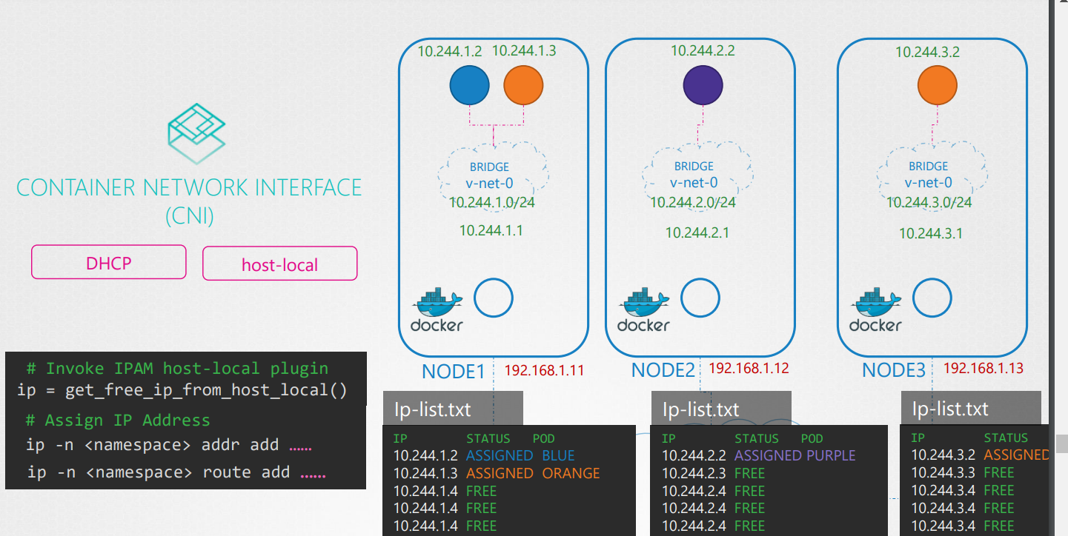

* Instead of coding that ourselves in our script, CNI comes with two built-in plug-ins to which you can outsource this task too.
* In this case, the plug-in that implements the approach that we followed for managing the IP addresses locally on each host is the host local plugin. But it is still our responsibility to invoke that plugin in our script, or we can make our script dynamic to support different kinds of plugins.
* The CNI configuration file has a section called IPAM in which we can specify the type of plugin to be used, the subnet and route to be used.
* These details can be read from our script to invoke the appropriate plugin instead of hard coding it to use host local every time.

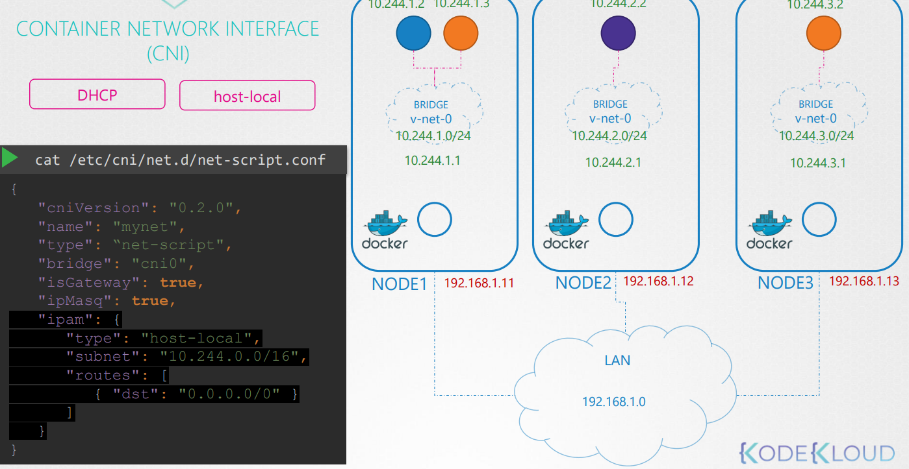

* Different network solution providers does it differently.
* Let's see how Weaveworks manages IP addresses.
* In fact, you have seen some of the IP's assigned by Weave in the previous practice test. Weave, by default, allocates the IP range 10.32.0.0/12 for the entire network.
* That gives the network IP's from range 10.32.0.1 to 10.47.255.254. That's about a million IP's that you can use for pods on the network. From this range, the peers decide to split the IP addresses. equally between them and assigns one portion to each node. Pods created on these nodes will have IP's in this range. Of course, these ranges are configurable with additional options past while deploying the Weave plugin to a cluster.

**Service Network**

* we talked about pod networking. How bridge networks are created within each node, and how pods get a namespace created for them, and how interfaces are attached to those namespaces, and how pods get an IP address assigned to them within this subnet assigned for that node. And we also saw through routes or other overlay techniques, we can get the pods in different nodes, to talk to each other, forming a large virtual network where all pods can reach each other.
* Now, you would rarely configure your pods to communicate directly with each other.
* If you want a pod to access services hosted on another pod, you would always use a service.
* Let's quickly recap the different kinds of services. To make the orange pod accessible to the blue pod, we create an orange service. The orange service gets an IP address, and a name assigned to it. The blue pod can now access the orange pod through the orange services IP or it's name.

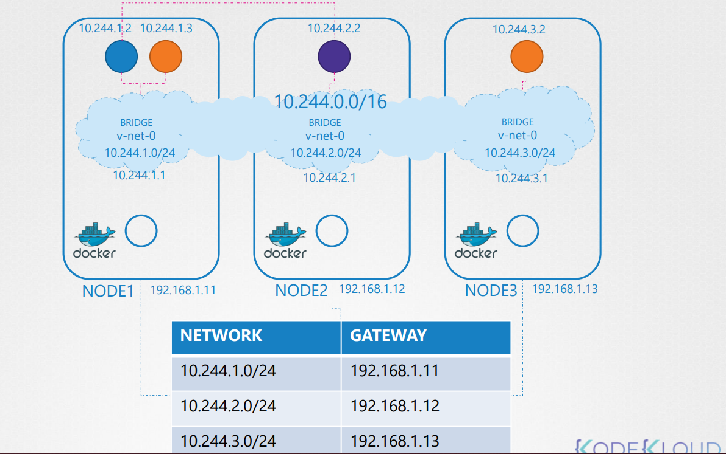

* The blue and orange pods are on the same node. What about access from the other pods, on other nodes? When a service is created, it is accessible from all pods on the cluster, irrespective of what nodes the pods are on. While a pod is hosted on a node, a service is hosted across the cluster. It is not bound to a specific node,but remember, the service is only accessible from within the cluster. this type of service is known as cluster IP.
* If the orange pod was hosting a database application, that is to be only accessed from within the cluster, then this type of service works just fine.
* Say for instance, the purple pod was hosting a web application to make the application on the pod accessible outside the cluster, we create another service of type node port. This service also gets an IP address assigned to it and works just like cluster IP, as in all the other pods can access the service using it's IP.

But in addition, it also exposes the application on a port, on all nodes in the cluster. That way external users, or applications, have access to the service.

So, that's the topic of our discussion.

* Our focus is more on services, and less on pods. How are the services getting these IP addresses, and how are they made available across all the nodes in the cluster?
* How is the service made available to external users, through a port on each node? Who is doing that? and how, and where do we see it?
* Let's start on a clean slate. We have a three node cluster No pods or services yet.
* We know that every Kubernetes node runs a kubelet process, which is responsible for creating pods. Each kubelet service on each node watches the changes in the cluster through the kube API server, and every time a new pod is to be created, it creates the pod on the nodes.
* It then invokes the CNI plugin to configure networking for that pod.
* Similarly, each node runs another component, known as Kube-proxy.
* Kube-proxy watches the changes in the cluster through Kube API server, and every time a new service is to be created, Kube-proxy gets into action.
* Unlike pods, services are not created on each node, or assigned to each node. Services are a cluster-wide concept. They exist across all the nodes in the cluster.
* As a matter of fact, they don't exist at all. There is no server, or service, really listening on the IP of the service.
* We have seen that pods have containers, and containers have namespaces with interfaces and Ips assigned to those interfaces. with services, nothing like that exists. There are no processes, or namespaces, or interfaces for a service.
* It's just a virtual object.
* Then how do they get an IP address and how are we able to access the application on the pod, through service?
* When we create a service object in Kubernetes, it is assigned an IP address from a predefined range.
* The kube-proxy components running on this node gets that IP address, and creates forwarding rules on each node in the cluster. Saying, any traffic coming to this ip, the IP of the service, should go to the IP of the pod. Once that is in place, whenever a pod tries to reach the IP of the service, it is forwarded to the pod's IP address, which is accessible from any node in the cluster.
* Now remember, it's not just the IP, it's an IP, and port combination. Whenever services are created, or deleted, the kube-proxy component creates or deletes these rules. So how are these rules created?
* Kube-proxy supports different ways, such as userspace, where kube-proxy listens on a port for each service, and proxies connections to the pods by creating IPVS rules. Or the third, and the default option, and the one familiar to us, is using IP tables. The proxy mode can be set using the proxy mode option, while configuring the kube-proxy service. If this is not set, it defaults to IP tables.
* So we'll see how IP tables are configured by kube-proxy, and how you can view them on the nodes.
* We have a pod named DB, deployed on node one.
* It has IP address, 10.244.1.2.
* We create a service of type cluster IP, to make this pod available within the cluster. When the service is created, Kubernetes assigns an IP address to it. It is set to 10.103.132.104. This range is specified in the Kube API servers option, called service cluster IP range, which is by default, is set to 10.0.0.0/24.
* In my case, if I look at my Kube API server option, I see it is set to 10.96.0.0/12. That gives my services IP anywhere from 10.96.0.0 to 10.111.255.255.
* A relative point to mention here, when I set up my POD networking, I provided a pod network CIDR range of 10.244.0.0/16. which gives my pods IP addresses from 10.244.0.0 to 10244.255.255.
* The reason I brought this up here, is because whatever range you specify for each of these networks, it shouldn't overlap, which it doesn't, in this case. Both of these should have its own dedicated range of IPs to work with. There shouldn't be a case where a pod, and a service, are assigned the same IP address.
* So getting back to services, that's how my service got an IP address of 10.103.132.104. You can see the rules created by Kube-proxy in the IP tables net table output. Search for the name of the service, as all rules created by Kube-proxy, have a comment with the name of the service on it.
* 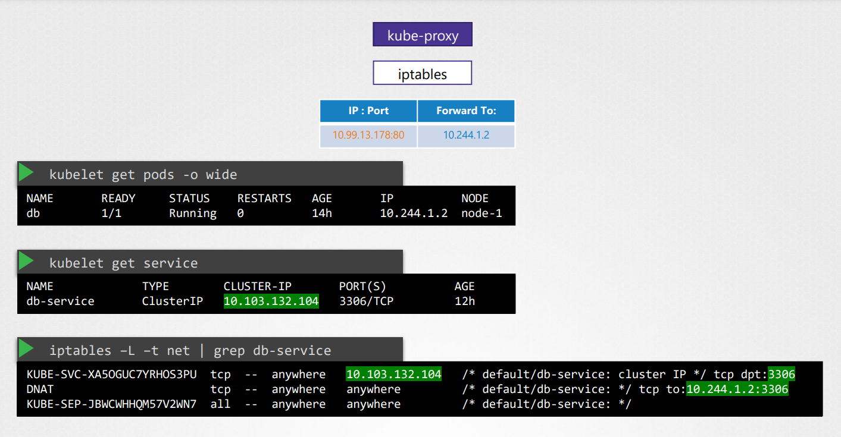
* These rules mean any traffic going to the IP address, 10.103.132.104 on port 3306, which is the IP of the service, should have its destination address changed to 10.244.1.2 and port 3306, which is the IP of the pod.
* This is done by adding a DNAT rule to IP tables.
* Similarly, when you create a services of type node port, Kube-proxy creates IP table rules to forward all traffic coming on a port on all nodes to the respective backend pods.
* You can also see kube-proxy create these entries in the kube-proxy logs, itself. In the logs, you will find what proxy it uses. In this case, it's IP tables, and then adds an entry when it added a new service for the database.
* Note, that the location of this file might vary depending on your installation. If you don't see these entries, you must also check the verbosity level of the process, as well.

**Kubernetes DNS**

* Kubernetes deploys a built-in DNS server by default when you set up a cluster. if you set up Kubernetes manually, then you do it by yourself.

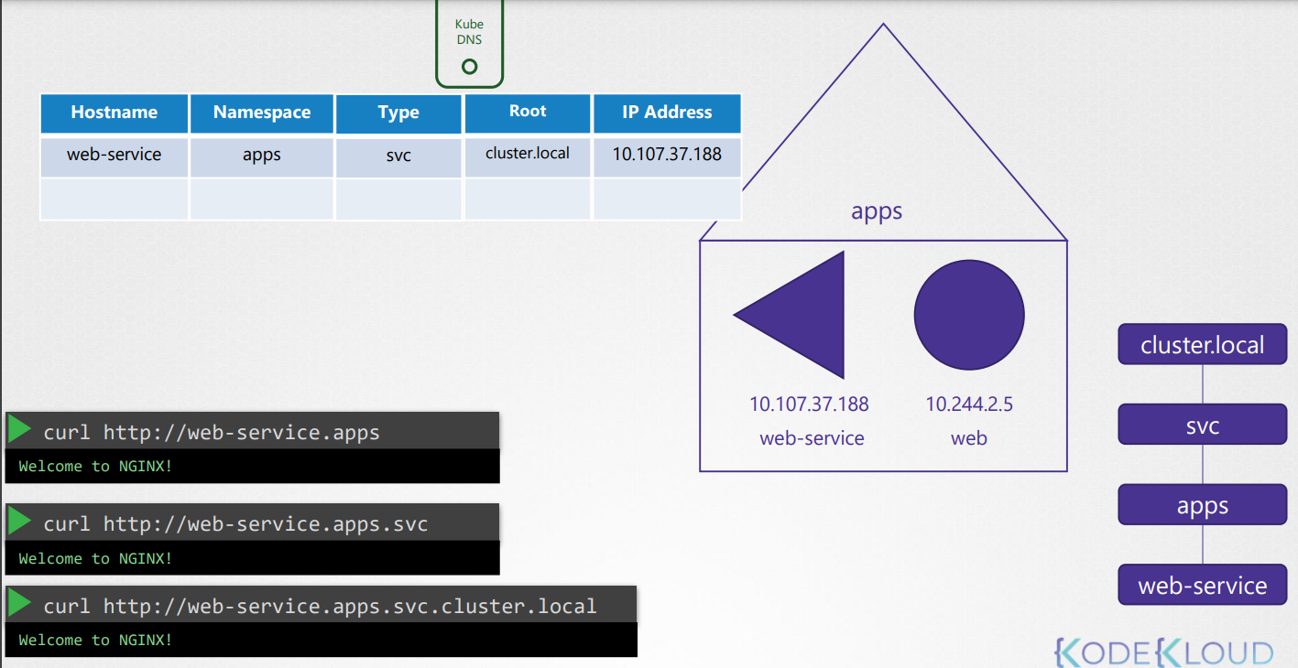

* Web Service is the name of the service, and Apps is the name of the name space.
* For each name space the DNS server creates a Sub domain.
* All the services are grouped together into another Sub Domain called SVC.
* So what was that about?
* Let's take a closer look. Web service is the name of the service and Apps is the name of the name space. For each name space, the DNS server creates a Sub domain with its name. All pods and services for a name space are thus grouped together within a Sub domain in the name of the name space. All the services are further grouped together. into another Sub domain called SVC. So you can reach your application, with the name webservice.apps.svc.
* Finally, all the services and pods are grouped together, into a route domain for the cluster, which is set to cluster.local by default. So you can access the service using the URL
* webservice.apps.svc.cluster.local and that's the fully qualified domain name for the service.
* So that's how services are resolved within the cluster.
* What about pods?
* Records for pods are not created by default, but we can enable that explicitly. We will see that in the next lecture.
* Once enabled records are created for pods as well. It does not use the pod name though.
* For each pod, Kubernetes generates a name by replacing the dots in the IP address with dashes.
* The name space remains the same and type is set to pod.
* The route domain is always cluster.local
* Similarly, the test pod in the default name space gets a record in the DNS server with its IP converted to a dash host name,
* 10- 244-1-5 and namespace set to default.
* Type is pod and the route is cluster.local

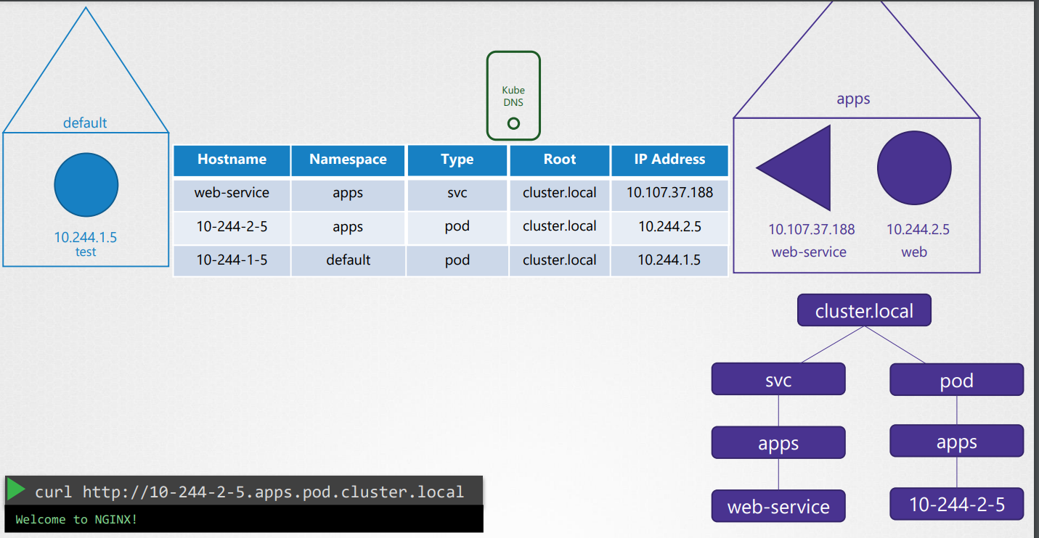

**CoreDNS**

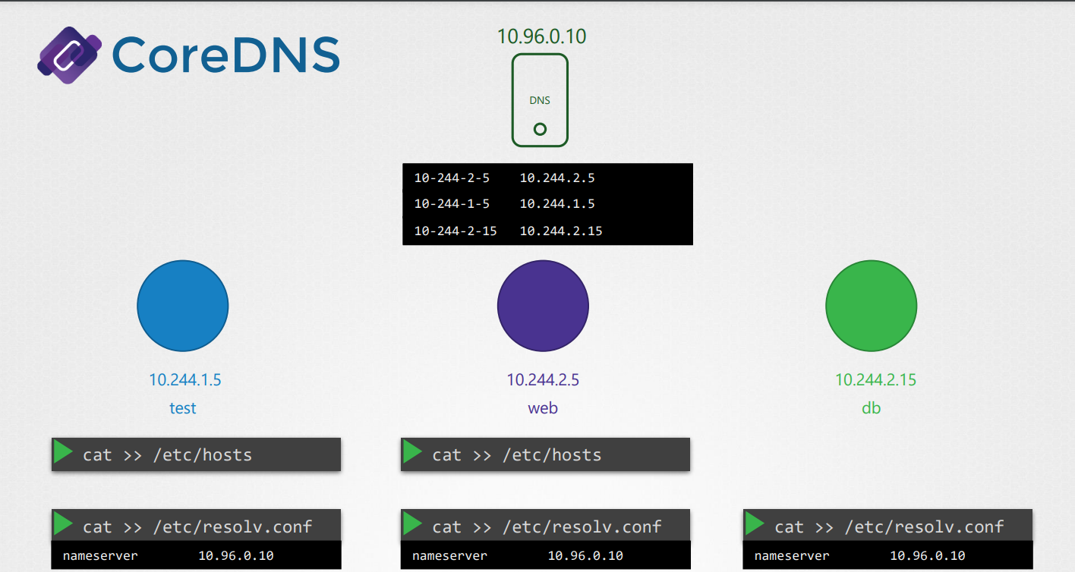

* Every time a new pod is created, we add a record in the DNS server for that pod so that other pods can access the new pod and configure the /etc/resolv.conf file in the pod to point to the DNS server. So that the new pod can resolve other pods in the cluster. This is kind of how Kubernetes does it, except, but it does not create similar entries for pods to map pod name to its IP address as we have seen that. It does that for services. For pods, it forms host names by replacing dots with dashes in the IP address of the pod. Kubernetes implements.
* DNS in the same way. It deploys a DNS server within the cluster. Prior to version 1.12, the DNS server implemented by Kubernetes was known as KubeDNS, with Kubernetes version 1.12,
* the recommended DNS server is CoreDNS.
* So how is the CoreDNS set up in the cluster?
* The coreDNS server is deployed as a pod in the Kube system namespace in the Kubernetes cluster. Well, they're deployed as two pods for redundancy as part of a replica set. They're actually a replica set within a deployment, but it doesn't really matter. But we'll just see CoreDNS as a pod in this lecture.
* This pod runs the CoreDNS executable. The same executable that we ran when we deploy CoreDNS ourselves.
* CoreDNS requires a configuration file. In our case, we used a file named Core file, so does Kubernetes. It uses a file named Core File located at /etc/coredns.
* Within this file, you have a number of plug-ins configured.

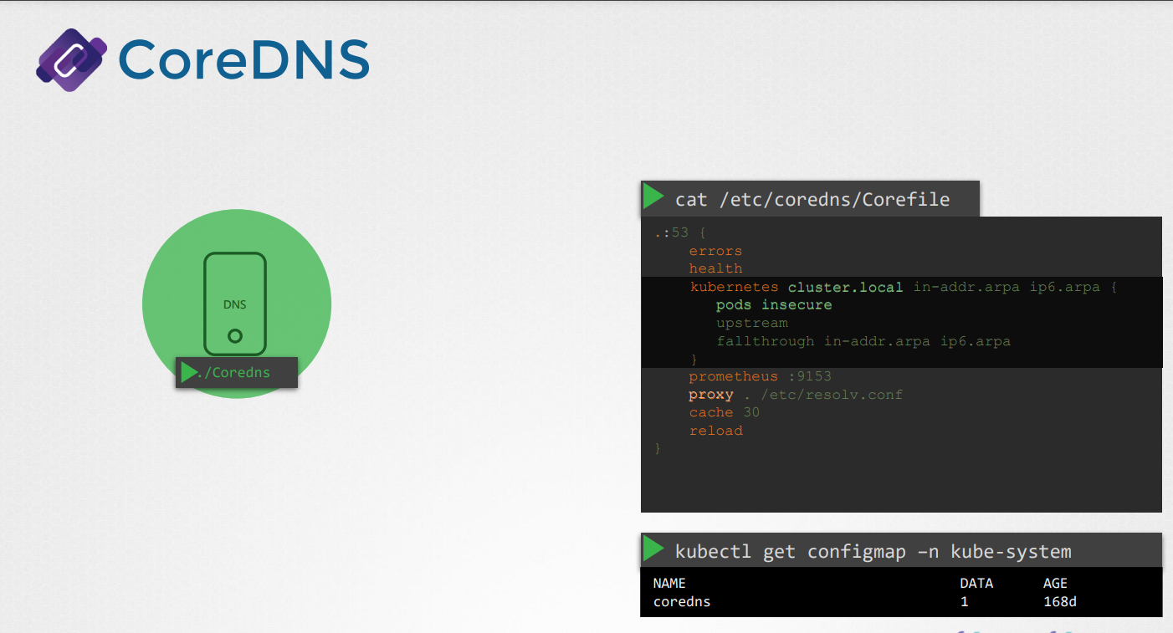

* The ones highlighted in orange. Plug-ins are configured for handling errors, reporting health, monitoring metrics, cash, et cetera.
* The plug-in that makes CoreDNS work with Kubernetes is the Kubernetes plug-in. And that is where the top-level domain name of the cluster is set.
* In this case, cluster.local. So every record in the CoreDNS DNS server falls under this domain.
* With the Kubernetes plug-in, there are multiple options. The pods option you can see here is what is responsible for creating a record for pods in the cluster.
* Remember, we talked about a record being created for each pod by converting the IPs into the dashed format. That's disabled by default but it can be enabled with this entry here.
* Any record that the DNS server can't solve, for example, say a pod tries to reach [www.google.com](http://www.google.com), it is forwarded to the name server specified in the CoreDNS pods etc resolv.conf file.
* The /etc/resolv.conf file is said to use the name server from the Kubernetes node.
* Also note, that this core file is passed into the pod as a config map object. That way, if you need to modify this configuration you can edit the config map object.
* We now have the CoreDNS pod up and running using the appropriate Kubernetes plug-in. It watches the Kubernetes cluster for new pods or services and every time a pod or a service is created, it adds a record for it in it's database.
* Next step is for the pods to point to the CoreDNS server. What address do the pods use to reach the DNS server?
* When we deploy the CoreDNS solution, it also creates a service to make it available to other components within the cluster.
* The service is named as KubeDNS by default.
* The IP address of this service is configured as the name server on pods.
* Now, you don't have to configure this yourself. The DNS configurations on pods are done by Kubernetes automatically when the pods are created.
* Want to guess which Kubernetes component is responsible for that?
* The kubelet. If you look at the config file of the kubelet, you will see the IP of the DNS server and domain in it.
* Once the pods are configured with the right name server you can now resolve other pods and services.

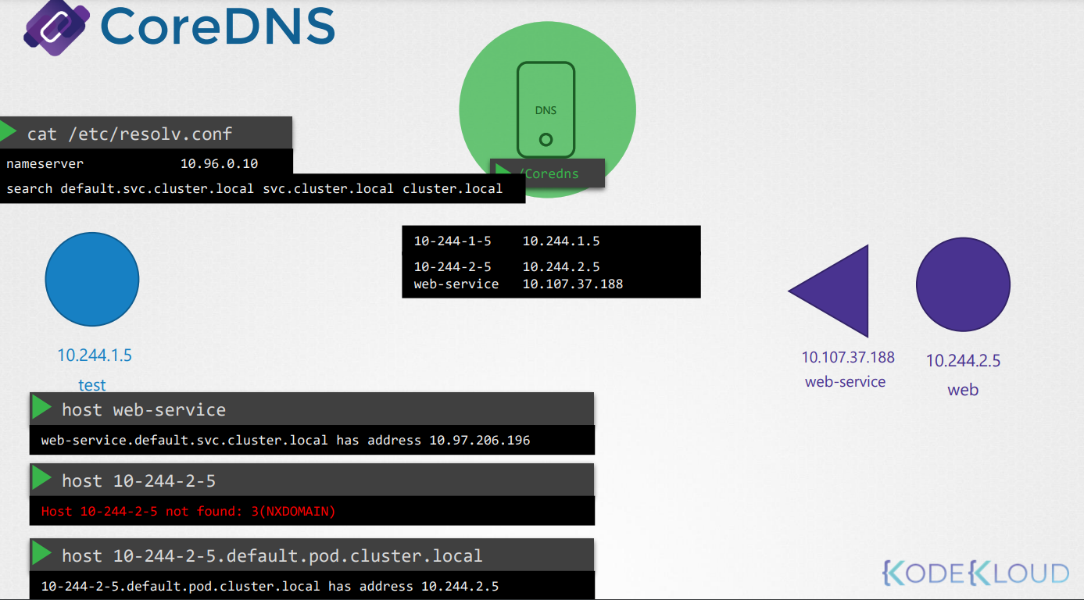

* You can access the web service using just webservice, or webservice.default, or web service.default.svc, or webservice.default.svc.cluster.local.
* If you try to manually look up the web service using nslookup or the host web service command, it will return the fully qualified domain name of the web service, which happens to be web-service.default.svc.cluster.local.
* But you didn't ask for that. You just said web-service.
* So how did it look up for the full name?
* It so happens the resolv.conf file also has a search entry which is set to default.service.cluster.local, as well as svc.cluster.local, and cluster.local.
* This allows you to find the service using any name, web service or web service.default, or web service.default.svc. However, note that it only has search entries for service, so you won't be able to reach a pod the same way.
* For that, you need to specify the full FQDN of the pod.

**Ingress**

* Ingress helps your users access your application using a single externally accessible URL that you can configure to route to different services within your cluster based on the URL path. At the same time, implement SSL security as well.
* Simply put, think of Ingress as a layer seven load balancer built in to the Kubernetes cluster that can be configured using native Kubernetes primitives just

like any other object in Kubernetes

Now remember, even with Ingress, you still need to expose it to make it accessible outside the cluster. So you still have to either publish it as a node port or with a cloud native load balancer but that is just a one-time configuration.

you do not have an Ingress controller on Kubernetes by default, so you must deploy one.

There are a number of solutions available for Ingress, a few of them being GCE,which is Google's layer seven, a CTP load balancer. NGINX, Contour, HAProxy, Traefik, and Astel. Out of this, GCE and NGINX are currently being supported and maintained by the Kubernetes project, and in this lecture we will use NGINX as an example.

* An NGINX controller is deployed as just another deployment in Kubernetes. So we start with a deployment definition file named NGINX Ingress controller with one replica and a simple pod definition template. We will label it NGINX Ingress and the image used is NGINX Ingress controller with the right version.
* We then need a service to expose the Ingress controller to the external world, so we create a service of type node port with the NGINX Ingress label selector

to link the service to the deployment.

* the Ingress controllers have additional intelligence built in to them to monitor the Kubernetes cluster for Ingress resources and configure the underlying NGINX server when something is changed. But for the Ingress controller to do this, it requires a service account with the right set of permissions.
* Now onto the next part of creating Ingress resources.An Ingress resource is a set of rules and configurations applied on the Ingress controller. You can configure rules to say, simply forward all incoming traffic to a single application or route traffic to different applications based on the URL. So if a user goes to myonlinestore.com/wear, then route to one of the applications or if the user visits the watch URL, then route to the video app, et cetera. Or you could route users based on the domain name itself. For example, if the user visits wear.myonlinestore.com then route the user to the wear application or else route him to the video app.
* Let us look at how to configure these in a bit more detail.
* The Ingress resource is created with a Kubernetes definition file, in this case,

**Open Shift**

OpenShift is an open source container application platform and is built on top of Kubernetes. It provides a set of additional tools and a nice GUI to create and manage Kubernetes constructs and easily integrate with CICD pipelines.

**Cluster HA**

* the master node hosts the control plane components including the API, controller manager, scheduler, and etcd server. In a HA setup with an additional master node you have the same components running on the new master as well. So how does that work, running multiple instances of the same components, are they going to do the same thing twice? How do they share the work among themselves? Well that differs based on what they do.
* Now we know that the API server is responsible for receiving requests and processing them or providing information about the cluster. They work on one request at a time so the API servers on all cluster nodes can be alive and running at the same time in an active active-mode.

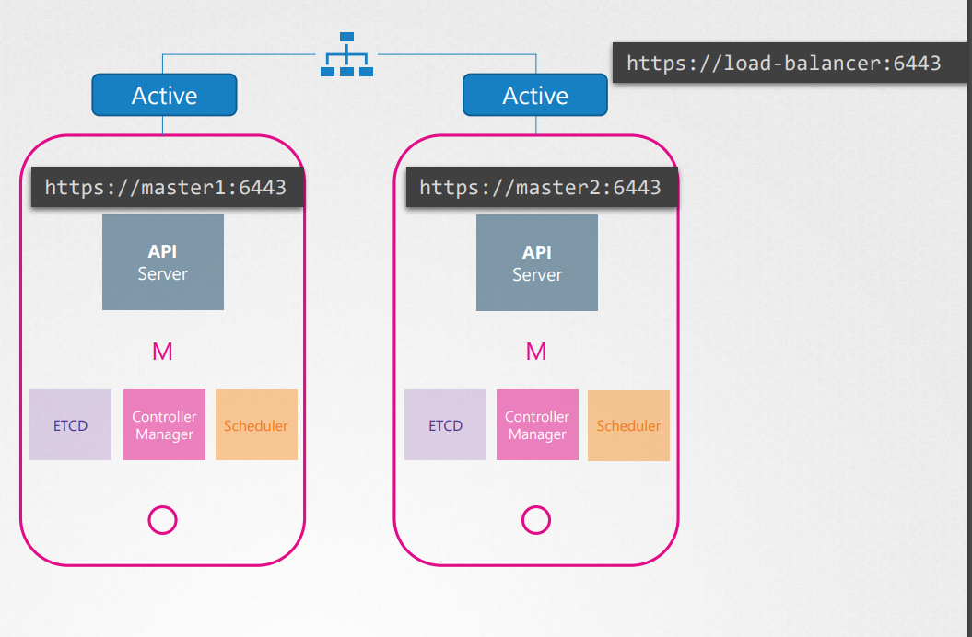

* So far in this course we know that the kubectl utility talks to the API server to get things done and we point the kubectl utility to reach the master node at port 6443. That's where the API server listens and this is configured in the kube conflict file.
* Well now with two masters where do we point the kubectl to?

We can send the request to either one of them but we shouldn't be sending the same request to both of them.

* So it is better to have a load balancer of some kind configured in the front of the master nodes that split traffic between the API servers. So we then point the kubectl utility to that load balancer. You may use engine X or HA proxy or any other load balancer for this purpose.
* What about the scheduler and the controller manager?
* These are controllers that watch the state of the cluster and take actions. For example the controller manager consists of controllers like the replication controller that is constantly watching the state of pods and taking necessary actions like creating a new pod when one fails, etc. If multiple instances of these run in parallel then they might duplicate actions resulting in more pods than actually needed. The same is true with scheduler. As such, they must not run in parallel. They run in an active standby mode. So then who decides which among the two is active and which is passive? This is achieved through a leader election process. So how does that work? Let's look at controller manager for instance.
* When a controller manager process is configured you may specify the leader elect option which is by default set to true with this option. When the controller manager process starts it tries to gain a lease or a lock on an endpoint object.
* in Kubernetes named as kubectl manager endpoint. Whichever process first updates the endpoint with its information gains the lease and becomes the active of the two. The other becomes passive. It holds the lock for the lease duration specified using the leader elect lease duration option which is by default set to 15 seconds.
* The active process then renews the lease every 10 seconds which is the default value for the option leader elect renew deadline.
* Both the processes try to become the leader every two seconds set by the leader elect retry period option. That way if one process fails maybe because the first master crashes then the second process can acquire the log and become the leader.
* The scheduler follows a similar approach and has the same command line options.

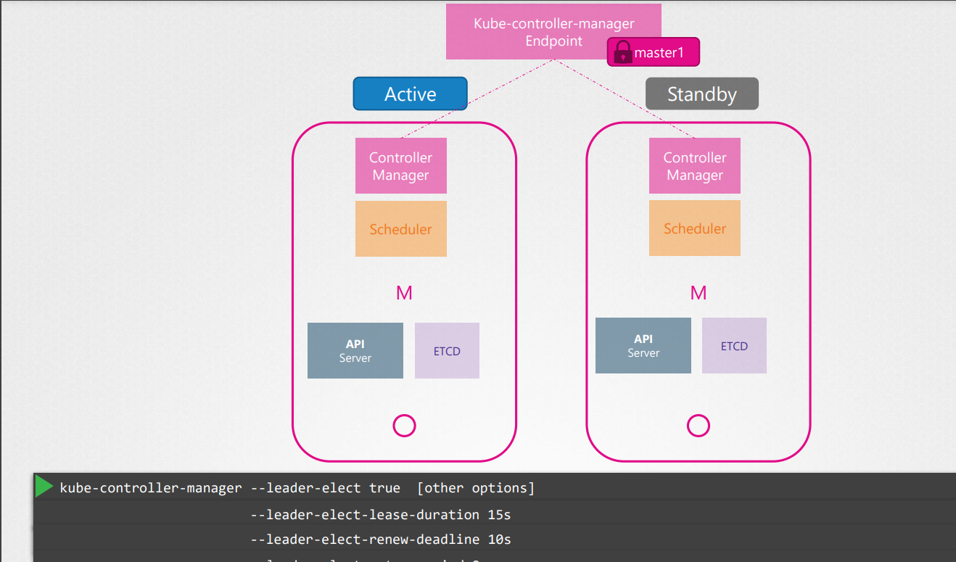

* Next step at etcd.
* Now just to quickly refresh your memory as we're going to discuss some more related topics to how etcd works
* With etcd there are two topologies that you can configure in Kubernetes. One is as it looks here and the same architecture that we have been following throughout this course where etcd is part of the Kubernetes master nodes. It's called as a stacked control plane nodes topology.

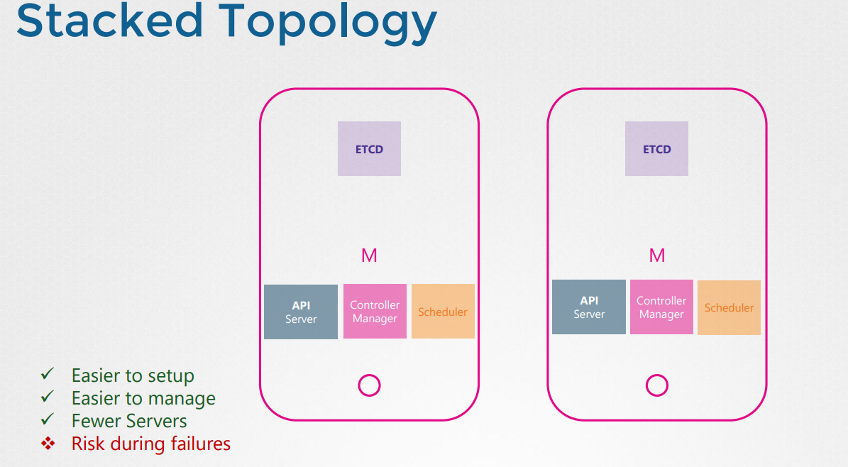

* This is easier to set up and easier to manage and requires fewer nodes. But if one node goes down both an etcd member and the control plane instances are lost and redundancy is compromised,
* the other is where etcd is separated from the control plane nodes and run on its own set of servers. This is a topology with external etcd servers. Compared to the previous topology, this is less risky as a failed control plane node does not impact the etcd cluster and the data it stores. However it is harder to set up and requires twice the number of servers for the external etcd nodes.
* So remember the API server is the only component that talks to the etcd server and if you look into the API service configuration options we have a set of options specifying where the etcd server is.
* So regardless of the topology we use and wherever we configure at ETCD servers whether on the same server or on a separate server, ultimately we need to make sure that the API server is pointing to the right address of the etcd servers.
* Now remember etcd is a distributed system so the API server or any other component that wishes to talk to it can reach the etcd server at any of its instances. You can read and write data through any of the available etcd server instances.
* This is why we specify a list of etcd servers in the kupe-apiserver configuration.

**ETCD HA**

* we will talk about etcd in a high availability setup. So this is really a prerequisite lecture for the next lecture where we talk about configuring Kubernetes in a highly available mode.
* Well, one portion of that deals with configuring etcd in a HA mode.
* we took a quick look at etcd. We will now recap real quick and more importantly, focus on the cluster of configuration on etcd.
* So what is etcd? It's a distributed, reliable key value store that is simple, secure, and fast. So let's break it up. Traditionally, data was organized and stored in tables like this. For example, to store details about a number of individuals. A key value store stores information.

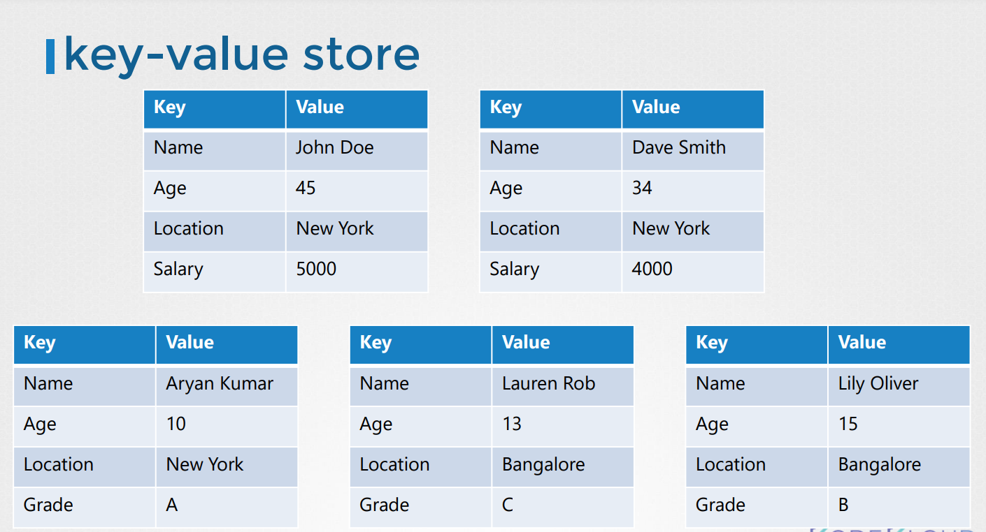

* So each individual gets a document, and all information about that individual is stored within that file. These files can be in any format or structure, and changes to one file does not affect the others.
* In this case, the working individuals can have their files with salary fields. While you could store and retrieve simple key and values, when your data gets complex, you typically end up transacting in data formats like JSON or YAML.



* So that's what etcd is and how you quickly get started with it. We also said that etcd is distributed. So what does that mean?
* We had etcd on a single server, but it's a database and maybe storing critical data. So it is possible to have your data store across multiple servers.
* Now, you have three servers all running etcd and all maintaining an identical copy of the database. So if you lose one, you still have two copies of your data. But how does it ensure the data on all the nodes are consistent? You can write to any instance and read your data from any instance.
* etcd ensures that the same consistent copy of the data is available on all instances at the same time. So how does it do that? With reads, it's easy. Since the same data is available across all nodes, you can easily read it from any nodes. But that is not the case with writes.
* What if two writes requests coming on two different instances? Which one goes through?
* For example, I have writes coming in for the name set to John on one end, with the name Joe on the other. Of course, we cannot have two different data on two different nodes. When I said etcd can write through any instance, I wasn't 100% right. etcd does not process the writes on each node. Instead, only one of the instances is responsible for processing the writes.
* Internally, the two nodes elects a leader among them. Of the total instances, one node becomes the leader and the other node becomes the followers. If the writes came in through the leader node, then the leader processes the write. The leader makes sure that the other nodes are sent a copy of the data. If the writes came in through any of the other follower nodes, then they forward the writes to the leader internally and then the leader processes the writes. Again, when the writes are processed, the leader ensures that copies of the write are distributed to other
* instances in the cluster. Thus, a write is only considered complete.
* if the leader gets consent from the other members in the cluster. So how do they elect the leader among themselves? And how do they ensure a write is propagated across all instances? etcd implements distributed consensus using raft protocol. Let's see how that works in a three node cluster. When the cluster is set up, we have three nodes that do not have a leader elected.
* 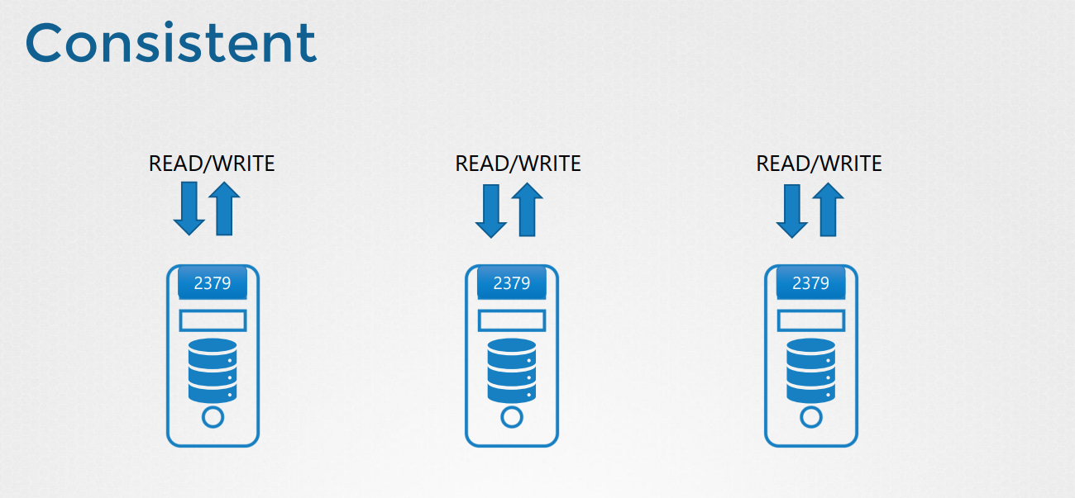
* Raft algorithm uses random timers for initiating requests. For example, a random timer is kicked off on the three managers. The first one to finish the timer sends out a request to the other nodes requesting permission to be the leader. The other managers on receiving the request response with their vote, and the node assumes the leader role.

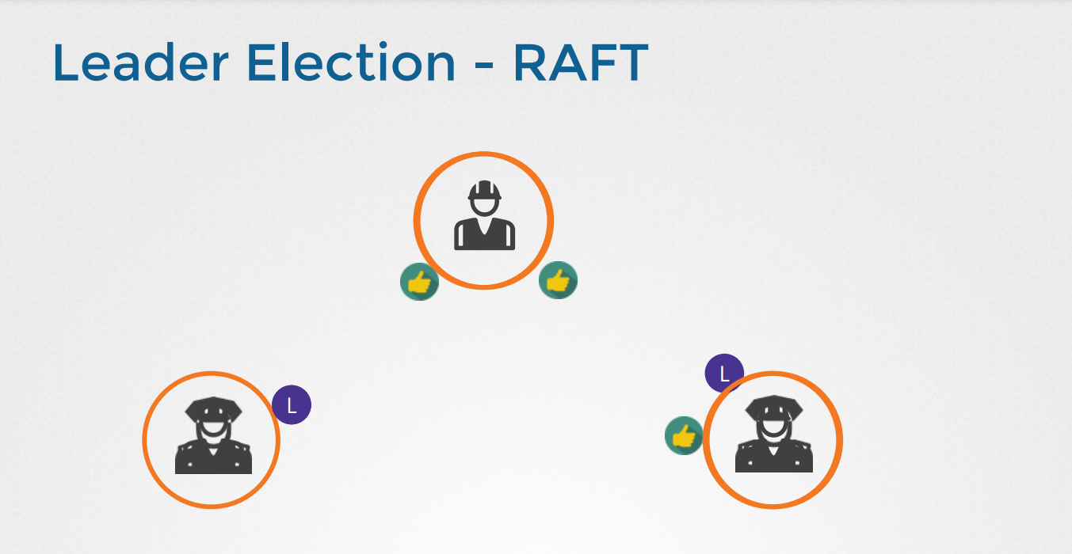

* Now that it is elected the leader, it sends out notification at regular intervals to other masters informing them that it is continuing to assume the role of the leader. In case the other nodes do not receive a notification from the leader at some point in time, which could either be due to the leader going down or losing network connectivity, the nodes initiate a reelection process among themselves, and a new leader is identified.

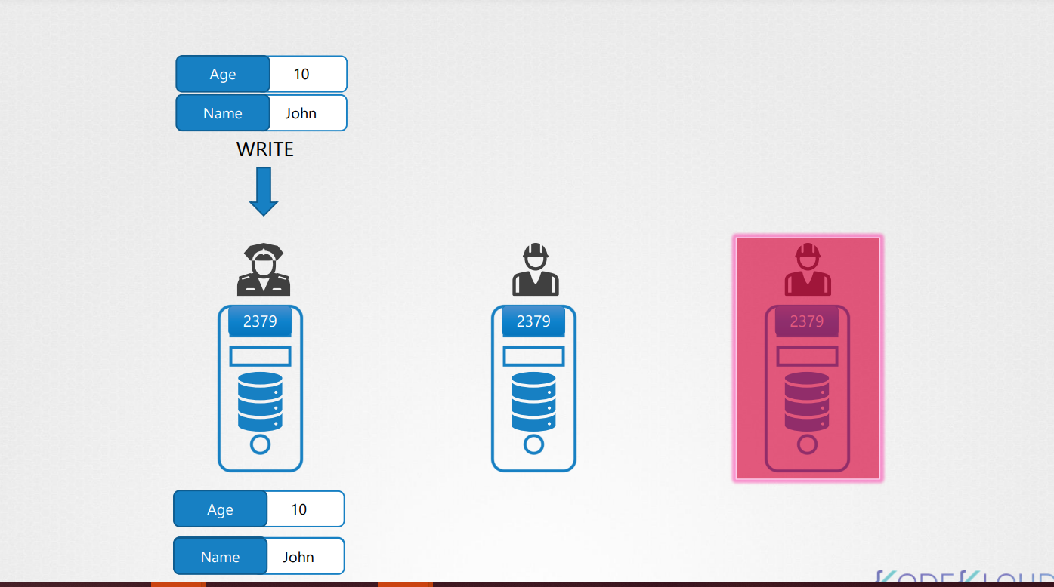

* Going back to our previous example where a write comes in, it is processed by the leader and is replicated to other nodes in the cluster. The write is considered to be complete only once it is replicated to the other instances in the cluster. We said that the etcd cluster is highly available.
* So even if we lose a node, it should still function.
* Say for example, a new write comes in, but one of the node is not responding, and hence, the leader is only able to write to two nodes in the cluster. Is the write considered to be complete? Does it wait for the third node to be up? Or does it fail? And write is considered to be complete if it can be written on the majority of the nodes in the cluster. For example, in this case of three nodes, the majority is two. So if the data can be written on two of the nodes, then the write is considered to be complete. If the third node was to come online, then the data is copied to that as well. So what is the majority?
* Well, a more appropriate term to use would be quorum.
* Quorum is the minimum number of nodes that must be available for the cluster to function properly or make a successful write. In case of three, we know it's two. For any given number of nodes, quorum is the total number of nodes divided by 2 plus 1. So quorum of three nodes is 3 by 2, which is 1.5, plus 1 equals 2.5. If there is a .5, consider the whole number only. So that's 2. Similarly, quorum of five nodes is 3. So here is a table that shows the quorum of clusters of size one to seven. Quorum of three and five are what we calculated. Quorum of one is one itself. Meaning if you have a single node cluster, none of these really apply. If you lose that node, everything's gone.

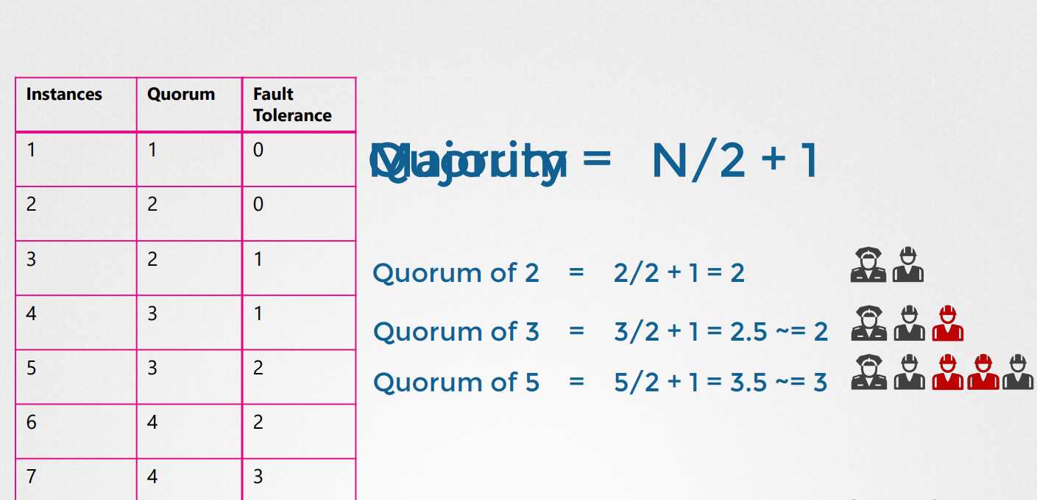

* If you look at two and apply the same formula, the quorum is two itself. 2 by 2 is 1, and 1 plus 1 is 2. So even if you have two instances in the cluster, the majority is still two. If one fails, there's no quorum, so writes won't be processed. So having two instances is like having one instance.
* It doesn't offer you any real value as quorum cannot be met, which is why it is recommended to have a minimum of three instances in an etcd cluster.
* That way it offers a fault tolerance of at least one node.
* If you lose one, you can still have quorum and the cluster will continue to function. So the first column minus the second column gives you the fault tolerance, the number of nodes that you can afford to lose while keeping the cluster alive. So we have one to seven nodes here. One and two are out of consideration.
* So from three to seven, what do we consider? As you can see, three and four have the same fault tolerance of one. Five and six have the same fault tolerance of two.
* When deciding on the number of master nodes, it is recommended to select an odd number, as highlighted in the table, three or five or seven. Say we have a six node cluster. Say, for example, due to a disruption in the network, it fails and causes the network to partition. We now have four nodes on one and two on the other. In this case, the group with four nodes have quorum and continues to operate normally. However, if the network got partition in a different way resulting in nodes being distributed equally between the two, each group now has three nodes only. But since we originally had six manager nodes, the quorum for the cluster to stay alive is four. But if you look at the groups here, neither of these groups have four managers to meet the quorum, so it results in a failed cluster.
* So with even number of nodes, there is possibility of the cluster failing during a network segmentation.
* In case we had odd number of managers originally, say seven, then after the network segmentation, we have four on one segmented network and three on the other. And so our cluster still lives on the group with four managers, as it meets the quorum of four.
* No matter how the network segments, there are better chances for your cluster to stay alive in case of network segmentation with odd number of nodes. So an odd number of nodes is preferred over even number. Having five is preferred over six, and having more than five node is really not necessary, as five gives you enough fault tolerance. To install etcd on a server,
* download the latest supported binary, extract it, create the required directory structure, copy over the certificate files generated for etcd. We discussed how to generate these certificates in detail in the TLS certificate section. Then, configure the etcd service.

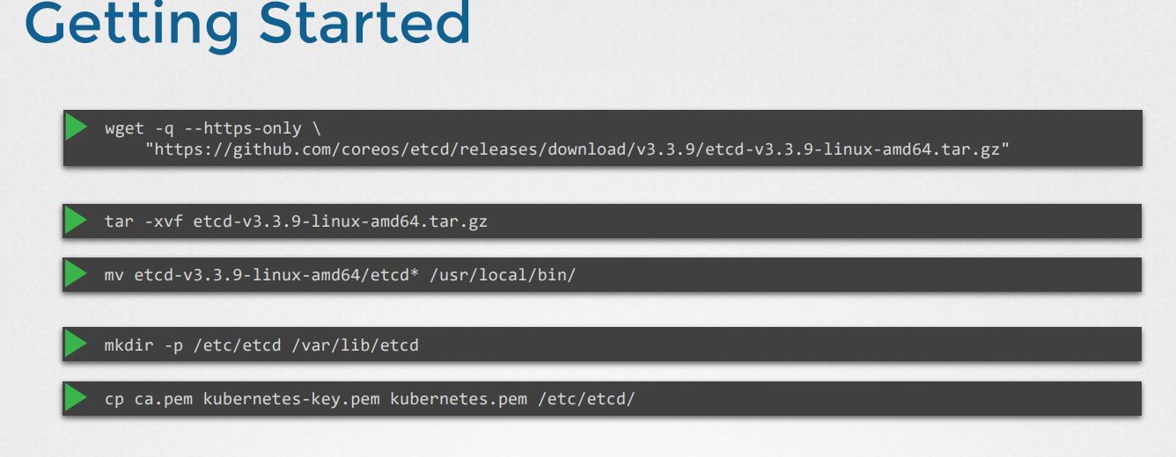

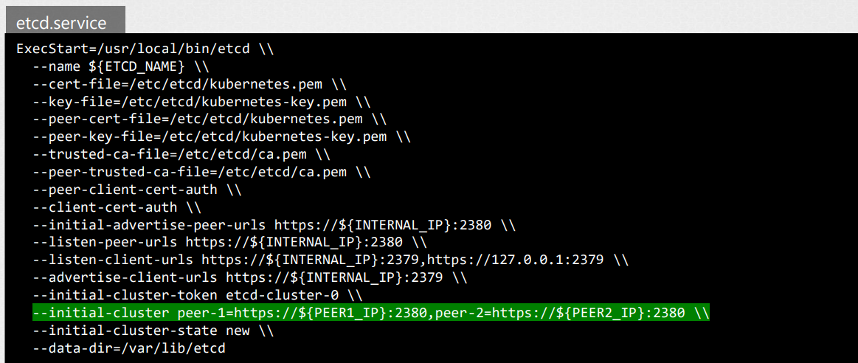

* What's important here is to note that the initial cluster option where we passing the peers information, that's how each etcd service knows that it is part of a cluster and where its peers are.
* Once installed and configured, use the etcdctl utility to store and retrieve data. The etcdctl utility has two API versions, V2 and V3. So the commands work different in each version. Version 2 is default. However, we will use version 3.
* So set an environment variable, etcdctl_api, to three. otherwise, the below commands won't work.
* Going back to our design, how many nodes should our cluster have? In an HA environment, as you can see, having one or two instances doesn't really make any sense, as losing one node in either case will leave you without quorum and thus, render the cluster non-functional. Hence, the minimum required nodes in an HA setup is three.
* We also discussed why we prefer odd number of instances over even number. Having even number of instances can leave the cluster without quorum in certain network partition scenarios. So all the even number of nodes is out of scope. So we are left with three, five, and seven, or any odd number above that. Three is a good start, but if you prefer a higher level of fault tolerance, then five is better. But anything beyond that is just unnecessary.
* So considering your environment, the fault tolerance requirements, and the cost that you can bear, you should be able to choose one number from this list. In our case, we go with three. So how does our design look now? With HA, the minimum required number of nodes for fault tolerance is three. Now, while it would be great to have three master nodes, we are limited by our capacity of our laptop, so we will just go with two. But if you're deploying the setup in another environment and have sufficient capacity, feel free to go with three.

**Troubleshooting**

**Application Failure**

* Take me to [Lecture](https://kodekloud.com/topic/application-failure/)
* In this lecture we will go step by step in troubleshooting Application failure.
* To check the Application/Service status of the webserver
* curl http://web-service-ip:node-port

[](https://github.com/kodekloudhub/certified-kubernetes-administrator-course/blob/master/images/app.PNG)

* To check the endpoint of the service and compare it with the selectors
* kubectl describe service web-service

[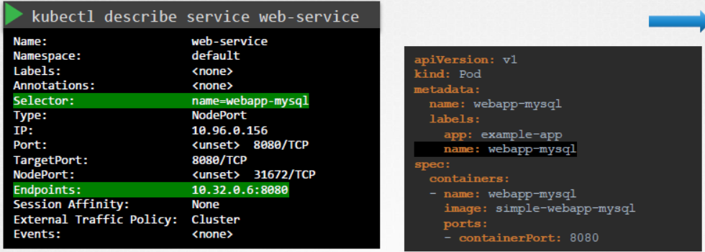](https://github.com/kodekloudhub/certified-kubernetes-administrator-course/blob/master/images/svc.PNG)

* To check the status and logs of the pod
* kubectl get pod
* kubectl describe pod web
* kubectl logs web
* To check the logs of the previous pod
* kubectl logs web -f --previous

[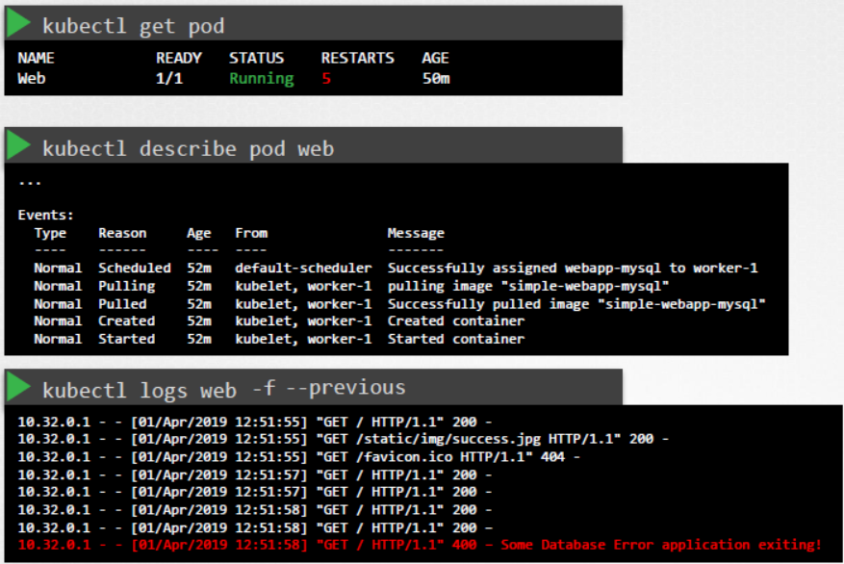](https://github.com/kodekloudhub/certified-kubernetes-administrator-course/blob/master/images/db.PNG)

**Worker Node Failure**

* Take me to the [Lecture](https://kodekloud.com/topic/worker-node-failure/)
* Lets check the status of the Nodes in the cluster, are they **Ready** or **NotReady**
* kubectl get nodes
* If they are **NotReady** then check the **LastHeartbeatTime** of the node to find out the time when node might have crashed
* kubectl describe node worker-1

[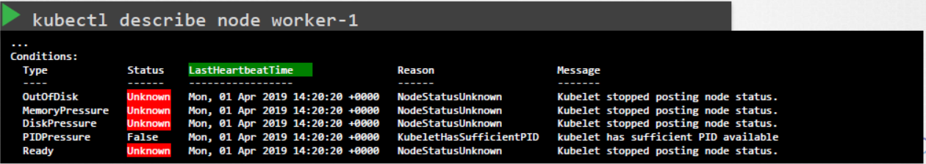](https://github.com/kodekloudhub/certified-kubernetes-administrator-course/blob/master/images/wrk.PNG)

* Check the possible **CPU** and **MEMORY** using **top** and **df -h**

[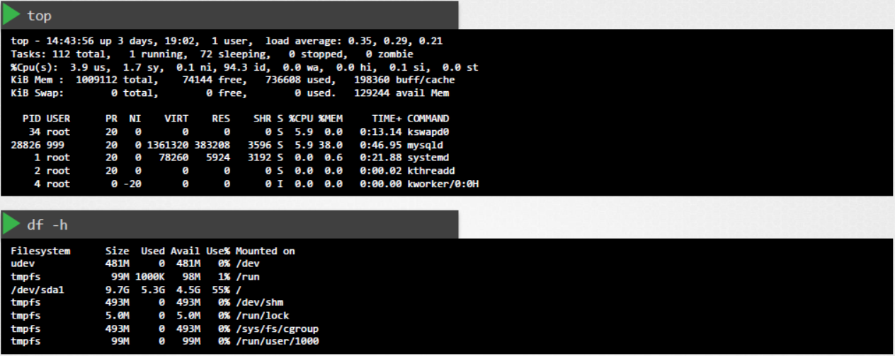](https://github.com/kodekloudhub/certified-kubernetes-administrator-course/blob/master/images/mem.PNG)

* Check the status and the logs of the **kubelet** for the possible issues.
* serivce kubelet status
* sudo journalctl –u kubelet

[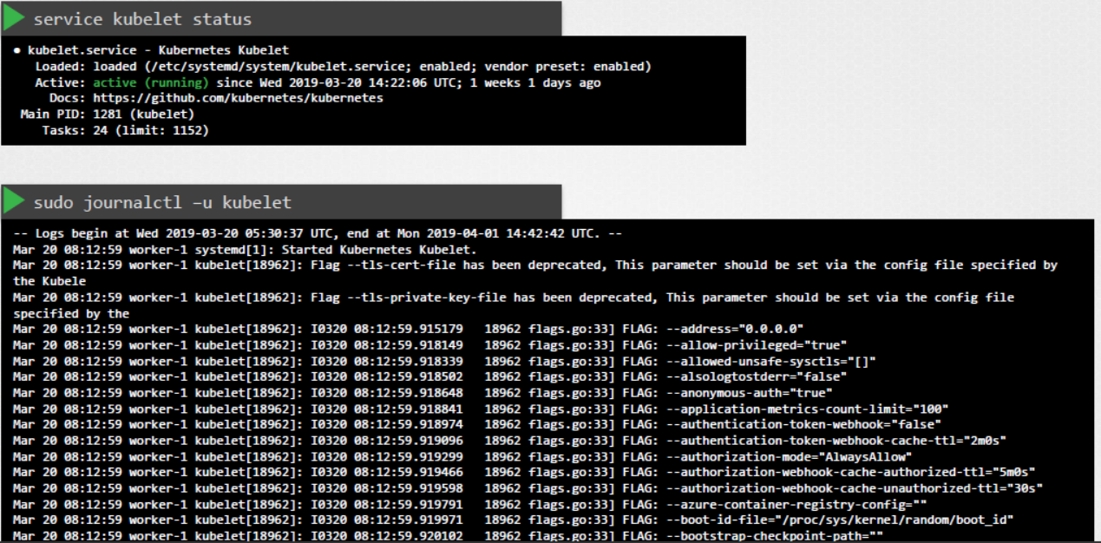](https://github.com/kodekloudhub/certified-kubernetes-administrator-course/blob/master/images/kublet.PNG)

* Check the **kubelet** Certificates, they are not expired, and in the right group and issued by the right CA.
* openssl x509 -in /var/lib/kubelet/worker-1.crt -text

[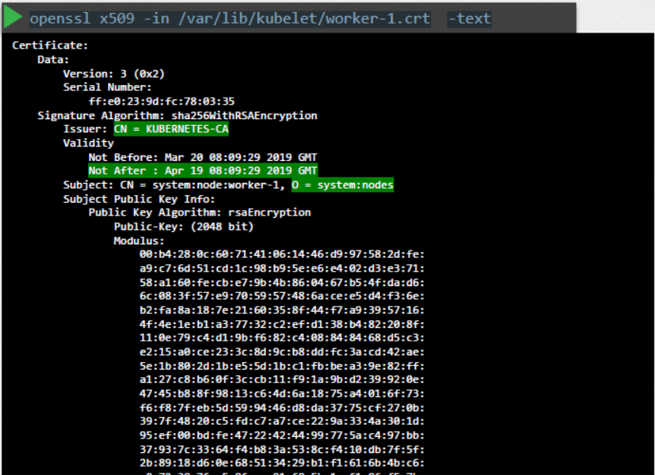](https://github.com/kodekloudhub/certified-kubernetes-administrator-course/blob/master/images/cert.PNG)

**Network Troubleshooting**

**Network Plugin in Kubernetes**

**--------------------**

Kubernetes uses CNI plugins to setup network. The kubelet is responsible for executing plugins as we mention the following parameters in kubelet configuration.

***- cni-bin-dir*:**   *Kubelet probes this directory for plugins on startup*

***- network-plugin:*** *The network plugin to use from cni-bin-dir. It must match the name reported by a plugin probed from the plugin directory.*

*There are several plugins available and these are some.*

**1. Weave Net:**

To install,

kubectl apply -f https://github.com/weaveworks/weave/releases/download/v2.8.1/weave-daemonset-k8s.yaml

You can find details about the network plugins in the following documentation :

<https://kubernetes.io/docs/concepts/cluster-administration/addons/#networking-and-network-policy>

**2. Flannel :**

 To install,

kubectl apply -f https://raw.githubusercontent.com/coreos/flannel/2140ac876ef134e0ed5af15c65e414cf26827915/Documentation/kube-flannel.yml

*Note: As of now flannel does not support kubernetes network policies.*

**3. Calico :**

   To install,

   curl https://docs.projectcalico.org/manifests/calico.yaml -O

*Apply the manifest using the following command.*

      kubectl apply -f calico.yaml

   Calico is said to have most advanced cni network plugin.

In CKA and CKAD exam, you won't be asked to install the CNI plugin. But if asked you will be provided with the exact URL to install it.

*Note: If there are multiple CNI configuration files in the directory, the kubelet uses the configuration file that comes first by name in lexicographic order.*

**DNS in Kubernetes**

**-----------------**

Kubernetes uses **CoreDNS**. **CoreDNS** is a flexible, extensible DNS server that can serve as the Kubernetes cluster DNS.

**Memory and Pods**

In large scale Kubernetes clusters, CoreDNS's memory usage is predominantly affected by the number of Pods and Services in the cluster. Other factors include the size of the filled DNS answer cache, and the rate of queries received (QPS) per CoreDNS instance.

Kubernetes resources for **coreDNS**are:

1. *a service account named****coredns****,*
2. *cluster-roles named****coredns****and****kube-dns***
3. *clusterrolebindings named****coredns****and****kube-dns****,*
4. *a deployment named****coredns****,*
5. *a configmap named****coredns****and a*
6. *service named****kube-dns****.*

While analyzing the coreDNS deployment you can see that the the ***Corefile plugin*** consists of important configuration which is defined as a ***configmap***.

Port **53** is used for for *DNS resolution*.

1. kubernetes cluster.local in-addr.arpa ip6.arpa {
2. pods insecure
3. fallthrough in-addr.arpa ip6.arpa
4. ttl 30
5. }

This is the backend to k8s for *cluster.local and reverse domains*.

proxy . /etc/resolv.conf

Forward out of cluster domains directly to right *authoritative DNS server*.

Troubleshooting issues related to coreDNS

1. If you find **CoreDNS** pods in pending state first check network plugin is installed.

2. coredns pods have **CrashLoopBackOff or Error state**

If you have nodes that are running SELinux with an older version of Docker you might experience a scenario where the coredns pods are not starting. To solve that you can try one of the following options:

a)Upgrade to a newer version of Docker.

b)Disable **SELinux.**

c)Modify the coredns deployment to set **allowPrivilegeEscalation** to *true*:

1. kubectl -n kube-system get deployment coredns -o yaml | \
2. sed 's/allowPrivilegeEscalation: false/allowPrivilegeEscalation: true/g' | \
3. kubectl apply -f -

d)Another cause for **CoreDNS**to have CrashLoopBackOff is when a **CoreDNS** Pod deployed in Kubernetes detects a loop.

  There are many ways to work around this issue, some are listed here:

* Add the following to your kubelet config yaml: ***resolvConf: <path-to-your-real-resolv-conf-file>*** This flag tells ***kubelet*** to pass an alternate ***resolv.conf*** to Pods. For systems using**systemd-resolved**, ***/run/systemd/resolve/resolv.conf*** is typically the location of the ***"real" resolv.conf***, although this can be different depending on your distribution.
* Disable the local DNS cache on host nodes, and restore ***/etc/resolv.conf*** to the original.
* A quick fix is to edit your **Corefile**, replacing forward ***. /etc/resolv.conf*** with the IP address of your upstream DNS, for example forward **. 8.8.8.8**. But this only fixes the issue for **CoreDNS**, ***kubelet*** will continue to forward the invalid ***resolv.conf*** to all default dnsPolicy Pods, leaving them unable to resolve DNS.

3. If **CoreDNS** pods and the**kube-dns** service is working fine, check the **kube-dns** service has valid ***endpoints***.

*kubectl -n kube-system get ep kube-dns*

If there are no endpoints for the service, inspect the service and make sure it uses the correct selectors and ports.

**Kube-Proxy**

**---------**

**kube-proxy**is a network proxy that runs on each node in the cluster. **kube-proxy**maintains *network rules on nodes*. These network rules allow network communication to the Pods from network sessions inside or outside of the cluster.

In a cluster configured with **kubeadm**, you can find **kube-proxy** as a ***daemonset***.

**kubeproxy** is responsible for watching *services and endpoint associated with each service*. When the client is going to connect to the service using the *virtual IP* the**kubeproxy**is responsible for *sending traffic to actual pods*.

If you run a kubectl describe ds kube-proxy -n kube-system you can see that the**kube-proxy** binary runs with following command inside the kube-proxy container.

1. Command:
2. /usr/local/bin/kube-proxy
3. --config=/var/lib/kube-proxy/config.conf
4. --hostname-override=$(NODE_NAME)

    So it fetches the configuration from a configuration file ie, ***/var/lib/kube-proxy/config.conf***and we can override the hostname with the node name of at which the pod is running.

  In the config file we define the **clusterCIDR, kubeproxy mode, ipvs, iptables, bindaddress, kube-config** etc.

Troubleshooting issues related to kube-proxy

1. Check **kube-proxy** pod in the **kube-system** namespace is running.

2. Check **kube-proxy**logs.

3. Check **configmap** is correctly defined and the config file for running **kube-proxy**binary is correct.

4. **kube-config** is defined in the **config map**.

5. check **kube-proxy** is *running* inside the container

1. # netstat -plan | grep kube-proxy
2. tcp 0 0 0.0.0.0:30081 0.0.0.0:* LISTEN 1/kube-proxy
3. tcp 0 0 127.0.0.1:10249 0.0.0.0:* LISTEN 1/kube-proxy
4. tcp 0 0 172.17.0.12:33706 172.17.0.12:6443 ESTABLISHED 1/kube-proxy
5. tcp6 0 0 :::10256 :::* LISTEN 1/kube-proxy